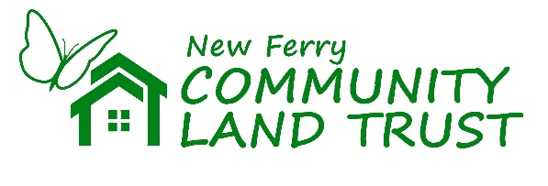
New Ferry Market: Business Survey

Since its inception in 2018, New Ferry Community Land Trust has had an ambition to run regular markets in the New Ferry precinct to bring in visitors and footfall that will hopefully be beneficial to existing businesses here. These markets will probably occur quarterly. We’d like to ask you a few questions to help understand any positive and negative impacts of introducing a regular New Ferry Market on local businesses. The survey will take five minutes of your time and all answers will be confidential.

To participate in this survey, please save this document to your device. Fill in, and when completed, save again and then email it to newferrymarkets@gmail.com

Many thanks for participating in this survey.

- To what extent do you agree or disagree with the following statements?
[Please tick one per row]
 | Strongly disagree | Tend to disagree | Neither agree nor disagree | Tend to agree | Strongly agree
A regular market would bring additional footfall into the town | ☐ | ☐ | ☐ | ☐ | ☐
A regular market would benefit my business financially | ☐ | ☐ | ☐ | ☐ | ☐
Having a regular market would add character to the area | ☐ | ☐ | ☐ | ☐ | ☐
Having a regular market would build a sense of community | ☐ | ☐ | ☐ | ☐ | ☐
Events and entertainment in the market would help to promote my business | ☐ | ☐ | ☐ | ☐ | ☐

Please use this space if you would like to expand on any of the statements made above:
- Any other comments or write your name and phone number here to be entered into the draw to win a £10 Amazon voucher

