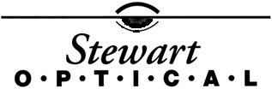

I understand that, under the Health Insurance Portability & Accountability Act of 1996 (“HIPAA”), I have certain rights to privacy regarding my protected health information. I under that this information can and will be used to:

●Conduct, plan and direct my treatment and follow-up among the multiple healthcare providers who may be involved in that treatment directly or indirectly.
● Obtain payment from third-party payers.
● Conduct normal healthcare operations such as quality assessment and physician certifications.

I have read and understood the Notice of Privacy Practices of Stewart Optical, LLC which contains a more complete description of the uses and disclosures of my health information. I understand that this organization has the right to change its Notice of Privacy Practices at any time and that I may contact this organization at any time to address above to obtain a current copy of the Notice of Privacy Practices.

I understand that I may request in writing that you can restrict how my private information is used and disclosed to carry out treatment, payment or health care operations. I also understand that you are not required to agree to my requested restrictions, but if you do agree then you are bound to abide by such restrictions.

Name (please print): ___________________________________

Signature: ____________________________________________ Date: ____/____/____

