Welcome to “team limitless”
Here to help you rock your Xosialx business
Team leaders Bob Cannata and Brad Emmert
 video #1
GETTING STARTED GUIDE
Lets get going today !!
just do it – follow the plan
If you want to succeed: Treat this like a business
Please print this guide and watch the getting started videos on this team site for better clarification
Initial set up – education-
Join $42.49 nucalm app to qualify for commissions and get positioned in the 3x20 forced matrix - 30 day refund policy- add products if desired /starter product kit best value or 3 sprays
Email from nu calm- set up –
Email from xosialx- instructions as follows - Login main company site - your username.xosialx.com . login in to back office with username and password
Click to become associate (share and earn)- once you do that . see links on the left in red it will say (your web sites/nu calm marketing site ) get both website links to send out
Commissions set up – I payout- once you earn a commission – week runs wend am to tue midnight - commissions paid following Monday
Start using the app
Go thru thru your nucalm marketing site to get familiar with what your guest will see
Go thru our team site – teamlimitless.biz
Team site – watch the comp plan video training
Back office video tutorial – on team site
Go thru your regular xosialx site and back office to get familiar
company zooms = xsoialx.com/webinar--- tue biz opp / thur training
team zooms – zoom.com –join meeting – id # 7194025698- tue and thur biz opps 8pm est --- wends 8pm est and sat noon est 1 hr weekly team training try to make 1 of the 2

Building your team
All starts with proper Mind set = action taken
Your why - why are you building the business- ____________________________________________________________________________________________________________________
__________________________________________________________
Everyone you speak to can benefit from the business -app/products and the income opportunity. your mind set must be that you are doing that person a favor and let them decide to go forward or not
Once you understand residual income ,and what is waiting for you ,you will burst thru a wall to have it
Video #2 Step 1 launching your business
Launching = you want to have exposed this to at least 10 people in your 1st month – watch the 3 min video and maybe the longer video or visit teamlimitless.biz or get on a biz op zoom
to complete an exposure you do a follow up call with to discuss
Enroll your 3 associates-- power of 3
Exposure process
Because the cutting edge tech of nucalm ,better to lead with nu calm and depending on your prospect ,mention the bus opp
Option 1- Phone call with basic verbiage(see below) or Text verbiage along with your xosialx/nu calm web site / team site were bobby sets the table and shows the 3 min nucalm video and the rest of the nucalm site they received from you .or company or bobby team zoom
when can u watch the info, shoot for 1 day ,book follow up call right after
Follow up – any Q then simple close if they are ready, Or get on a zoom- team or company or personal- see schedule
Option 2- you can do it in reverse if desired - zoom then website info
You can also lead with the business or a more general open ended pitch
Are you open to looking at other ways to make money
You have to hear about this crazy app that I think everyone will want

2 Ongoing recruiting process-after your initial launch
4 parts to the process 90/30/10 /3 system- track progress
1. Approach- 3 new people a day = 90 month –strike interest- we will use the verbiage below text or call
2. Activity- 1 of 3 will react favorable and agree to getting on a presentation zoom or checking out your web site -- 30 new people a month in the funnel
3. 10 of the 30 will actually get on a zoom or go thru your site watching the videos and respond to your follow up efforts
4. follow up to a decision- at least 3 of the 10 will enroll it could be more - that’s 3 new people per month $$$$$
it’s a numbers game
_______________________________________________________
text / verbal verbiage to put out with your video– use your own style
hi jim , I recently parted with a company that secured the worldwide marketing rights to an incredible technology that I truly feel everybody in the planet would want to use

Before February 2026 , this technology called NuCalm was only used by high-level organizations

US military , Special Forces , 78 professional sports teams

And countless doctors in medical facilities throughout the world used in over 2.7 million surgeries

Now being launched to the general public Worldwide and the company I am working with have the exclusive rights

This technology helps with --- sleep issues…. Energys… Health issues athletic performance and focus all masses markets

Accompanying this text will be my personal Nu Calm website explaining the nu Calm technology

scroll through the site ,start off with the three minute video on the front by the CEO and founder

towards the bottom of the site click on the link that says “Nu Calm vault” the longer video version really gets into the technology deeper , its fascinating
look for the chicken soup for the soul author 3 people sitting at a table

this downloadable technology app is available for just $42 a month

Complete 30 day money back guarantee And you can cancel anytime you desire

you can choose just to be a customer and enjoy the nu calm experience or you can choose to benefit financially just by sharing an app everybody will want

get back to me as soon as you check out my website

_____________________________________________________________
Video # 3

cold market – there are countless people looking for this technology or desiring to make money- need to add then into the mix besides your warm market

- Talk to new people- They may be reluctant to give you their number or your making a quick pitch so make up cards utilizing teamlimitless.biz website
This site in bobs opening video will show the 3 minute nu calm video – as well as a tour of the nu calm site- instructing them to look further by viewing your personal website that was also on the card (see sample card below)

2.Utilizing social media – a lot of you know how to use the different sites to draw traffic- using your nu calm web site / with or without the aid of teamlimitless.biz

Below this getting started training we will have a attachment to help with utilizing social media program/ documents

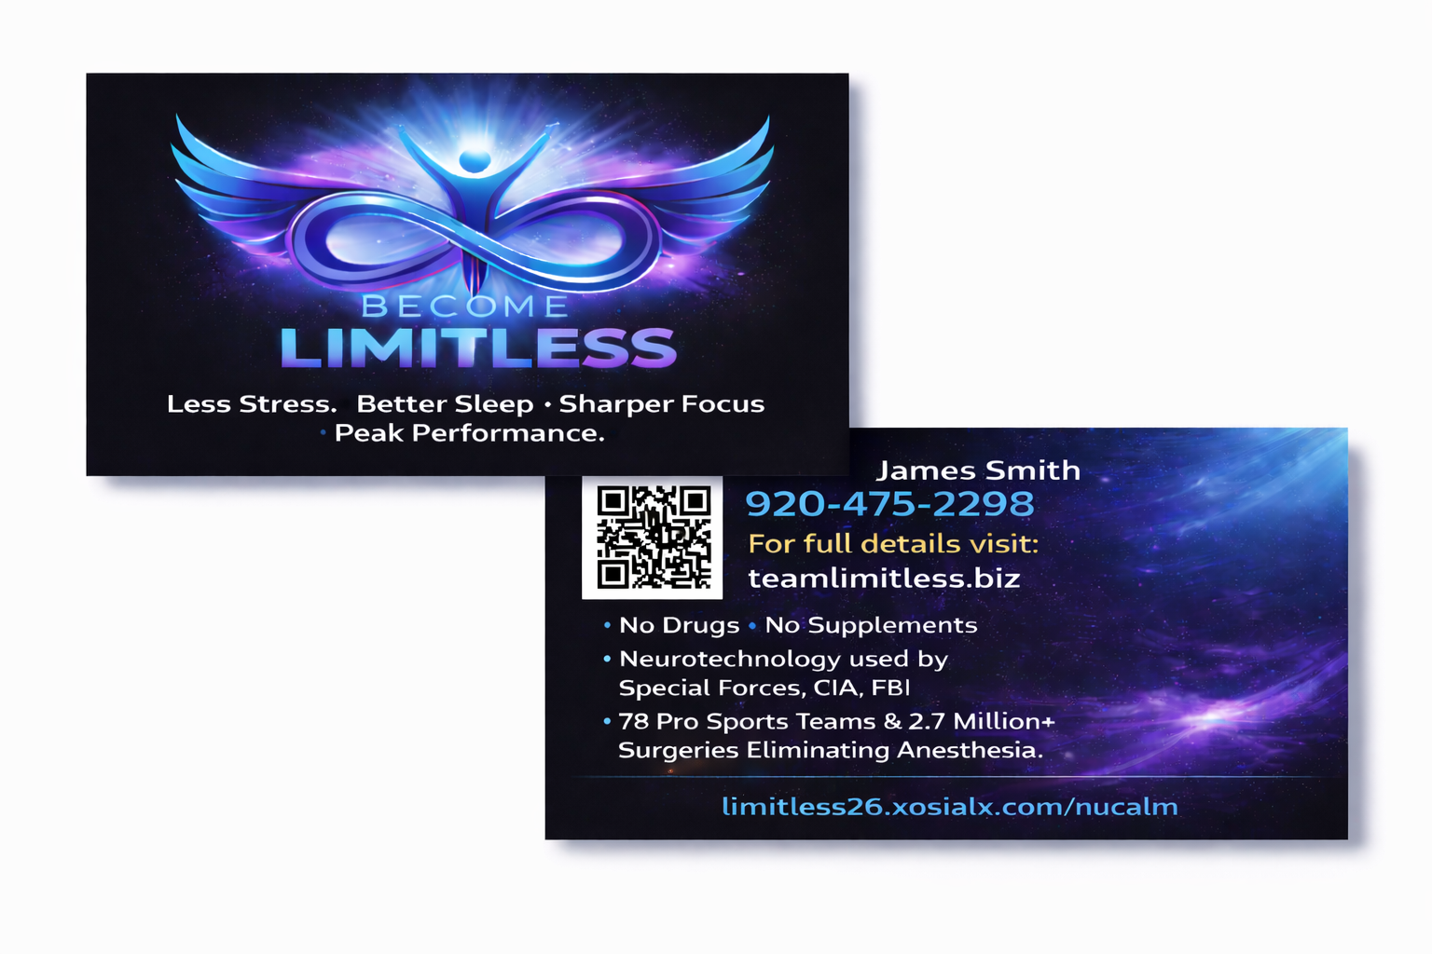

Increasing your team CV-
this is very important to duplicate- remember we get paid from potentially 20 levels of team sales – so do u want to earn on each person 21 cv month (app) or 100+ per month
the app is the best way to build a team / must we must educate everyone to add more CV by buying a few xosialx fantastic wellness products also 100 cv will be about the app and two products at 40cv each (100cv) although not mandatory
the plan – option 1. Get educated and purchase products right away
option 2 as soon as your making $100-$200 a month commissions its time to choice a few products 100cv or more, look at the difference
1000 team members x 21 cv =21,000 cv x 4% = $840 month
1000 team members x100 cv= 100,000 cv x 4% = $4,000 month
Training/Duplication Process – simply duplicate these same steps with your personally enrolled and their team .
- Make sure they are instructed to follow this guide and review these same training videos
- Attend any team or company trainings live or zoom .
- Keep in weekly contact with your leaders

Action plan checklist
___Did you watch the team limitless getting started videos?
___Do you have a monthly subscription (app or products)
___Did u click to become an associate
___Did you get your two web site links (nucalm and product)
___Join our team text message group (free) opt our anytime
___Once you have a commission did u set up your I Payout
___Experience all channels on the app
___Did you view the back office tutorial video
___Did you view the product educational videos/xosial site
___Did you watch / understand the basics of the comp plan?
___Did u set up and order your teamlimitless business cards
___Did you write down your paragraph on your WHY?
___Did you draft your short text to send with your site link
___Launch your business 10 people saw the a overview
___ 3 active associates
___Daily reminder- talk to 3new/ 1 new prospect per day
___ 7 active associates – keep in contact with your enrolled
___ Did you increase your personal cv to at least 100cv

