Welcome to “team limitless”
Here to help you rock your Xosialx business
Team leaders Bob Cannata and Brad Emmert

GETTING STARTED GUIDE 4/1
Lets get going today !!
just do it – follow the plan
If you want to succeed: Treat this like a business
Please print this guide and watch the getting started videos on this team site for better clarification
Education ---as you are building
Go thru thru your nucalm marketing site to get familiar with what your guest will see
Go thru your regular xosialx site and back office to get familiar
Go thru our team site – teamlimitless.biz – which includes complete zoom guest overviews and trainings both company and our team
Building your team
All starts with proper Mind set = action taken
Your why - why are you building the business- ____________________________________________________________________________________________________________________
__________________________________________________________
Everyone you speak to can benefit from the business -app/products and the income opportunity. your mind set must be that you are doing that person a favor and let them decide to go forward or not
Once you understand residual income ,and what is waiting for you ,you will burst thru a wall to have it
Step 1- in conjunction with the more conventional getting started steps I will cover below, please make it a priority to completely review and work with brads social media program he has on this site – people often feel limited in just working in their warm market or meeting new people in daily life. Accessing social media platforms to find the people interested in our technology /products or opportunity is endless. You can still apply the more conventional methods below , but incorporate the social media platform to your daily regiment
Conventional ways to build your business
- Launching your business
Launching = you want to have exposed this to at least 10 people in your 1st month – (exposure options covered below)
Suggested to schedule 1-2 private zooms for new person (accountability and sense of urgency to take action)
Other exposure methods listed below
Enroll your 3 associates-- power of 3
Exposure process
Because the cutting edge tech of nucalm ,better to lead with nu calm and depending on your prospect ,mention the bus opp (see sample initial pitch below)

Whatever method u choose its always better to lead with a Phone call over a text when possible /Always SCHEDUAL a follow up call at the same time of inviting /Also if sending them to view info, ask WHEN can they view the info.
Option 1 – send them your NuCalm web site with 3 min video , however, they will need a little info on what they are seeing and maybe the longer video in the vault
Option 2 – start with the longer video that we have circulating as a first look
Option 3- teamlimitless.biz (team site) my opening video plays the 3 minute nuclam video and directs thru the rest of the nucalm site.. I reference the longer video on the team site , as well as mentioning the business/products by showing them the rest of the teamlimitless site
Option -4 company or team limitless zoom calls every tue/thur 8pm EST info on our team site

- Ongoing recruiting process-after your initial launch
1.Activity- add 1 new name to your activity list =someone who reacts favorable hearing about the opportunity or Nucalm
You might have to approach 2-4 people to have one interested
Every month you will have a new 30 people in activity

2. 10 of the 30 will actually get on a zoom or go thru your site watching the videos and respond to your follow up efforts
3.. 1-3 of the 10 enroll that’s 1- 3 new people per month $$$$$
it’s a numbers game 1 a day =30mn/10 see plan /1-3 new members
_______________________________________________________
text or verbal initial longer pitch- use your own style
hi jim , I recently parted with a company that secured the worldwide marketing rights to an incredible technology that I truly feel everybody in the planet would want to use

Before February 2026 , this technology called NuCalm was only used by high-level organizations

US military , Special Forces , 78 professional sports teams

And countless doctors in medical facilities throughout the world used in over 2.7 million surgeries

Now being launched to the general public Worldwide and the company I am working with have the exclusive rights

This technology helps with --- sleep issues…. Energys… Health issues athletic performance and focus all masses markets

this downloadable technology app is available and affordable by everyone

Complete 30 day money back guarantee And you can cancel anytime you desire

you can choose just to be a customer and enjoy the nu calm experience or you can choose to benefit financially just by sharing an app everybody will want

shorter pitch
technology --I’m working with a company that has a technology that for the last 15 yrs has been used by us military/ special forces/ 78 pro sports teams / and 2.7 million surgeries we now have worldwide rights to offer this to the general public

Business -Are you open to looking at other ways to make money?

_____________________________________________________________

cold market – there are countless people looking for this technology or desiring to make money- need to add then into the mix besides your warm market
one group -is thru social media – I already talked about brads entire system to utilize

other group – people you meet doing life every day

A lot of people may be reluctant to give you their number or your making a quick pitch so make up cards utilizing teamlimitless.biz website with written pitch (see below)
If possible get their phone number 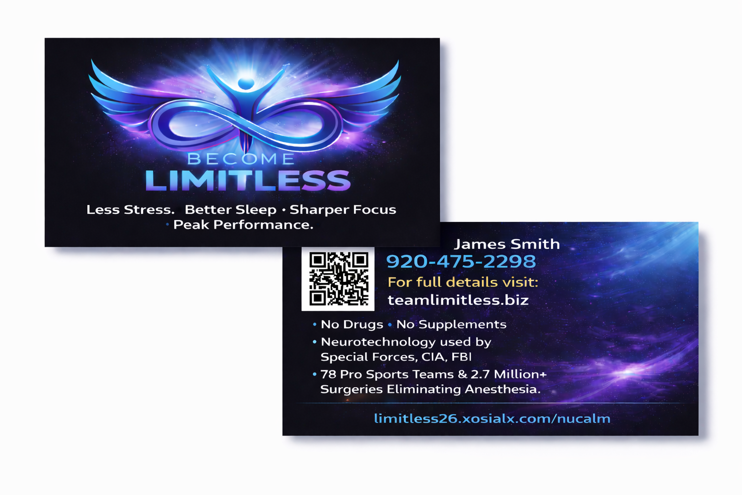

Increasing your team CV-
this is very important to duplicate- remember we get paid from potentially 20 levels of team sales – so do u want to earn on each person 21 cv month (app) or 100+ per month
the app is the best way to build a team / must we must educate everyone to add more CV by buying a few xosialx fantastic wellness products also 100 cv will be about the app and two products at 40cv each (100cv) although not mandatory
the plan – option 1. Get educated and purchase products right away
option 2 as soon as your making $100-$200 a month commissions its time to choice a few products 100cv or more, look at the difference
1000 team members x 21 cv =21,000 cv x 4% = $840 month
1000 team members x100 cv= 100,000 cv x 4% = $4,000 month
Training/Duplication Process – simply duplicate these same steps with your personally enrolled and their team .
- Make sure they are instructed to follow this guide and review these same training videos
- Attend any team or company trainings live or zoom .
- Keep in weekly contact with your leaders

Action plan checklist
SET UP
___Did you watch the team limitless getting started videos?
___Do you have a monthly subscription (app or products)
___Did u click to become an associate
___Did you get your two web site links (nucalm and product)
___Join our team text message group (free) opt our anytime
___Once you have a commission did u set up your I Payout
___Experience all channels on the app
Education- while getting into action/start building
___Did you go thru the entire teamlimitless site (recruiting section and training section
___Did you go thru your nuCalm site /Xosialx Back office
Prospecting and recruiting new members
___ Did you start workin brads social media program
____Did u set up and order your teamlimitless business cards
___Did you write down your paragraph on your WHY?
___Launch your business- 10 people saw the a overview
___ 3 active associates ___ 7 active associates
___Daily reminder -adding 1 new prospect per day
___ keep in contact with your enrolled weekly
___ Did you increase your personal cv to at least 100cv

Initial set up
Join $42.49 nucalm app to qualify for commissions and get positioned in the 3x20 forced matrix - 30 day refund policy- hold subscription at any time (retain your matrix position)
add products if desired /
look for email from nu calm- set up – download app/ headphones/ speaker/mask
Email from xosialx- instructions as follows - Login main company site - your username.xosialx.com . login in to back office with username and password you created
Click to become associate (share and earn)- once you do that . see links on the left in red it will say (your web sites/nu calm marketing site ) get both website links to send out ..
Get your 7 digit id # top right
Commissions set up – I payout- once you earn a commission – week runs wend am to tue midnight - commissions paid following Monday
Start using the app – my favorite channels
Rescue- should be used daily for overall health and wellness /
Deep sleep –I like sonic essence more like white noise.
Ignite- before working out- 14 min unstoppable is a must

