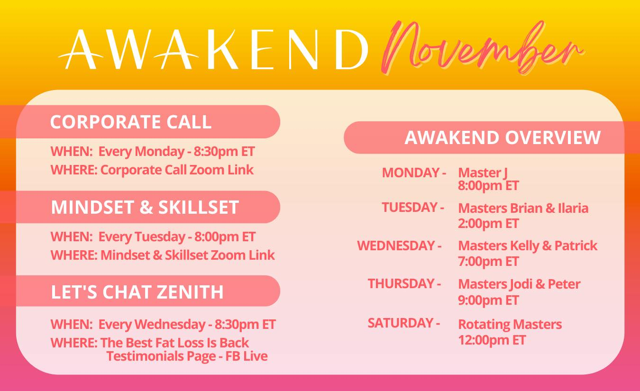

Go to Zoom.us / join meeting and enter 11 digit #

Awakend Corporate Call: Mondays
Zoom Link: https://us02web.zoom.us/j/87381946298
Mindset & Skillset Training
Zoom Link: https://us02web.zoom.us/j/86985722726
Awakend Overview Presentation
Zoom Link: https://us02web.zoom.us/j/85465456423

