Dr. Chase R Carpenter, DC, CCSP/714 Main St. Pleasanton, KS 66075
Pediatric Intake Form: 0-12
Patient (Child) Information: Name: _____________________________________________ Date: ___________________ Address: ___________________________________________________________________________________________ Sex: Male Female Date of Birth: _______________ Height:___Weight: ______ Patient SSN: _________
Name of Parents/Guardian:______________________________ Home Phone:_____________________
Cell Phone: _________ Work Phone: ______________Email:_________________________________________________ Whom may we thank for referring you? _________________________________________________________________ Authorized Representative/Parent/Guardian:_________________________________ Phone: _____________________
Insured’s Name:_________________________________________________________ Dob:_______________________
●●●●●●●●●●●●●●●●●●●●●●●●●●●●●●●●●●●●●●●●●●●●●●●●●●●●●●●●●●●●●●●●●●●●●●●●●●●●●●●●●
Prenatal History:
Any complications during pregnancy? Y N Explain: ______________________________________________________ Medications taken during pregnancy: ___________________________ Cigarettes or alcohol during pregnancy: Y N
Birth Intervention: Forceps Vacuum C-Section Complications during delivery? Y N Explain: ___________________
Genetic disorders or disabilities:________________________________________________________________________ How many times has your child been prescribed antibiotics in the past 6 months? _______ Total during lifetime:_______ Has your child received vaccinations? Y/N Breast Fed: Y N How long: _______ Formula Fed: Y N How long: ______
Chicken Pox: Y/N Age:_________ Rubella: Y/N Age:_________ Rubeola: Y/N Age:_________ Mumps: Y/N Age:_______
Whooping Cough: Y N Age:_____________ Cows milk at ________ Introduced to: Solids at _______ Months
Food Allergies or Intolerances: Y/N List:________________________________ Other: _______________ Age:_________
●●●●●●●●●●●●●●●●●●●●●●●●●●●●●●●●●●●●●●●●●●●●●●●●●●●●●●●●●●●●●●●●●●●●●●●●●●
Developmental History:
During the following times your child’s spine is the most vulnerable to stress and should routinely be checked by a doctor of chiropractic for prevention and early detection of vertebral subluxation (spinal nerve interference). At what age was your child able to: ______________ Respond to Sound ______________ Cross Crawl ______________
Respond to Visual Stimuli ______________ Stand Alone ______________ Hold Head Up Alone ______________
Walk Alone ______________ Sit Up Alone According to the National Safety Council, approximately 50% of children fall head first from a high place during their first year of life (ie: a bed, changing table, down stairs, etc). Was this the case with your child? Y N Explain: ___________________________________________________________________________ Is/has your child been involved in any high impact or contact type of sports (ie: soccer, football, gymnastics, baseball, cheerleading, martial arts, etc)? Y N
Has your child ever been involved in a car accident? Y N Explain:_________________________________________
Other traumas not described above? Y N Explain:_________________________________________
Prior surgeries? Y N Explain:_________________________________________
●●●●●●●●●●●●●●●●●●●●●●●●●●●●●●●●●●●●●●●●●●●●●●●●●●●●●●●●●●●●●●●●●●●●●●●●●●●●●●●●●
Review of Systems:
Please Circle if your child has had any of the following: Headaches Postural Imbalances Growing Pains Scoliosis Tonsillits Asthma Torticollis Ear Infection Seizures Sleep Problems Digestive Problems Bedwetting PDD/Autism ADD/ADHD Frequent Fever Colic Learning Difficulties Acid Reflux Hip Dysplasia Allergies
How would you rate your child’s diet? ____ Well Balanced ____ Average ____High sugar/processed foods
Does your child consume artificial sweeteners? Y/ N Number of hours your child sleeps:______hours per night _________hours per day/naps Sleep Quality: ____Good ____Fair ____Poor

Current Symptoms:
Select which is true for your child:
○ My child DOES NOT have symptoms. I am seeking chiropractic care for my child to maintain wellness. ***(Insurance doesn’t pay for wellness or maintenance care)
○ My Child Does have symptoms. Please list:______________________________________________________________
____________________________________________________________________________________________________________________________________________________________________________________________________
When did these symptoms begin?_______________ Are these symptoms from an accident Y/N?___________________
__________________________________________________________________________________________________
What makes it better?__________________________ Worse?_______________________________________________
Please mark on the below diagram where you pain is, and the type of pain ie. Sharp, achy, dull, numb,burning etc…
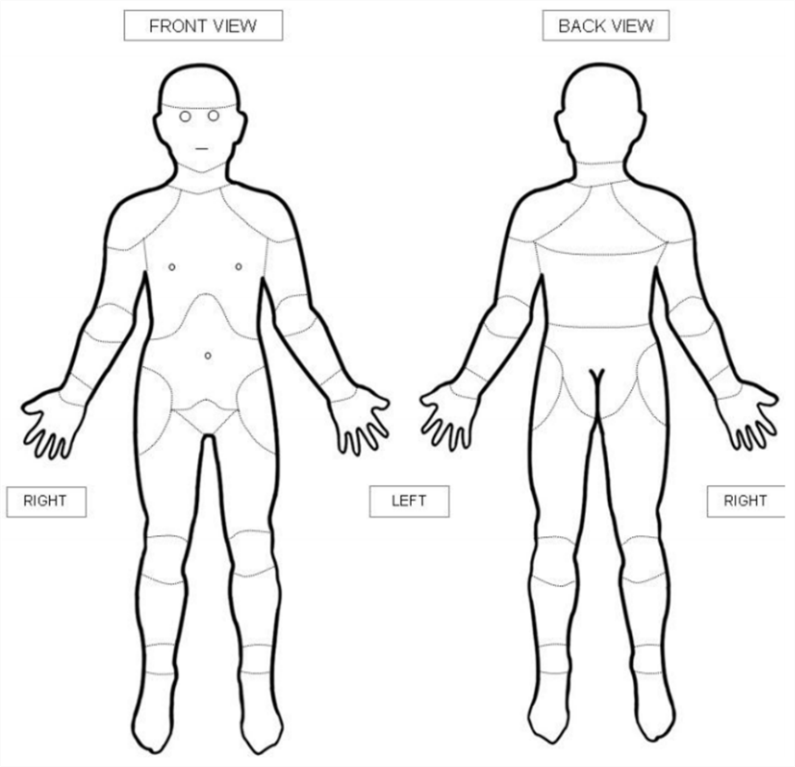
How often are your childs symptoms? 0% (Never) - 100% (Every Waking Minute) :__________________
What are your health goals for being here today?__________________________________________________________
Please Circle or mark your pain levels today for each complaint:

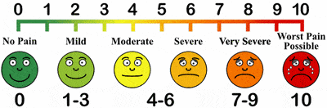

************************************************************************************************** Authorization to Treat a Minor I, _____________________________________ the undersigning parent/guardian having legal custody/guardianship of ______________________________________, a minor, do hereby authorize, request and direct Dr. Carpenter and whomever he might designate as assistant to perform in judgment any examination and chiropractic diagnosis or treatment which is deemed necessary. Any specific written authorization you provide may be revoked at any time by writing to us at the address provided on the front of this form.
Parent/Legal Guardian Signature X:____________________________________________________________
Patient Name_______________________________________________Date______________________

Payment Policy:
Carpenter Chiropractic Health Center, LLC
Thank you for choosing us as your Chiropractic provider. We are committed to providing you with quality and affordable health care. Due to some of the questions our patients have regarding patient and insurance responsibility for services rendered, we have been advised to develop this payment policy. Please read it, ask any questions you may have, and sign in the space provided below. A copy will be provided to you upon request.
- INSURANCE. We participate in most insurance plans, including Medicare. If you are not insured by a plan we participate with, payment in full is expected at each visit. If you are insured by a plan we do participate with, but do not have an up-to-date insurance card, payment in full for each visit is required until we can verify your coverage. Knowing your insurance benefits is your responsibility, please contact your insurance company with any questions you may have regarding your coverage. If your insurance company requires a referral it is your responsibility to provide us with a referral dated the day of your first visit from your primary care physician prior to your first visit. We are only able to provide a summary of your chiropractic benefits.
- CO-PAYMENT AND DEDUCTIBLES. All co-payments and deductibles must be paid at the time of service. This arrangement is part of your contract with your insurance company. Failure on our part to collect co-payments and deductibles from patients can be considered fraud. Please help us in upholding the law by paying your co-payment at each visit.
- PROOF OF INSURANCE. All patients must complete our patient information form before seeing the provider. We must obtain a copy of your most current insurance card to provide proof of insurance. If you fail to provide us with the correct insurance information in a timely manner, you may be responsible for the balance of a claim.
- CLAIM SUBMISSION. We will submit your claims and assist you in any way we reasonably can to help get your claim paid. Your insurance company may need you to supply certain information directly. It is your responsibility to comply with their request. Please be aware that the balance of your claim is your responsibility whether or not your insurance pays your claim. Your insurance benefits are a contract between you and your insurance company; we are not party to that contract.
- CONVERAGE CHANGES. If your insurance coverage changes, please notify us before your next visit so we can make the appropriate changes to help you receive your maximum benefits. If your insurance company does not pay your claim in 90 days, the balance will automatically be billed to you.
- Personal Injury Patients: Many auto insurance policies include “Med Pay” which will pay your medical expenses within the limits of your policy. If your auto policy does not include “Med Pay” we will ask you to sign a lien to authorize and guarantee payment for your medical expenses for services rendered.
Please help us to serve you better by keeping your regular scheduled appointment.
Our practice is committed to providing the best treatment to our patients. Our prices are representative of the usual and customary charges for our area.

I have read and understood the payment policy and agree to abide by its guidelines.

______________________________________ _____________________
Signature of patient or responsible party Date

CARPENTER CHIROPRACTIC HEALTH CENTER, LLC
714 MAIN STREET, PLEASANTON, KS 66075 913 352 8344
Acknowledgement for Consent to Use and Disclosure of Protected Health Information
Use and Disclosure of your Protected Health Information
Your Protected Health Information will be use by Carpenter Chiropractic Health Center, LLC or may be disclosed to others for the purposes of treatment, obtaining payment or supporting the day-to-day health care operations of this office.
Notice of Privacy Practices
You should review the Notice of Privacy Practices for a more complete description of how your Protected Health Information may be used or disclosed. It describes your rights as they concern the limited use of health information, including your demographic information, collected from you and created or received by this office. A copy of our Privacy Practices is available upon your request.

Requesting a Restriction on the Use or Disclosure of Your Information
- You may request a restriction on the use or disclosure of your Protected Health Information
- This office may or may not agree to restrict the use or disclosure of your Protected Heath Information
- If we agree to your request, the restriction will be binding with this office. Use or disclosure of protected information in violation of an agreed upon restriction will be a violation of the federal privacy standards.
Notice of Treatment in Open or Common Areas
Describe and Notify private areas available upon request
Revocation of Consent
You may revoke this consent to the use and disclosure of your protected health information. You must revoke this consent in writing. Any use or disclosure that has already occurred prior to the date on which your revocation of consent is received will not be affected.
By my signature below I give my permission to use and disclose my health information.
___________________________________________________________________ _____________
Patient or Legally Authorized Individual Signature Date

Print Patients Full Name
___________________________________________________________________ _____________
Witness Signature Date

ACCEPTANCE OF TERMS & CONSENT TO TREAT

Medicare Limits and Responsibilities
The only charge for Chiropractic that is covered is manipulation of the spine. I accept responsibility to know the current Medicare guidelines and limits for covered services. I understand that Medicare may reimburse me for chiropractic adjustments, and that the Medicare program frequently does not consider treatments for me medically necessary. I accept responsibility to pay for all covered, non-covered and denied services. If Medicare denies payment, I agree to be personally and fully responsible for payment. I understand that I must pay for services at the time of service. I also understand that Carpenter Chiropractic Health Center, LLC will bill all charges directly to Medicare as required by law. I authorize the release of my records as necessary for Medicare billing.

Statement of Acknowledgement of Financial Responsibility
I understand that I may be responsible for any charges incurred at this office, including co-pays, deductibles and any services denied or not covered by my insurance company. I realize my care may be subject to pre-authorization by the insurance company and I accept any responsibility for charges not approved. The insurance company will review any/all documentation submitted by either chiropractor for their assessment of medical necessity and base their approval/denial upon this documentation.

I understand that this office agrees to notify me as soon as possible if a service is not covered and will notify me if my insurance does not approve my care. If a treatment plan is approved, this office will make me aware of the number of visits allowed and the time frame of the authorization. Initial visits may be denied and this may be beyond the office’s ability to notify the patient prior to rendering acute care, while waiting for insurance coverage approval. The3se charges will be the patients’ responsibility if denied by the insurance company.

This office may seek payment from you for any services your health insurance determines to be not medically necessary or not covered by your plan. Signing below indicates that you have read and understand your obligation for payment for care in the absence of insurance coverage. Patient is responsible for collection fees, court cost and reasonable attorney fees to collect unpaid accounts.

Informed Consent/Consent to Treat
I have been informed of the nature, purpose and scope of care to be provided by the doctors of this office of the possible limitations and consequences of that care and the possibility that the care given may not completely resolve my complaint, dysfunction or condition. I consent to care and recommendations made by the doctors for myself (or my children, if minors including, but not limited to examinations, x-rays, chiropractic adjustments, adjunctive therapies and rehabilitation.) Understand that my care will be individualized and therefore may not be comparable with standards or guidelines required by insurance companies, Medicare, professional association and /or consensus groups. I understand that my treatment will comply with the standard of care defined by the laws in the State of Kansas. I recognize that all health care procedures, including those used in the clinic, have risk associated with them. Risks, although rare, associated with chiropractic adjusting procedures may include minor aggravation of symptoms, musculoskeletal sprain/strain, neurological deficits, osseous fracture, vertebral artery syndrome, including cerebral vascular accident (stroke) or death through complicating factors. I hereby accept the risk associated with any care by the doctor or any liability for any injury or loss directly related to care I have received at this clinic. In the event or emergency, I grant doctor and staff permission to provide Emergency Care and any follow-up necessary, including referral to Emergency Medical Services.

I am signing this consent and acceptance of terms after having been fully informed to my satisfaction of the risks and benefits of proceeding with care and declining care. I have been informed and fully understand that there are no guarantees of treatment success. By my presence and continuation of appointments, I consent and elect to care provided by Carpenter Chiropractic Health Center, LLC.

__________________________________________________________________________
Patient Name (Please Print)

Patient Signature Date

I have reviewed the above terms of acceptance and consent with the patient named above and I am satisfied that he/she fully understands the nature and content of agreement.

Witness Date

