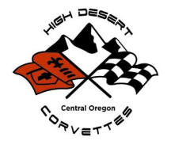

The High Desert Corvette Club of Bend, Oregon, will be hosting our biennial event, “Corvettes on the High Desert”, June 26th and 27th 2026 at Rivers Edge Golf Course in Bend OR. This year’s event will benefit the Friends of the Children, Central Oregon and Partners in Care, Bend.
The High Desert Corvette Club is proud of its record of contributing to several local charities in the Central Oregon area. The proceeds from our past three events allowed us to donate thousands of dollars to a selected non-profit organization. We have also donated to many local charitable agencies during the holiday season, including, but not limited to: Crystal Peaks Youth Ranch, Saving Grace, Equine Outreach, Humane Society, Ronald McDonald House, The Giving Plate, Central Oregon Veteran’s Outreach, and many more.
The High Desert Corvette Club would appreciate your generosity of any items you may contribute to our raffle/silent auction for us to continue with our support and contributions to local charities.
We thank you for your consideration.

High Desert Corvette Club
P.O. Box 6442
Bend, Oregon 97708
501 (c) (7)

