Hidden Meadows Community Foundation Scholarship Application

Name of Applicant:

Permanent Address:

Email:

Phone Number:

Criteria: To apply for a Scholarship Grant from the Hidden Meadows Community Foundation, the applicant must:

● Be a Hidden Meadows or Rim Rock Resident

● Be a recent or pending High School Graduate

● Plan to attend college in the fall semester

● Not have previously received a bachelor’s degree

● Be a US Citizen or Resident Alien

● Have a preferred high school GPA of 3.5 or higher. This will need to be certified by submitting an official school transcript

The applicant shall submit the following to the Foundation:

● A 250 + word essay regarding your education objectives

● Email a short Bio and picture for the newspaper in word document to [zipsemichelle@gmail.com](mailto:zipsemichelle@gmail.com)

● A letter of recommendation from a school faculty member

● A transcript of credits

● A statement of commitment to remain in school for the term of the grant

● Verification of participation in at least one Hidden Meadows Community Event in the past two years

Send the required information by email to [vickeyciarlanti@gmail.com](mailto:vickeyciarlanti@gmail.com) by Wednesday, April 30th. You may also deliver your application in person by attending our Meet and Greet at the Side Yard Public House on April 30th - 6pm - 8pm.

On May 7th Applicant’s will be notified of their Scholarship status via email.

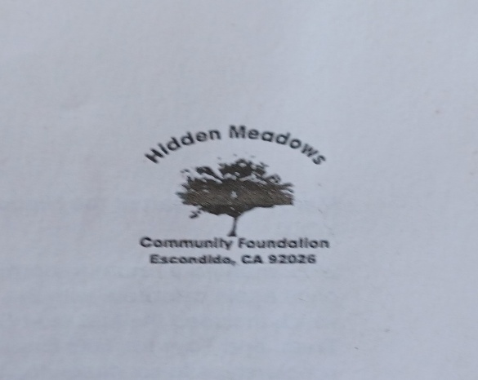The Scholarship Awards Dinner will be held on Wednesday, May 21st - 6-9pm

Location: Side Yard Public House.