Donation Request Form

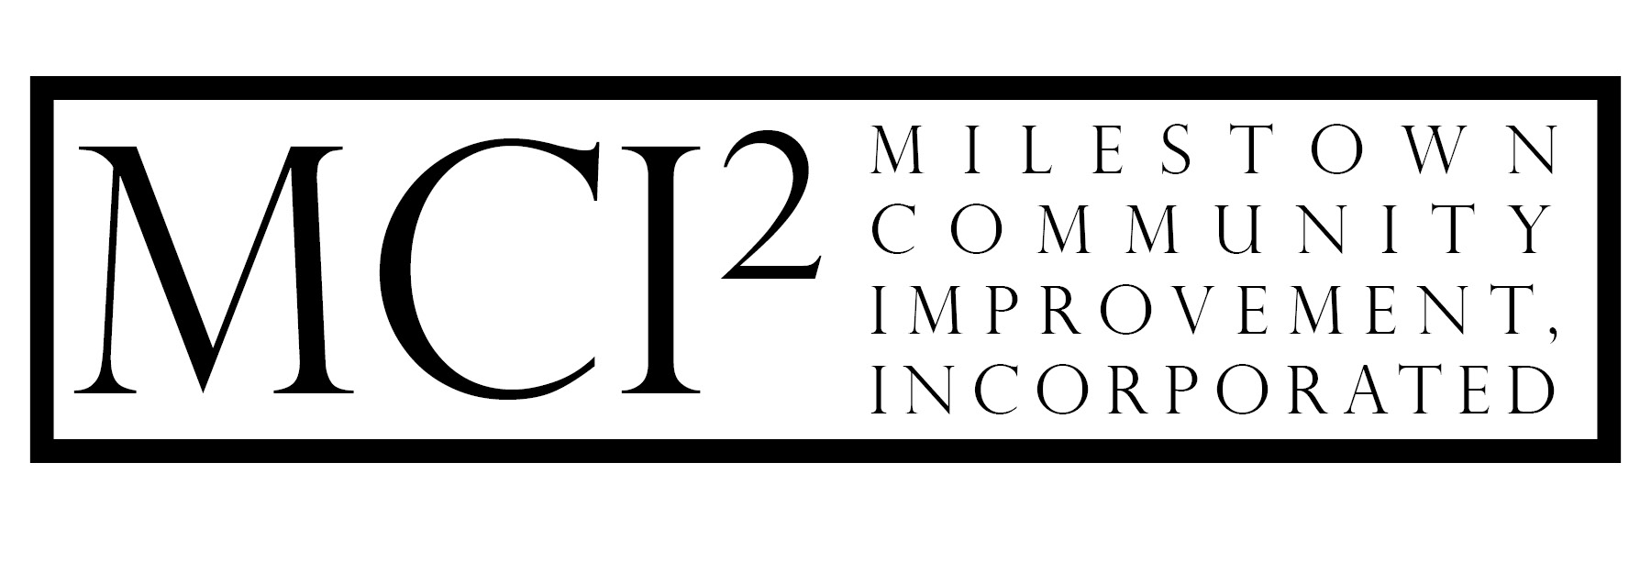

Milestown Community Improvement, Inc., is a Montana nonprofit corporation dedicated to the improvement of Miles City, Montana, with a particular focus on recreational opportunities for children and families.

Background

MCI² has earmarked 10% of the proceeds received from the state-wide sales of our license plates for direct monetary donations back into our community outside of our own projects. For consideration, please fill out this form to the best of your abilities and return to any MCI² member. These requests are circulated and discussed at the Board meetings which generally take place on the first Wednesday of each month. Please note that MCI² generally likes to supplement, not fully fund, projects whenever possible and may table the donation request until more information is provided or remaining funds are procured.

Applicant Contact Information

Name/Organization:
Mailing Address:
City, State, Zip Code:
Contact Phone:
Contact E-mail:

Questions

Are you or your organization a federally recognized non-profit? Yes / No (circle one)
If so, please include your IRS approval letter.

How much is your total cost of your project?

How much are you requesting?

Have you already received any funds raised for this project? Yes / No (circle one)
If yes, how much have you raised?

What is the anticipated completion date of your project?

How soon would you need the requested funding?

Please provide a brief description of your project.
(Attach separate sheet if needed)

Please provide a brief description of how your project fits into our mission statement listed above.
(Attach separate sheet if needed)

If applicable, please explain how our organization would be acknowledged for our contribution.
(Attach separate sheet if needed)

