CEAL CODE OF CONDUCT 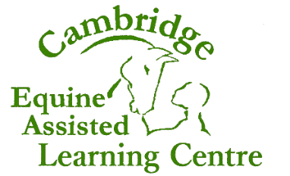

Underlying Principles & Assumptions

Equine assisted learning involves both horses and humans and requires an understanding and commitment to the physical, mental and emotional needs of both. There is a great deal of power in the role of facilitator, and with that power, comes responsibility.
Horses

We need to take good care of the horse’s needs, as without the horse there can be no equine assisted learning! Facilitators have a responsibility for the physical, emotional and mental welfare of horses at all times, not just when they are in contact with learners. We recommend that horses are kept outdoors, in a herd, 24/7. Anything other than this is a compromise and the horse’s needs may not be fully met.
It is possible that a horse’s physical, mental or emotional wellbeing could be harmed as a result of their interactions with humans. Facilitators need to be aware of this and have strategies in place to deal with it.
As often as possible, horses need to be able to choose whether to interact with learners rather than having their choices taken away (e.g. by being on a halter and lead rope).
Recommended horse handling techniques are those which look at life from the horse’s point of view and do not use force to obtain results.
Horses will not be used as a ‘tool in the process’ but there will be true interaction with activities that maintain the dignity and emotional wellbeing of the horse.
Learners

Learners often have little or no experience with horses, are vulnerable, disadvantaged or have suffered some personal trauma. Learners need a safe environment in which to learn and their safety is of paramount importance. Experiential learning will form the basis of all interactions. Every learner has the right to reach their full potential.
Practitioners
CEAL Certified Facilitators will:

- ensure that horses are kept in a way that best meets the horse’s physical, mental and emotional needs
- limit the amount of time that any horse is required to interact with learners
- have a strategy to help horses both before and after sessions
- handle horses in a way that shows an understanding of the horse and does not use force to obtain results
- use experiential learning and a creative, non-judgmental, person-centred approach
- respect the value and beliefs of all learners without prejudice
- protect the privacy, confidentiality, physical safety and welfare of the learner
- build professional relationships with learners. Sexual relationships between staff and learners is expressly forbidden, no matter what the age of the learner.
- refer learners to other professionals if this is felt to be in the learners’ best interest
- conduct themselves with professionalism, honesty and integrity
- value the work of other professionals and treat them with courtesy and respect
- take part in regular supervision
- undertake at least 50 hours of continuing professional development each year.
Proprietor’s Signature: Sophie Keene
Adopted on: 17th April 2023
Reviewed on: 16th April 2026
Next Review: 16th April 2027

I agree to abide by this Code of Conduct.

CEAL CODE OF CONDUCT
Signature Date

