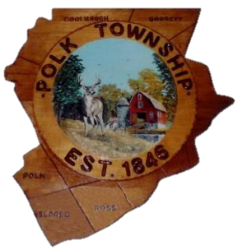
165 Polk Township Rd., PO Box 137, Kresgeville, PA 18333
“A Sesquicentennial Community”
Phone: 610-681-5376 Fax: 610-681-3063 E-mail: info@polktwp.org
Brian K. Ahner - Chairman
Michael D. Hurley – Vice Chairman
Carl S. Heckman - Supervisor

POLK TOWNSHIP SUPERVISORS

APPLICATION FOR CERTIFICATE OF NON-CONFORMANCE
Applicant/Owner _ Date
Property Address:
PIN #
Mailing Address:
The owner of the property listed above is requesting that the non-conformity was in existence
prior to the adoption of the Polk Township Zoning Ordinance. The Polk Township Zoning Ordinance was adopted on September 9, 1985.
The non-conforming status applies to: Land Building Use Structure Sign
Other:
Zoning District of property is: (RR, R-1, R-2, R-3, Commercial or Industrial)
Date when non-conforming use began:
Describe all nonconforming aspects of the property:

Attach all evidence, proof or other documentation to support your application.
I attest the above information and attachments are true, correct and valid.

Signature of owner or agent Date

