Renton Eagles Auxiliary 1722, Issaquah 3054

And District 14

Proudly Support Carol Schnorr for Election

To the office of

Washington State Auxiliary Madam Conductor

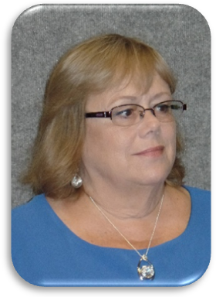

Renton Auxiliary #1722, Issaquah 3054 and District 14 are proud to support Carol Schnorr as

she runs for election to the position of Washington State Auxiliary Madam Conductor.

Carol joined Renton Auxiliary in 1992 and has been an active member for the last 27 years.

Carol went thru the chairs in her local auxiliary and has served as Madam President twice. She is

the ritual coach for Renton Auxiliary and has chaired several committees over the years.

She is a committed and dedicated leader and mentor’s our new officers and new members. Carol is dependable and we know we can count on her to step whenever needed.

Carol believes in the mission of our organization to be “People Helping People.”

She is a Past District 14 Deputy and serves on multiple district committees including Ritual Coach.

Carol has been a part of the State Family since 2005 serving as a State Heart Chairman and other

State Chairmanships over the last several years. Carol served three years as a Washington State Trustee 2009 thru 2013 and Outside Guard 2017 - 2018. Carol is serving this year as Washington State Inside and hopes to continue to serve Washington State as next year’s Madam Conductor.

Since joining Renton Auxiliary, she has been active with the youth program in Renton. She coached the Spinnakers Renton Eagles Junior Drill Team from 1990 until the team was disbanded in 2006. Since the Drill Team reformed in 2011 Carol now serves as one of their advisers. Carol is our local Auxiliary Youth Chairman and truly believes that our youth are our future.