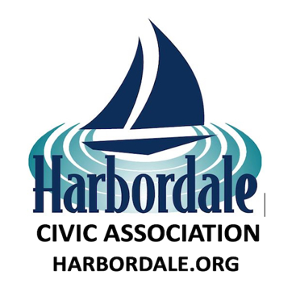
HARBORDALE CIVIC ASSOCIATION
MEMBERSHIP APPLICATION 2026
YOUR VOICE COUNTS!! SPEAK UP!! BE HEARD!
HELPING TO IMPROVE AND PROTECT THE QUALITY OF LIFE IN HARBORDALE
Meetings on the 1st Wednesday of The Month, 7:00pm at the Police Sub Station Harbor Shops
Name: ______________________________________________________________
Address: ______________________________________________________________
Email*: _______________________________________________________________________
*We will never share or sell your email address.
Annual Membership Dues $15.00 (January 1- December 31)
Pay online with a credit card or PayPal account at:
Harbordale.org
Mail this Membership Application/ and $15 Annual Dues to:
Harbordale Civic Association P.O. Box 460416
Fort Lauderdale FL 33346-0416
Contact Harbordale

