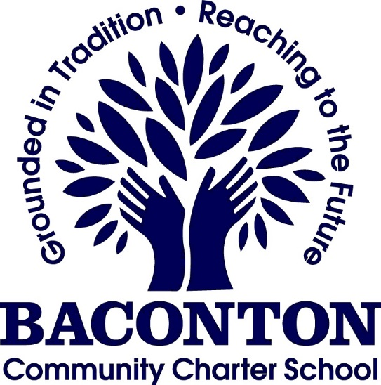
DRAFT
October 15th, 2020
Governing Board Meeting Agenda via Zoom Link Below
Our Mission:
Providing a safe, nurturing environment for a diverse community of learners to develop academic potential and ethical character leading to productive citizenship in the 21st century
Lynn Pinson is inviting you to a scheduled Zoom meeting.

Join Zoom Meeting
https://us04web.zoom.us/j/78613076792?pwd=Nm9mcGdkUTdEeVkxV25KNVhMK3g0Zz09

Attendance:
John Hilliard ___, Sonya Williams___,Christina Hayes ___, Kitty Beasley ___, Benjamin Brooks ___, Jenny Van Meter ___Jermaine King___, Shanetta Davis ___, Kate Von Glahn___, Rashelle Beasley, ____ Ex Officio: Lynn Pinson ___

- Call to Order and Opening Prayer…………………….……….…………………………….…...…………John Hilliard

- Recognition of Guests and Public Comment…………………………………………………………….John Hilliard

- Minutes for approval, September 24th, 2020………………………………………………..……….Christina Hayes

- Committee Updates
  - Finance Committee (Jenny VanMeter, John Hilliard, Benjamin Brooks, Larry Burkett, Lynn Pinson)
    - Approval of minutes, October 6th, 2020
    - Reports
      - Profit and Loss,
      - Balance Sheet
      - New Kitchen Addition
      - Investment Fund Update
      - USDA update on loan
  - Student Affairs (Rashelle Beasley, Jermaine King, Kate VonGlahn, Sonya Williams, Penny Neeld, Missy Huber, Meredith Powell, Tina Coalson, Nicole Hatcher)
    - Monthly Report
      - Enrollment Report-Pam Sangster
      - Attendance Report-Penny Neeld
      - Special Education Report-Tina Coalson
      - Benchmark Testing Updates-(MAP)-Meredith Powell/Mary Sullivan
      - Health and Wellness-Nicole Hatcher
  - Governance (Christina Hayes, Kitty Beasley, Shanetta Davis, Mary Sullivan)
    - Training updates

- Administrator’s Reports…………………………………………….……………………………………………..Lynn Pinson
  - Update on Remote Learning and re-opening face to face
  - Elementary Updates- Kelly Rucker
  - Middle School Updates- Missy Huber
  - High School Updates- Mary Sullivan/Gabe Council

- Adjourn

