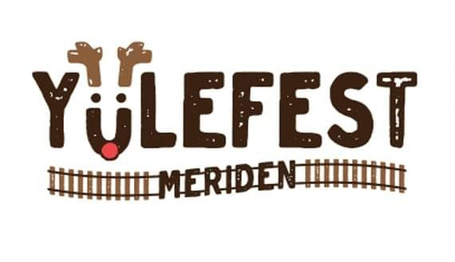
Nov. 30th
1-5pm
^{Colony St.}

Business Name________________________________________________________

Organization Name_________________________________________________

Email Address_________________________________________________

Phone Number_________________________________________________

Mailing Address________________________________________________

Sponsor Amount ______________________________________

Please email your logo to meridenevents@yahoo.com
Logo image must be high resolution or Vector file

Sponsorship checks made payable to; YMCA Memo; Meriden YuleFest2024 and mailed to Carrie Teele,
391 Gravel St.
Meriden, CT.
06450

THANK YOU FOR YOUR KIND SPONSORSHIP

