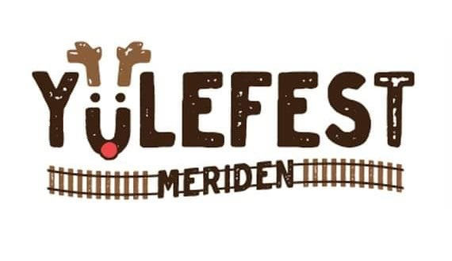
Meriden YuleFest 2024 returns on Saturday Nov. 30th. There will be a Lighting Ceremony for our annual holiday event that lights up the downtown Meriden area and brings the community together. We are asking you for your kind sponsorship to help us with this year’s event.
Santa will be arriving at the pocket park on Colony St. via train again (time TBD). Small businesses and artisans will be showcasing their products at the Vendors Market on Colony St. from 1-5pm. We will also have a variety of Local Talent Exhibition, Food Trucks, Bake Sale with holiday goodies, Hot Chocolate, and so much more on Saturday.
We anticipate that the Meriden YuleFest 2024 will be well attended by local families excited to start their Holiday season and shopping on Small Business Saturday at the Market, participate in the various family-friendly activities and to enjoy the decorations celebrating the upcoming holiday season.
Can you help with a contribution to support our 6th Annual Meriden YuleFest? Any amount is appreciated, and your donation is tax deductible.
Sponsorships will be promoted on the Meriden YuleFest website and social media platforms
Checks should be made payable to “YMCA.”. (Please designate Meriden YuleFest in the memo line).
We look forward to your participation and support for the Meriden YuleFest 2024.
Sincere thanks,
Meriden YuleFest Committee
Carrie Teele Chair Person
David Grodzicki Co-Chair Person

