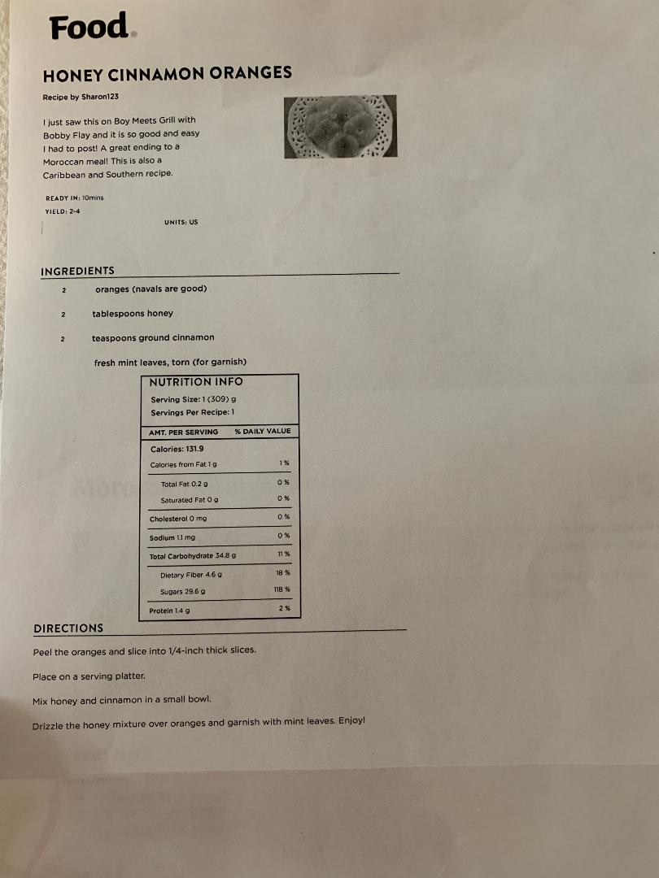

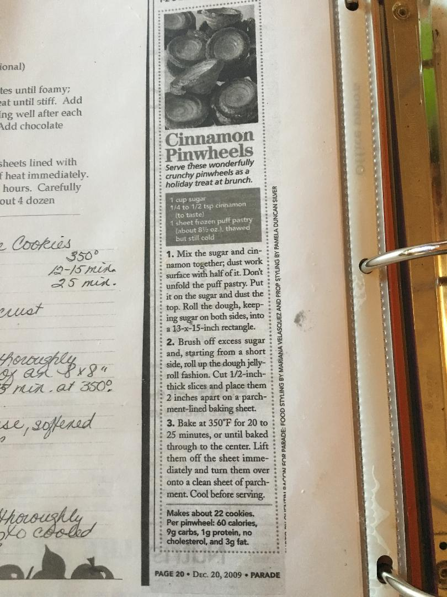

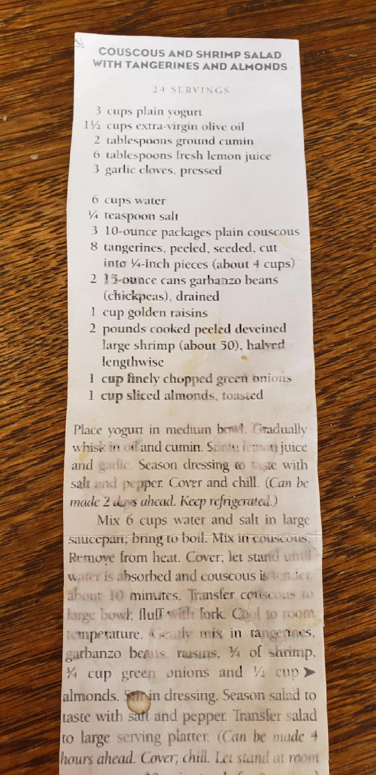

CHICKEN TAGINE IN A SLOW COOKER
From: 1,000 Gluten Free Recipes -Makes 4 Servings
Tagine refers to both a Moroccan dish and the clay pot in which it is cooked. But I think a slow cooker is a perfect way for busy cooks to prepare it. You can prepare, then chill the ingredients (chicken through carrots) in a heavy duty food storage bag overnight, so all you have to do is put them in the slow cooker the next morning to have a delicious dish awaiting you that evening.

4 boneless skinless chicken breast halves( about 1 ¼ pds.)
1 ¼ tsp. Salt
1tsp. Ground cinnamon
1 tsp. Ground ginger
½ tsp. Ground coriander
½ tsp. Ground turmeric
½ tsp. Ground cumin
½ tsp. Ground black pepper
1 medium red onion, halved and thickly sliced
2 large carrots, peeled and sliced diagonally in ¼ inch pieces
1 large clove of garlic, minced
1cup gluten free, low sodium chicken broth
2 TBLS. Honey
1TBLS. Fresh lemon juice
1TBLS. Tomato paste
¼ cup dark raisins
¼ cup finely chopped dried apricots
2 cups cooked hot white basmati rice
1 TBLS. Cornstarch whisked into 2 TBLS. Of cold water
Garnishes
Chopped fresh cilantro, sliced almonds, sliced pitted green olives

- In a 6 quart slow cooker, add the chicken, salt, cinnamon, ginger, coriander, turmeric, cumin, pepper, onion, carrots, and garlic. In a small bowl or measuring cup, whisk together the broth, honey, lemon juice and tomato paste and pour into the slow cooker. Sprinkle with raisins and apricots. Cover.
- Cook 5 hours on High heat. Or, cook 8 hours of Low heat. Just before serving, turn slow cooker to High Heat, whisk together cornstarch mixture into liquid in slow cooker and replace lid. The juices should thicken slightly. Serve over hot basmati rice and garnish.
- HINTS- I used boneless, skinless chicken thighs, I did the shorter time for cooking. ( I have found the meat stay moist this way) I used Trader Joes-Organic Low Sodium Gluten Free Chicken Broth. I also add a bit more raisins, apricots and carrots to my pot. I did not use Coriander.
- I tripled the recipe for serving 8-10 people.

https://www.youtube.com/watch?v=MBMtPg1jrEQ&list=PLZpEix2HAZeelFL0hf3SlcpvNBW28o45l&index=1
This link is for all the Moroccan Cookies!

Moroccan Orange Cake
A traditional Moroccan Orange Cake is a quick and easy dessert that is the perfect way to end a flavorful meal!
5 from 1 vote
Print
Course: Dessert
Cuisine: Middle Eastern
Keyword: moroccan, orange, cake, recipe, easy
Prep Time: 10 minutes
Cook Time: 50 minutes
Total Time: 1 hour

Servings: 12 Servings

Calories: 289kcal
Author: Lisa Johnson

Ingredients
- 4 large eggs
- 1 1/2 cups granulated sugar
- 1/2 cup canola oil
- 2 cups unbleached all-purpose flour
- 4 teaspoons baking powder
- 1/2 teaspoon salt
- 1/2 cup fresh orange juice
- zest of one very large orange or two medium oranges
- 1 teaspoon pure vanilla extract
- powdered sugar for dusting

Instructions
- Preheat oven to 350 degrees. Grease and flour or spray with baking spray, a 10-cup bundt pan, set aside.
- Zest and juice orange (s), set aside.
- In a large bowl, beat together eggs and sugar until thick. Gradually beat in the oil.
- Add the flour, baking powder, salt, and orange juice. Beat until smooth, then add the zest and vanilla.
- Pour the batter into the prepared pan, tap out the air bubbles on the counter or flour. bake for 40 - 50 minutes, or until a toothpick comes out clean when inserted into the center.
- Remove cake from oven and allow to cool in the pan for 10 minutes.
- Turn cake out onto a cooling rack and allow to cool completely.
- Dust cake with powdered sugar and serve.

Notes
If you use a larger bundt pan, reduce cooking time.

Nutrition
Calories: 289kcal | Carbohydrates: 42g | Protein: 4g | Fat: 11g | Saturated Fat: 1g | Cholesterol: 70mg | Sodium: 125mg | Potassium: 203mg | Sugar: 25g | Vitamin A: 125IU | Vitamin C: 5.2mg | Calcium: 73mg | Iron: 1.4mg

