ORGANIZED PRIOR TO MAY 20, 1789
MOTORIZED MAY 3, 1907

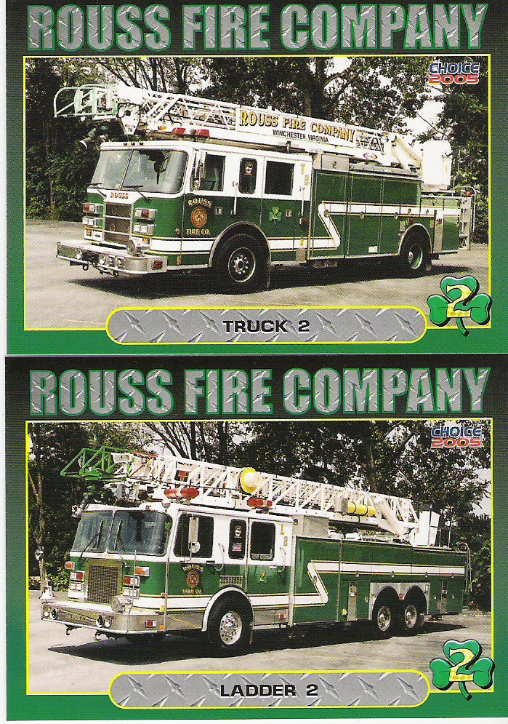

“THE PRIDE OF OLD TOWNE”

Station 2

To the Officers and Membership of the Charles Rouss Fire Company, I hereby respectfully submit my application membership with the Charles Rouss Fire Company. I will be governed by the Constitution and By-Laws of the Charles Rouss Fire Company, and pledge my Loyal Support for its Future, Welfare and Success. I am not a member of any fire company in the City of Winchester and give the following information for the Charles Rouss Fire Company to use for consideration for my membership.

I am applying for the position of: ( ) Operational
( ) Administrative

Full Name:

Address:

City: State: Zip:

Social Security Number: D.O.B.

Home Phone #: Cellular Phone #:

Employer:

Employers Address:

City: State: Zip:

Employers Phone #:

Occupation:

Next of Kin:

Next of Kin Phone #: Relationship:

Other Emergency Contact Person(s):

Please list three of your previous employers:

- Name:

Address:

Supervisor:

Phone #: Occupation:

Number of years with Employer:

- Name:

Address:

Supervisor:

Phone #: Occupation:

Number of years with Employer:

- Name:

Address:

Supervisor:

Phone #: Occupation:

Number of years with Employer:

What is your reason for wanting to become a member of the Charley Rouss Fire Company?

Have you ever been found guilty of a criminal offense? Yes ( ) No ( )
If yes, please explain.

Please list any training and/or experience in the fire and rescue field:

Please list three personal references (other than relatives)

- Name:

Phone #:

- Name:

Phone #:

- Name:

Phone #:

Have you ever been a member of any other fire or rescue company?
Yes ( ) No ( ) If yes please list:

- Company Name:
City, State:
Contact Person: Phone:

- Company Name:
City, State:
Contact Person: Phone:

- Company Name:
City, State:
Contact Person: Phone:

Do you have a valid driver’s license? Yes ( ) No ( )

License #: State:

Do you have any Physical disabilities? Yes ( ) No ( )
If yes please list:

By signing this application, I am stating that ALL information contained within this application is TRUE and CORRECT to the best of my knowledge. Any false information will result in the termination of this application or if found at a later date, may disfranchise or expel the membership.

Given under my hand on the day of , 20

Signature

All applications MUST have TWO (2) sponsors that are active members of the Charley Rouss Fire Company, before this application will be acted upon.

Member Name: Signature:

Member Name: Signature:

Charley Rouss Fire Company has a monthly meeting on the first Thursday of each month at 7:30 p.m. (Unless changed by the Board of Directors in advance or other provisions outlined in the By-Laws of the company). We encourage you to attend these meetings and visit our station as a guest prior to the meeting dates.

