MANOR

CLEANING SERVICES

HOUSEKEEPING
DEEP CLEANING- FRIDGES AND STOVES

LAUNDRY SERVICES- WASH, DRY AND FOLD

PLEASE SEE CONTRACT FOR MORE DETAIL. AND PRICES.

MEAL SERVICES AND DELIVERY

MEAL SERVICES MONDAY- SUNDAY (8: O0AM- 5:00PM)

WEEKENDS (8AM -12:30PM).
- BREAKFAST INCLUDES: ENTRÉE, CEREAL, CEREAL BAR, JUICE, MILK AND WATER. $6.00
- .LUNCH INCLUDES: ENTRÉE, JUICE, WATER, DESSERT. $.8.00
- DINNER INCLUDES: ENTRÉE, WATER, JUICE, DESSERT. $10.00

SHOPPING: LET US GROCERY SHOP FOR YOU!!!!!!!!

STAND BY BATH ASSIST: ASSISTING WITH BATHING AND SHOWERS.

WELLNESS VISITS: - APARTMENT VISITS AND ENSURING THE RESIDENT IS DOING WELL.

TRASH PICK UPS- 2 BAGS OF TRASH REMOVAL.

MED REMINDERS; ENSURING THE RESIDENT HAS TAKEN THEIR MEDS AT THE APPROPRIATE TIMES.

MISCELLANEOUS HELP: DEEP CLEANING, STOVES, FRIDGES,
SEASONAL CLEANING OF CLOSETS ETC.



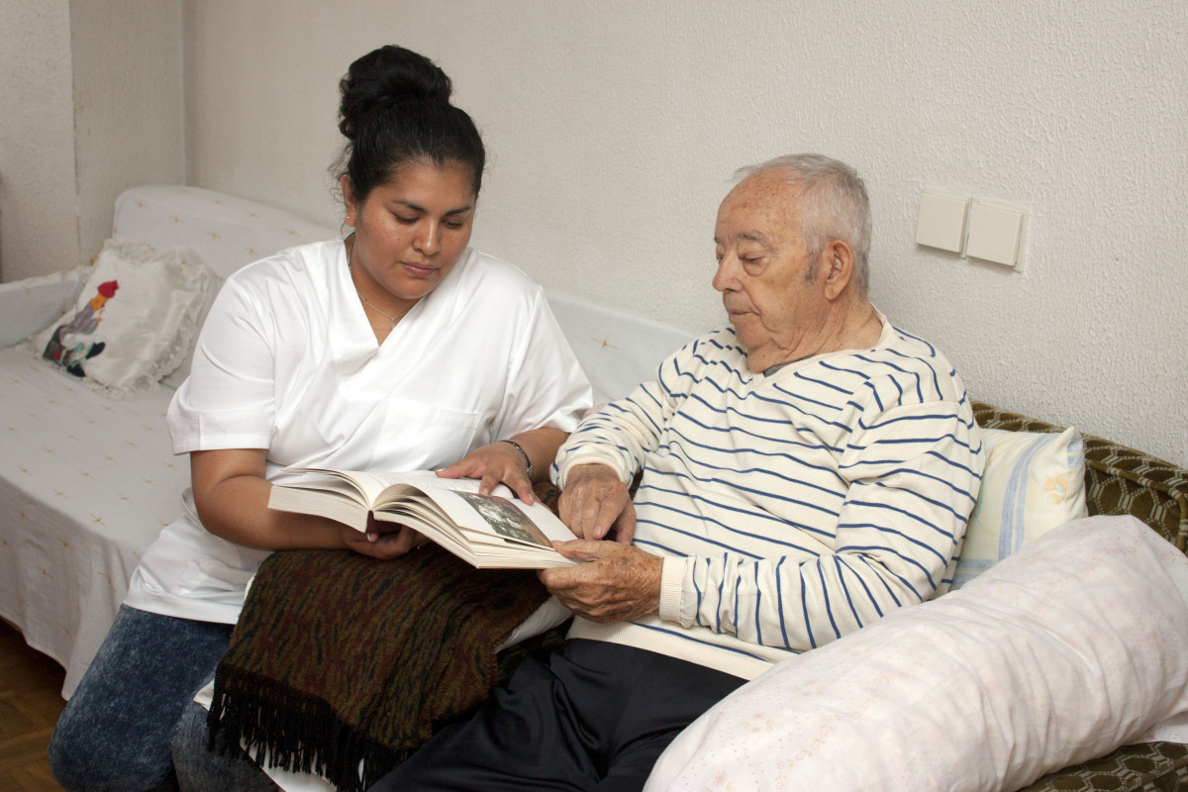

mes SERVICESS
Manor Enhanced Services
248 626-6560 Ext 306 OR 307 (EPSILON BLDG)
H.Hickman@TheBaptistManor.org
Henry Hickman- MES & FOOD SERVICE DIRECTOR
Please see your Service Coordinator for M.E.S. Contracts***
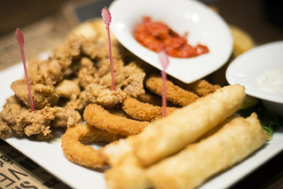
ENHANCED
SERVICES

