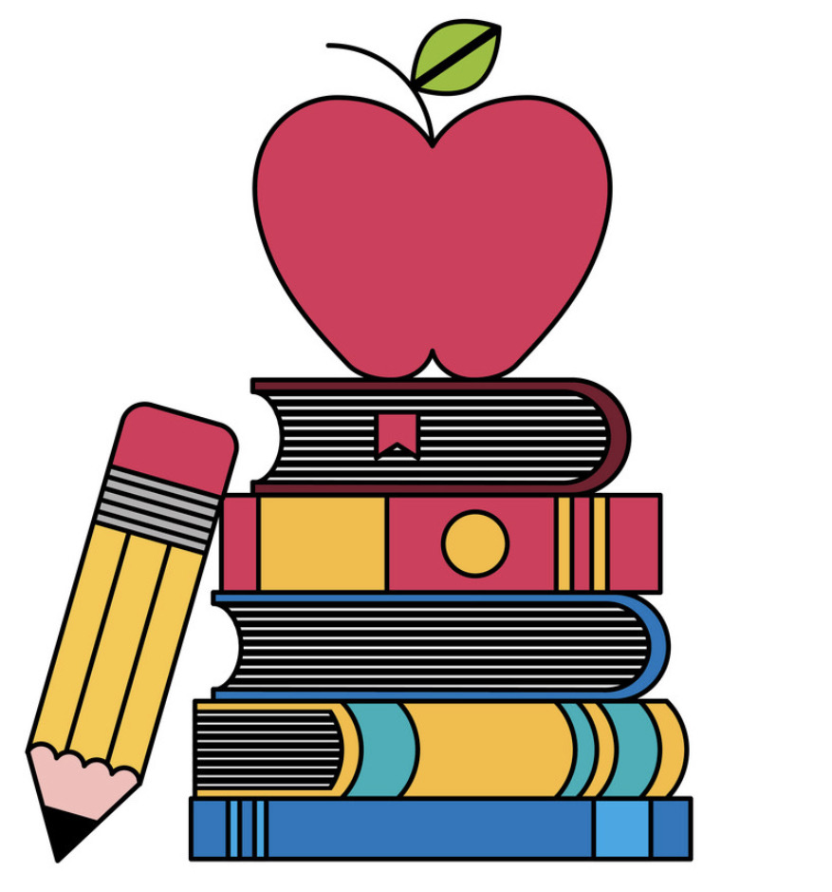These are a few of my favorite things

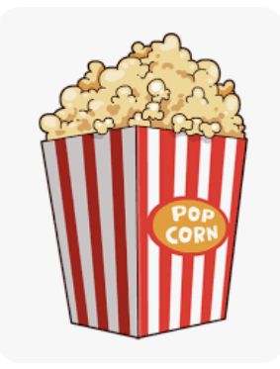

Teachers: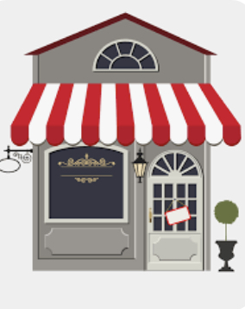 Ms. Sanabria

Snacks: 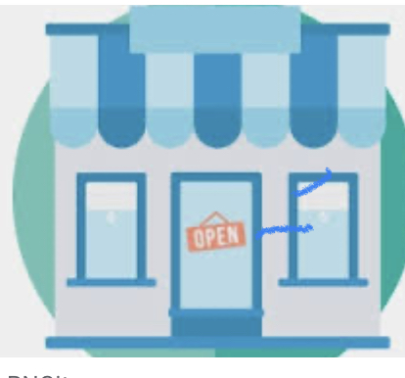Fruit, popcorn, pretzels.

Restaurants: Chick-fil-A,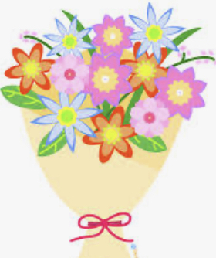 Cheesecake Factory

Stores: Target, Amazon, Lululemon

Flowers/Plants: Sunflowers 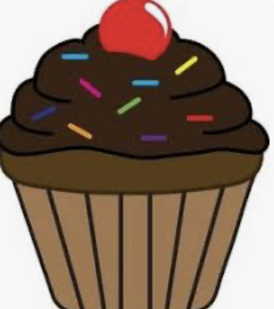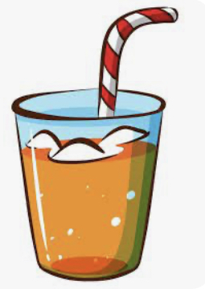

Sweets: Nothing Bundt Cakes, Crumbl Cookies, Reeses, Kit Kat 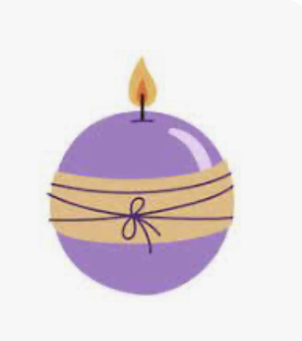

Drinks: Starbucks Iced Coffee, Raw Juce

Scents: 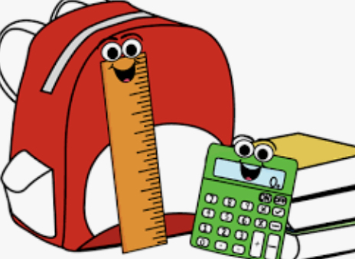Light/fresh, ocean/beach

School Supplies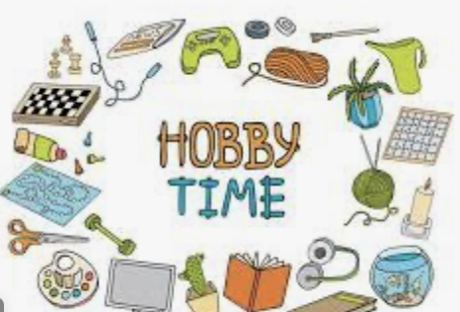 Needed: Flair pens, laminating sheets, Astrobright cardstock, white cardstock

Hobbies: Walking, going to the beach, relaxing, shopping, crafting

Birthday: June 9

