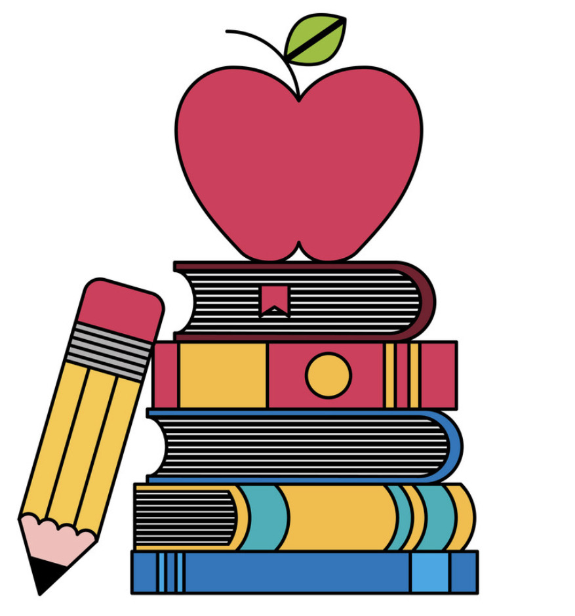These are a few of my favorite things

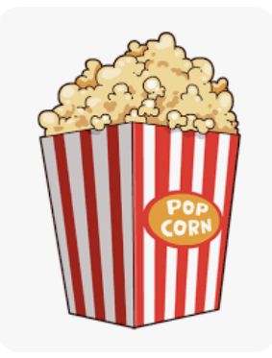

Teacher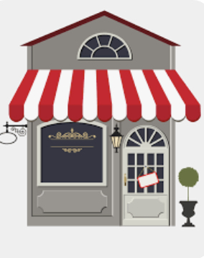: Rosina (Rosie) Bencivenga

Snacks: 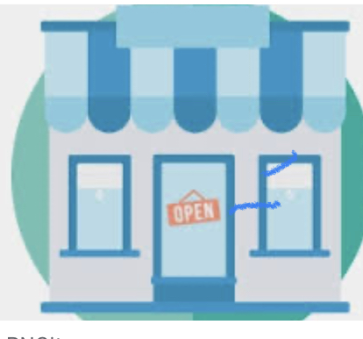Kind Bars, Cashews, Almonds, Bananas, Apples

Restaurants: Duffy’s, Bonefish, Outback, CJ Blacks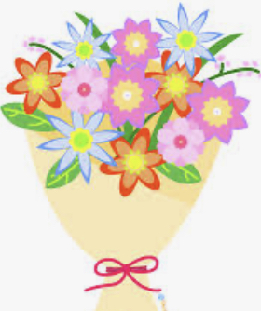

Stores: Macys, Target, Old Navy, Amazon

Flowers/Plants: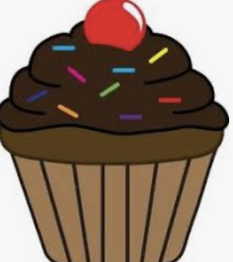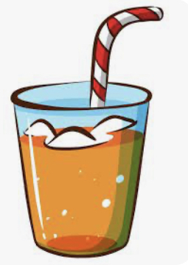 Roses, Sunflowers, etc.

Sweets: Anything chocolate - Cannoli’s 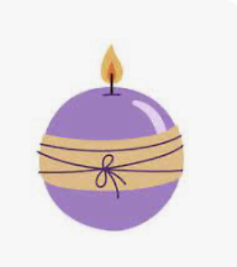

Drinks: Coke and water (school appropriate), Sour Apple Martinis (Other) lol

Scents: Bath and Body Works - Champagne Toast, Flowers by Kenzo Perfume, and anything sage, citrus, lemon, lavender 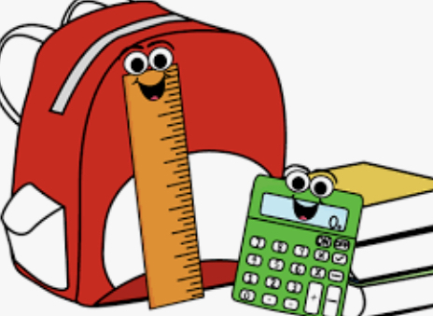

School Supplies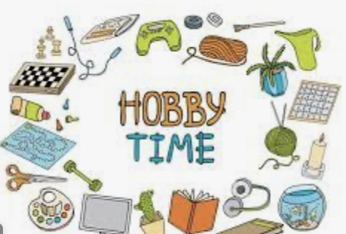 Needed: N/A

Hobbies: Bird & butterfly watching, bike rides and nature walks, crochet & crafting, GRANKIDS

