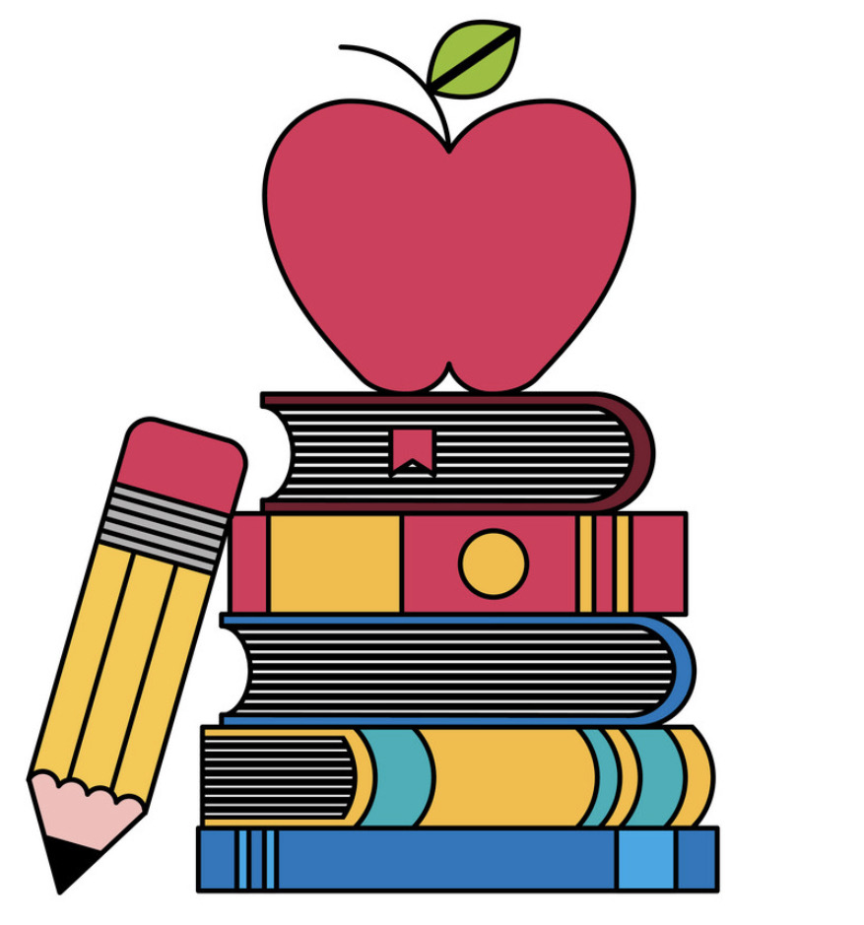These are a few of my favorite things

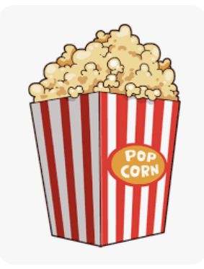

Teachers:__Angela Keller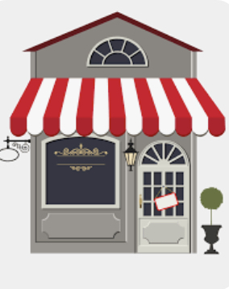 (birthday 8/22)

Snacks: __plaintain chips, cashews, chips & salsa______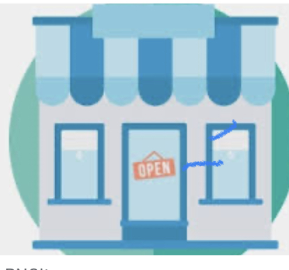

Restaurants:__BJ's Brewhouse, Ale House, Chili's___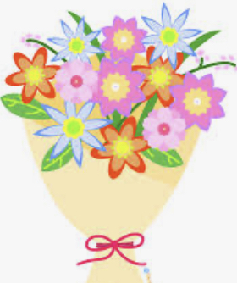

Stores:__Walmart, Amazon_

Flowers/Plants:_hydrangea, sunflowers__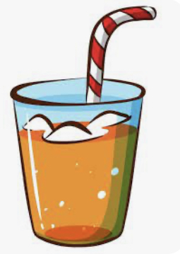

Sweets:_chocolate chip cookies- no nuts, bundt cakes__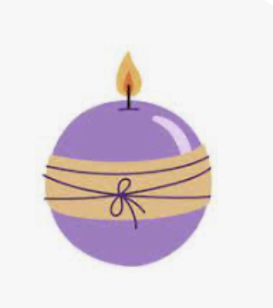

Drinks:_Dr. Pepper, water_

Scents:_midsummer night, anything with christmas or winter_

School Supplies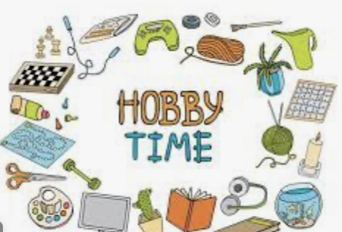 Needed:_sharpies in different colors__

Hobbies:_playing with the kids, riding bikes, cleaning-lol

