These are a few of my favorite things

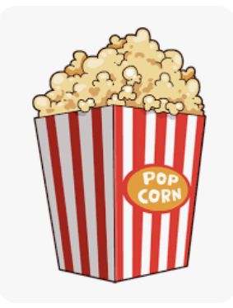

Teachers: BAQUEDANO 4th

Snacks: almonds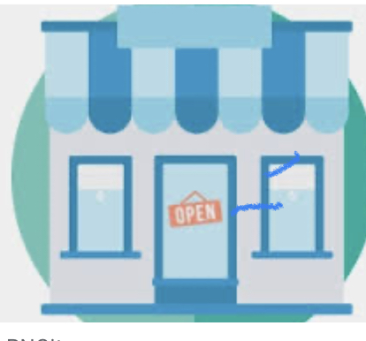

Restaurants: Scillian Oven, Anthony’s Coal Fired Pizza

Stores: Target, Amazon

Flowers/Plants: orchids 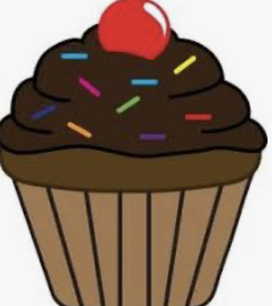

Sweets: Hershey’s Kisses, Sugarless Minty Gum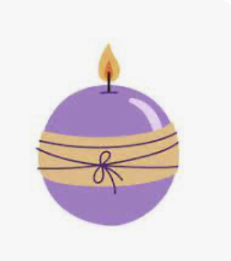

Drinks: Ginger Ale, Coke

Scents: Lavendar / Eucalyptus 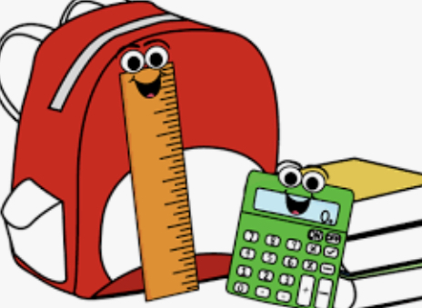

School Supplies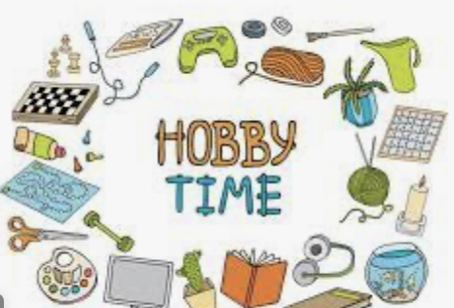 Needed: Bulk Student Reward Gifts

Hobbies: Pokemon Go

