These are a few of my favorite things



Teachers:__Gallagan_____

Snacks: ___caramel corn, cheese its______________________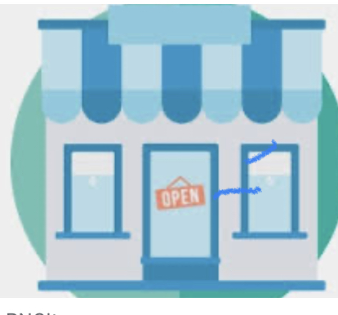

Restaurants:__Outback, Jersey Mikes, Chipotle _______

Stores:____amazon, Sephora______________

Flowers/Plants:___Sunflowers, succulents, daisies________________

Sweets:__anything milk chocolate, kit kat, 3 Muskateers, Milky Way__________________________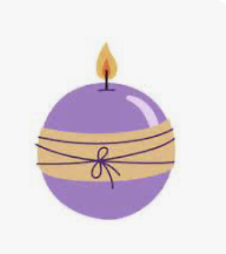

Drinks:____Coca-Cola, starbucks, Arnold Palmers_____________

Scents:__floral and fresh__________

School Supplies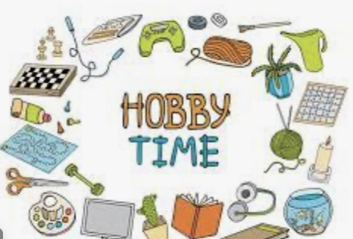 Needed: expo markers, clorox wipes, colored pens__________________

Hobbies:_working out and playing pickleball_________________

