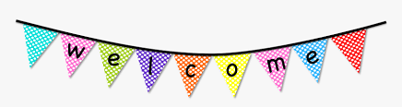
Please return this portion so we can reach out to you about current events in the classroom.
Your Name:_______________________________________
Child’s Name:______________________________________
Phone: ___________________________________________
Email: ___________________________________________
Is it OKAY for room parents to reach out to you on the Remind APP? (circle one) YES or NO
Are you available to volunteer during school hours? _______________________________________
Are you interested in volunteering in after school activities? _____________________________________

Dear Parents,
Welcome! Our names are XXXXXXXXXXXXXXXX and we are very excited to introduce ourselves as the room parents for this year in XXXXXXXX __ grade class. The year is off to a great start and will be a fantastic experience for our children. We will be coordinating the classroom parties, organizing teacher appreciation gifts, and coordinating any other help XXXXXXXX requires throughout the year.
How to reach us:
NAME
NUMBER
EMAIL

Throughout the year we'll be asking for parent volunteers to assist with class parties, send in items, and/or help the teacher. We know everyone’s schedule is a bit different, hope you’ll jump in when and how you can.
Please contact either one of us anytime with any questions or comments you might have. Thank you so much for all your help and participation in our class events.
Looking forward to an exciting and fun year!
NAME

