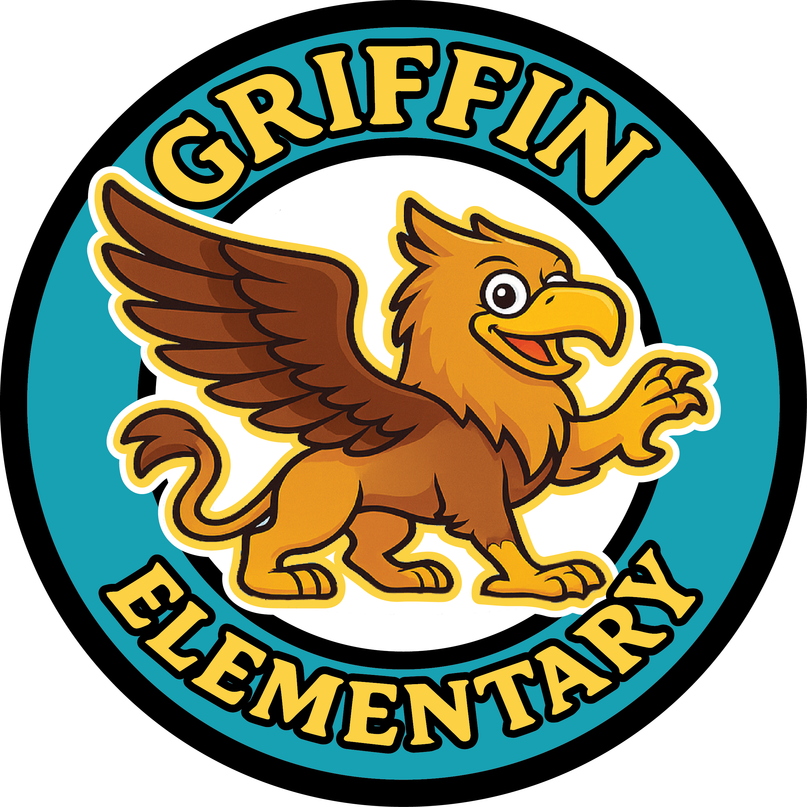
Griffin Elementary Room Parent

Hello, parents! My name is ______________________________ and I am the Room
Parent for ____________________________’s class this school year. I’m excited to connect with all of you and help make this year a memorable one for our kids!

I’ll be working with our teacher to coordinate fun in-class and schoolwide events like class parties, field trips, teacher appreciation activities & gifts, class fund collections, etc. I welcome your help when the class is participating in an activity that requires volunteers!

To make sure everyone stays informed, I will be utilizing ________________________ for a classroom parent chat. Please provide me with your contact information below. Please download the app and create your account using the contact info you provide me so I can get you connected quickly. In the meantime, I am providing you my contact info if you need anything.

Sincerely,

________________________ Phone: ___________________________

Email: __________________________________________________________

Thank you!

- - - - - - - - - - - - - PLEASE RETURN BELOW PORTION TO CLASS - - - - - - - - - - - - -

Your Name __________________________________________________

Child’s Name ________________________________________________

Phone ______________________________________

Email_________________________________________________________

Please list any food allergies for your child: ____________________________________

Is it okay to photograph your child for the yearbook? Y / N

