The Rose Vine
October 2007
Volume 41, Issue 3
Penn-Jersey District of the American Rose Society’s quarterly newsletter

Mother Nature’s Art

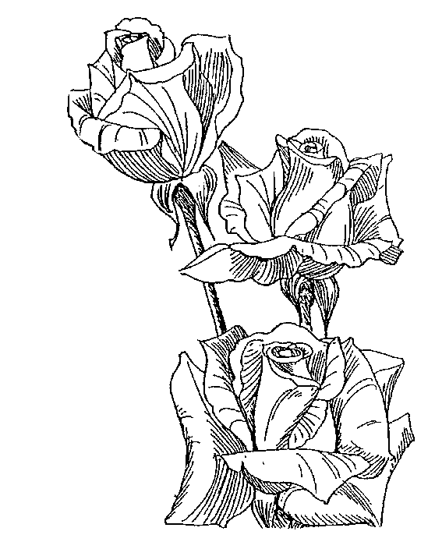
Rusty ‘83

Contents:
Director’s Message 2
Plan For Winter Getaway 3
The Reluctant Arranger 4
Convention Wrap-up 5
Report from ARS
Convention 7
Proposed Bylaws
Changes 10
Midge Survey 12
CR School in Pittsburgh 14
District CRs 16
What Were They Thinking?17

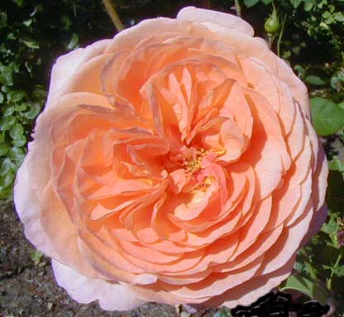
Louise Clements photo by Kevin Glaes

A glance at the calendar and you can tell it is October. The boxes for Saturdays and Sundays are not full of notes about rose shows – host society, location, etc. The “silly season” is over and we can return to being “normal” people. No walking along the beds looking at each shoot, bud or bloom with a critical eye. No seeing one spot of blackspot and running to the shed for the sprayer. No warily eyeing a bug hovering above a bloom to see if he is a good guy or bad guy. Or no? Are you still looking at every bloom in the garden and critiquing it on it’s show value? Are you thinking that the color of that bloom would be enhanced with a little extra phosphorous?

Well, Bunky, you need to relax and just enjoy the blooms. It is a great time of year – the pressures (self-made) of doing everything necessary to have the perfect bloom should be gone. I was out in the garden yesterday morning and caught myself looking at every bloom with a critical eye. Then I stopped and looked over all the beds and just said “wow!” There were blooms everywhere. All had great color. And the overall effect was stunning. So I just plopped down in my chair under the hemlock and soaked it all in.

It was a lot of fun turning off the schedule in my head and just seeing what I should be seeing all the time. Here are gorgeous blooms with nowhere to go and only me in the garden to enjoy them. No walking up to each bloom and tipping it towards me to critique the center. No plucking a petal to see if that enhances the bloom. Just enjoying the roses without the constant “Yes, but...” or Yes, maybe...” swirling in my head.

We should have good blooms through October and some nice ones into the third week of November (Reading, PA season). Those folks down in the tropics of Philadelphia will probably have blooms through December (Yeah, sure!)

It is time to go out in the garden without pruners, without the sprayer, without purpose and sit down and enjoy the blooms. You worked hard for some seven months. Now is the time to reap the rewards. Look at the rose, just look, and enjoy it for what it is – a great work of Mother Nature’s art.
Kevin

From the District Director’s Desk

Penn Jersey has been a very active District in recent months. We enjoyed an outstanding District Convention in Harrisburg, conducted a very successful Consulting Rosarian School which produced nine new CR’s, hosted a Joint Arrangement Judges School (with New York and Colonial District), and a Horticulture Judges School at the Convention. See elsewhere in the newsletter for reports on each of these schools. I’d like to congratulate the new Judges and remind all the Societies to invite these new Apprentice Judges to their shows. Jayne Shipman and Curtis Aumiller passed both the Horticulture and Arrangement tests and now face the challenge of at least ten apprentice judging assignments in the next three years in order to become Accredited Judges. Donna Smith, already a Horticulture Judge, is now an Apprentice Arrangement Judge and needs five apprentice assignments. Congratulations to all three.

The Harrisburg Convention was great fun – our thanks and congratulations to the Greater Harrisburg Rose Society for a job well done. ARS President Steve Jones was the dinner speaker. He also presented a program on Saturday afternoon and joined in on all of the other activities. The Hospitality Room was made available to the convention attendees during the day as well as in the evening and an expanded menu of refreshments was provided. This proved tremendously popular and may become a feature of future conventions.

At the District Business Meeting there were two items of particular interest. One was a report from Gus Banks, Chairman of the committee appointed to review the District By-Laws. The ARS had requested the District By-Laws be reviewed to assure that they met ARS requirements. The Penn Jersey By-Laws, last revised in 1996, are in compliance. However, the Committee found there were several provisions that did not agree with actual District practices and recommended changes. The Committee also recommended deleting the “Area Representatives”. The complete Committee report is on page 10.
The second item was a proposal that the District fund a part of the District Director’s expenses involved in attending national conventions. Attending the ARS Board Meeting at least one national convention each year is a requirement of the office. This proposal resulted from the fact that it has been difficult to find members willing to assume the responsibilities and expenses of serving as district officers. The sense of the meeting was that Penn Jersey should not do this. President Jones reminded the group that the national nomination form also required that the nominee accept the financial responsibility.

There was an ARS National Convention in St. Louis in September. Bruce Monroe was able to attend and has provided a report from the Board of Directors meeting on page 9. Of special interest, the York Rose Society’s application to host the National All Miniature Convention in 2009 was approved. Please support York’s efforts and lend a hand if possible.

Remember – Winter Rose Getaway February 15-17, 2008 – hope to see you there!

Elaine

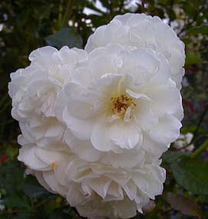
Prosperity photo by Kevin Glaes

Plan Now For the Winter Rose Getaway

Our 2008 Winter Rose Getaway Weekend will meet on February 15, 16 and 17 at the Eden Resort Inn in Lancaster. The room rates will be $94.95. This year we will have a change in the hospitality room. Mary and Bill Slade have volunteered to host the hospitality room. They did a great job of that at the Harrisburg District Convention so we can look forward to the hospitality room being open more during the day. This will give us for more casual meetings and visiting outside of the program room.
We are still working on getting speakers/programs lined up. We plan to have two landscaping programs.
One will discuss structures and one on incorporating roses. Pat Bilson will have hands on (or you can just watch) design work shop “Moving toward Modern.”
Mark your calendars now and plan on attending. Better bring someone new from your society. Remember attendance at the Winter Rose Getaway Weekend also bring you a year’s subscription to the Rose Vine. If anyone has a special program they would like to present or ideas about what they would like to hear please let me know at jrsyrose@verizon.net.

Gus Banks


Attention Arrangers - Come to the Getaway!

The Winter Rose Getaway will feature an Arrangers Challenge, theme to be announced in the next issue of the Rose Vine. Prizes will be awarded for the “Best Design”, the “Most Creative Design”, the “Craziest Design”, etc. at the Saturday night banquet where the designs will be displayed. The District will provide each arranger with a container, roses and other materials - arranger brings tools and mechanics. More information will be available with the Getaway registration material.

Weekend Photo Contest
Plan now for the Penn-Jersey District’s annual Photo Contest, which is held during the Winter Rose Getaway Weekend. The photo contest is open to any amateur photographer who is either a member of the Penn-Jersey District or who has registered for the Winter Rose Get-a-Way Weekend. You need not be present to win. The Novice class (Class 1) is open only to those who have never won a blue ribbon in a rose photo contest.
Each photo entry must be a 5x7 color print photograph. Exhibitors are limited to three entries per class. All entries must be received by Jan 15, 2008. Mail your entry to: Bruce Monroe, 3030 Maple Shade Lane, Wilmington, DE 19810-3424.
For proper identification of the photos, attach the following information to the back of each photo: the contestant’s name, the Photo Class that the photo is being entered into and, also properly identify, as appropriate, the rose, the rose arranger, the rose garden or the rose society activity. A piece of paper or a card containing the information and taped to the back of the photo is acceptable. Photos will be evaluated on 50% rose form and 50% photo quality. All photos entered will be on display and final judging and awards will be made at the Penn-Jersey District Mid-Winter Rose Getaway Weekend. The judges' decision is final. Ribbons will be given in each class and awards to the top three photos overall. By entering the contest, you agree to allow the Penn-Jersey District of the American Rose Society to publish your photo in the Rose Vine newsletter. The contest classes are:
Class 1 – Novice Class – One photo, appropriate for any of Classes 2-11.
Class 2 – One Exhibition Bloom, Hybrid Tea, Grandiflora, or Floribunda
Class 3 – One Exhibition Bloom, Miniature or Mini-Flora
Class 4 – One Open Bloom, Hybrid Tea, Grandiflora, or Floribunda
Class 5 – One Open Bloom, Miniature or Mini-Flora
Class 6 – One Spray, Hybrid Tea, Grandiflora, Floribunda, or Polyantha
Class 7 – One Spray, Miniature or Mini-Flora
Class 8 – One Exhibition Bloom or Spray, Species or Old Garden Rose
Class 9 – One Exhibition Bloom or Spray, Shrub or Climber
Class 10 – A Rose Arrangement
Class 11 – Rose Garden or Rose Society Activity

The Reluctant Arranger
by Doreen Saidman
Ed’s note: this article recently received an Award of Merit from the American Rose Society. Congratulations Doreen! It first appeared in the newsletter of the West Jersey Rose Society

Roses are beautiful in any shape, form or color. Why, then, should I bother to arrange them, when I can just put them in a vase with water and enjoy them?
Well, midsummer brings us smaller roses and, at the same time, we can't afford to cut long stems, as we need to preserve as many leaves as possible, so, a bunch of short stem roses would look wonderful arranged in a low container. They could brighten our dining room, or they could bring joy to a friend, while we admire and take pride in our own creation.
A while ago, I wrote instructions for making a table arrangement with roses and other flowers, and as I have been asked to repeat the instructions, this is as good a time as any. So, here goes. You will need a small, low container and you may use a cereal bowl, or any deli plastic container that you may have saved, and you can wrap it in foil, or any fancy paper.
You should also need a chunk of OASIS - which is a fresh flowers floral foam (not the one used for silk flowers) - that you should place in water and let it stay there until it sinks. This foam contains so many pores that absorb a lot of water, so that the flowers will have a good supply in their container. After placing the foam (cut and fit to the container), you should secure it with water proof tape (or plumbing tape cut in narrow strips), as shown in the drawing.
For the plant material you should have 7 roses, and any smaller flowers to be used as fillers, like daisies, snapdragons, or any wild flowers that you have available. You will also need any foliage to cover the oasis, after all the flowers have been placed. How you have to place the flowers, and I will tell you by numbers, the order to place them.
Place the first rose in the middle of the Oasis (1), and another two roses (2 and 3), in horizontal position on both sides of the container, as shown in the second drawing. These roses are important because they will give you the height and the width of your arrangement. Also, if you look at the position of these roses (1, 2 and 3), they seem to form a triangle. Next, add a bigger, more open rose in the middle of the container, close to the rim of the container (4), and another similar one on the opposite side, also close to the rim of the container (5), as shown in the third drawing. To reinforce the shape of a triangle, place also two shorter roses (6 and 7), somewhat leaning between the rose in the middle (1) and the two roses in horizontal position (2 and 3).



To reinforce the shape of a triangle, place also two shorter roses (6 and 7), both sides, somewhat leaning between the rose in the middle (1) and the two roses in horizontal position (2 and 3).
Finally, you may use any other small flowers as fillers, to complete the arrangement, as shown in the last drawing, and you should also cover the Oasis with any kind of foliage. It is not pleasant to look at the "mechanics" (in our case, the floral foam), so we should always conceal it with small flowers, or foliage.
If you want a taller arrangement, at this time, just raise your container with flowers on top of an inverted tumbler, or on top of a tin can covered with the same foil or paper as your container, A bit of floral clay will secure the top container in place. Next time, you may use a real nice, tall container, or learn how to make your own container, using a spray paint to cover nicely a modest "contrived" one.
I think with these "easy to do" instructions, you may consider yourself an arranger (and no more a reluctant one)
And you didn't think you could be artistic and create a beautiful flower arrangement! Enjoy it on your dining table, or in your favorite room, and have an easy, pleasant summer!

District Convention Wrap-UP
by Bill Kozemchak
Taken from the October edition of The Rose, the newsletter of the Philadelphia Rose Society

The Greater Harrisburg Rose Society did a wonderful job hosting the Penn-Jersey District Convention and Rose Show this year. The Friday dinner speaker was Craig George, Director of Hershey Gardens. He gave a very interesting talk about Milton Hershey and the history of Hershey Gardens. Prior to his talk, the District awards were presented. Harrisburg member Marva Spare was presented with the Outstanding Consulting Rosarian Award.
Our own Tom Mayhew was the Outstanding Judge in Penn-Jersey this year.
I was quite surprised to be presented with the Silver Honor Medal for 2007. It is quite an honor to join the ranks of previous winners who stand each year to join in the presentation. I would like to thank the local societies who voted for me this year, and the other Silver Medal winners who welcomed me to this distinguished group.
The District Rose Show had very high quality blooms and was a very lovely display. Ken Borrmann swept the hybrid tea court and won the McFarland along with many other classes. Pat Bilson, Tom Mayhew, Kevin Glaes, Diane & Ernie Szilagyi, Bruce & Liz Monroe, and Kathy & I were also winners from PRS.
Jim Redington started the Saturday programs with a very informative talk on rose rosette disease. Hybridizer David Clemons was next with “In Search of Secretariat”, his quest for the perfect red miniflora that he could name after the famous horse. ARS President Steve Jones followed with an excellent program on “Portlands and Early Hybrid Perpetuals”.
Steve Jones also was the Saturday dinner speaker. “Rose Book Collecting- For Fun Education and Profit” was very interesting and informative. Steve also had some awards to pass out. Presidential Citations were given to Frank Benardella and Gus Banks for outstanding service to the rose. Certificates of Merit were presented to Elaine Adler and Bruce Monroe for their work as District and Region Directors.

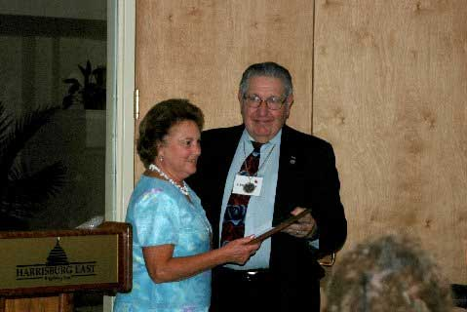
Marva Spare receiving her award from Gus Banks
Photo by Tom Mayhew

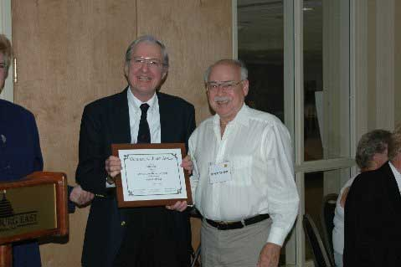
Tom receiving his award from Bruce Monroe
Photo by Sharon Davis

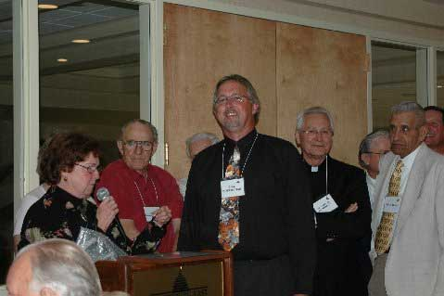
Bill Kozemchak surrounded by his posse. Looks like they are trying to protect him from “groupie” Nancy Redington! Photo by Tom Mayhew

Kathy and I were also presented with a Certificate of Merit for outstanding service and dedication to the ARS as editors of “The Rose”. This was another honor that was quite unexpected.
The District meeting Sunday morning was followed by tours of four beautiful local gardens. I would like to thank Jim & Marva Spare, Mary Jane Wrightstone, Judy Carey, and Mike & Sally Wrightstone for sharing their gorgeous gardens with us.
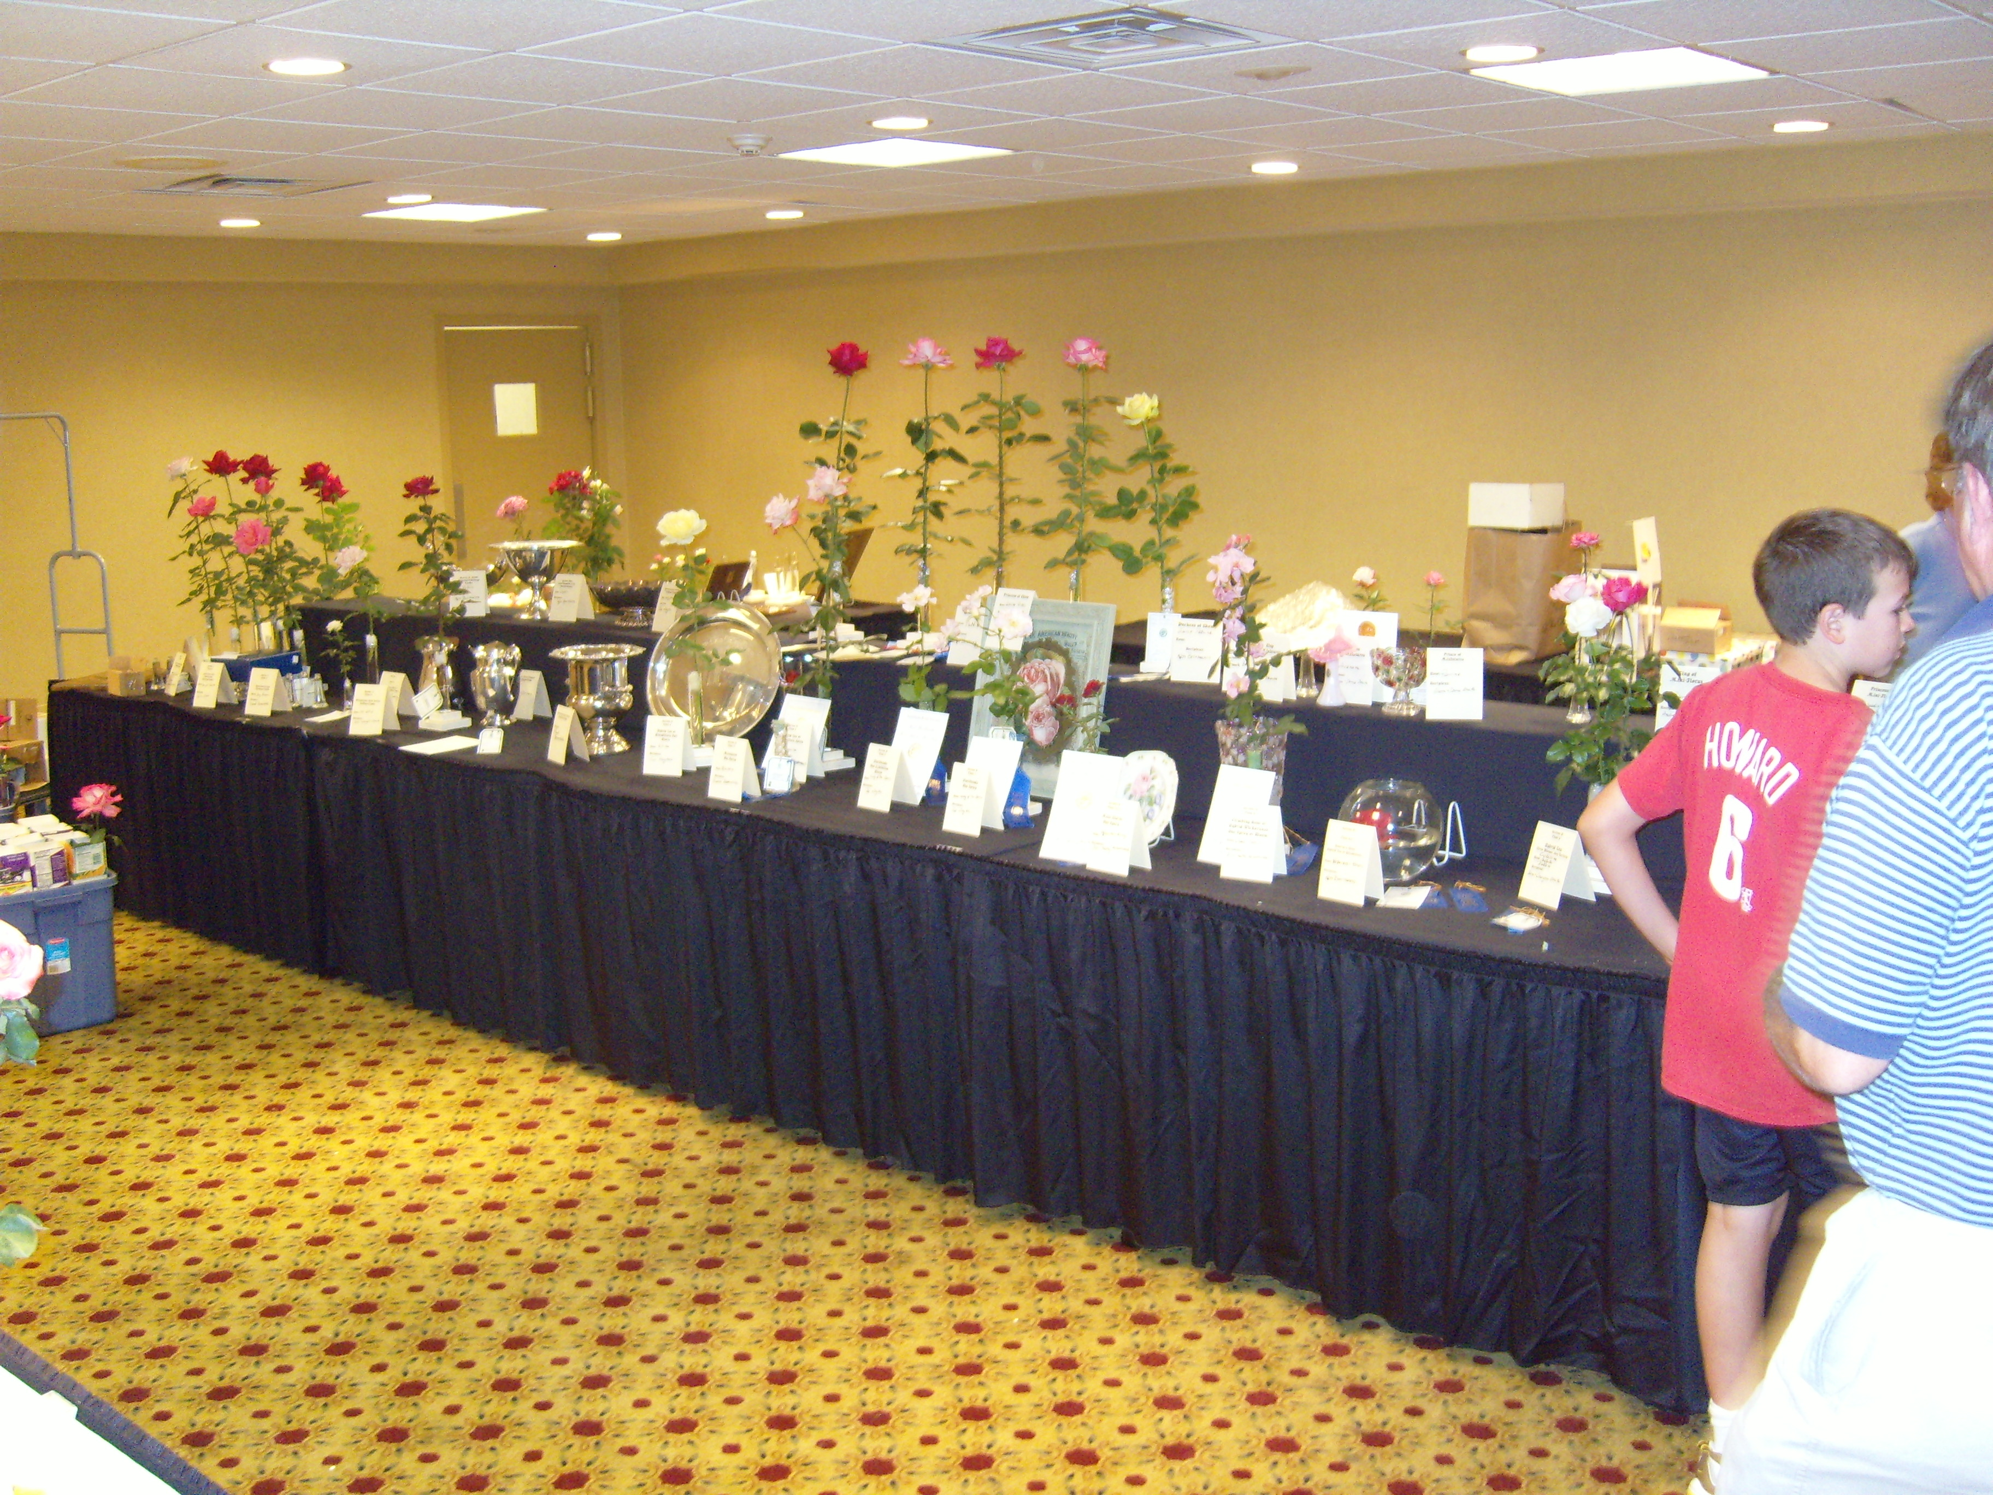
The Head Table photo by Bill Kozemchak

District Rose Show Results
AWARD ROSE RECIPIENT
Queen of Show Dublin Ken Borrmann
King of Show Mavrik Ken Borrmann
Princess of Show Louise Estes Ken Borrmann
Prince of Show Uncle Joe Ken Borrmann
Duchess of Show St. Patrick Ken Borrmann
Mini Queen Baby Boomer Frank Benardella
Mini King Kristin Andrew Hearne
Mini Princess Arcanum Glenn & Donna Smith
Mini Prince Pierrine Glenn & Donna Smith
Mini-flora Queen Tiffany Lynn Diane & Ernie Szilagyi
Mini-flora King Peter Cottontail Andrew Hearne
Mini-flora Princess Leading Lady Andrew Hearne
SECTION B
CLASS:
4 Grandiflora or HT Spray Gemini Bill & Kathy Kozemchak
5 HT or GF Full Blown Elina Tom Mayhew
6 Floribunda One Bloom Lady of the Dawn Pat Taylor
7 Floribunda Spray Lady of the Dawn Pat Taylor
8 Climber/Hybrid Wichuranas Clair Matin Bill & Kathy Kozemchak
9 HT 3 Blooms Crystalline, Suffolk, Dublin John & Cherylynn Smith
9A Rose In a Bowl Veteran’s Honor Ken Borrmann
11 Mini Spray Kristin Frank Benardella
11A Miniflora Spray Memphis King Bill & Kathy Kozemchak
14 Mini Floating Bloom Hot Tamale Diane & Ernie Szilagyi
14A Miniflora Floating Bloom Tiffany Lite James Spare
15 Mini-miniflora matched pair Leading Lady Andrew Hearne
16 Mini-Minifloras bloom & Spray Glowing Amber Bill & Kathy Kozemchak
17 Mini/Minifloras open bloom Incognito Diane & Ernie Szilagyi
18 OGR – Dowager Queen Green Rose Bill & Kathy Kozemchak
19 OGR – Victorian Queen Rose de Rescht Tom Mayhew
20 Classic Shrub Linda Campbell Bruce Monroe
21 Modern Shrub Country Dancer Marva Spare
23A Polyantha Verdun Tom Mayhew
23B Miniature Climbing Valentine’s Day Bill & Kathy Kozemchak
24 Most Fragrant Rose Ambridge Rose Bill & Kathy Kozemchak
25 Judges Entry Soroptimist International Nancy Redington
SECTION A
CLASS:
1 ARS J. Horace McFarland Penn-Jersey District Trophy (5 HT, Different Varieties)
Roses Signature, Mavrik, Dublin, Uncle Joe, Affirm Ken Borrmann
2 ARS Ralph S. Moore Penn-Jersey District Memorial Trophy (7 Miniatures, Different Varieties)
Roses: Luis Desamero, Pierrine, Old Glory, Cape Hatteras, Innocence, Figurine, Rookie Glenn & Donna Smith
3 Griffith Buck Shrub Trophy (3 Different Modern or Classic Shrubs)
Roses: Royal Bonica, Linda Campbell, Sally Holmes Bill & Kathy Kozemchak
4 George Hooker Memorial Trophy (7 miniatures, 3 or more varieties)
Roses: Pierrine -2, Rookie, Mary Beth, Soroptimist International, Citrus Candy, Cape Hatteras
Glenn & Donna Smith
5 Philadelphia Rose Society Challenge Trophy (Large English Box )
Roses: Crystalline, Gemini, Elizabeth Taylor, Dublin John & Cherylynn Smith
6 Greater Harrisburg Rose Society Challenge Trophy (Mini English Box)
Roses: Sweet Melody, Amber Star, Glowing Amber Bill & Kathy Kozemchak
7 Jack D. Lissemore Friendship Trophy (HT Matched Pair)
Rose: Uncle Joe-2 Ken Borrmann
8 Pittsburgh Rose Society Challenge Trophy (3 Matched HT, any var.)
Roses: Uncle Joe-2, Pop Warner Ken Borrmann
9 West Jersey Rose Society Challenge Trophy (3 Matched Minis, any variety)
Roses: Baby Boomer-3 Frank Benardella
10 South Penn Area Rose Society Challenge Trophy (HT Cycle of Bloom)
Rose: Marijke Koopman Kevin Glaes
11 York Rose Society Challenge Trophy (Mini Cycle of Bloom)
Rose: Baby Boomer Frank Benardella
12 Reading-Berks Rose Society Challenge Trophy (Hi- Lo, HT & Mini)
Roses: Moonstone, Irresistible James Spare
13 Penn-Jersey District Miniature Seedling Trophy (Mini Seedling)
Rose: Seedling Frank Benardella
14 Philadelphia Rose Society Seedling Trophy (Any Seedling except Mini)
Rose: 04-032 John & Cherylnn Smith

PENN JERSEY DISTRICT TROPHIES
Martin R. Jacobs Perpetual Challenge Trophy (Best HT, American Origin)
Rose: Dublin Recipient: Ken Borrmann
Garden State Club Champion of the District Trophy (Best Rose in Court of Honor)
Rose: Dublin Recipient: Ken Borrmann
Harrisburg Rose Society Perpetual Trophy (Best Open bloom in Show)
Rose: Lady of the Dawn Recipient: Pat Taylor
Lincoln Atkiss Perpetual Challenge Trophy (HT Sweepstakes)
Recipient: Ken Borrmann
Miniature Rose Trophy (Mini Sweepstakes)
Recipient: Diane & Ernie Szilagyi
Jersey Shore Rose Society Perpetual Trophy (Best Miniature in Show)
Rose: Baby Boomer Recipient: Frank Benardella
J. Benjamin Williams Horticultural Trophy (Miniflora Queen)
Rose: Tiffany Lynn Recipient: Diane & Ernie Szilagyi

ARRANGEMENTS:
Mrs. John Signaigo Challenge Trophy
Roses: Rina Hugo, Memorial Day, Spring’s A Comin’, Electron Recipient: Nancy Redington
Florence McNeil Penn-Jersey Perpetual Trophy
Rose: Traviata Recipient: Pat Bilson
Miniature Arrangement Perpetual Trophy
Rose: Sweet Revenge Recipient: Joan Singer
J. Benjamin Williams Artistic Trophy
See John SignaigoTrophy Recipient: Nancy Redington
Court of Etiquette
See John SignaigoTrophy Recipient: Nancy Redington
Artist's Award
Rose: Traviata Recipient: Pat Bilson
Royalty Award
Roses Electron, French Lace, Frederick Mistral, Dublin, Belami Recipient: Nancy Redington
Mini-Artist Award
Rose: Sweet Revenge Recipient: Joan Singer
Mini-Oriental Award
Rose: Sassy Cindy Recipient: Joan Singer
Mini-Royalty Award
Roses: Gourmet Popcorn, Seabreeze Recipient: Nancy Redington
Rose Craft Award
Rose: Tournament of Roses Recipient: Nancy Redington
Duke of Arrangements Award
Roses Recipient: Pat Lawrence

Gold Certificate Recipient: Nancy Redington
Silver Certificate Recipient: Pat Lawrence
Bronze Certificate Recipient: Nancy Redington
Mini Gold Certificate Recipient: Joan Singer
Mini Silver Certificate Recipient: Nancy Redington
Mini Bronze Certificate Recipient: Joan Singer

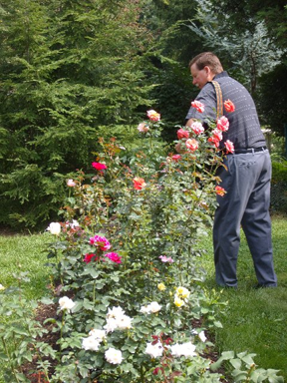
Views from the Garden Tour
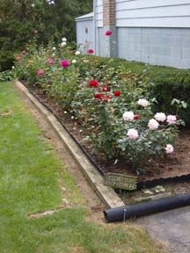
Left: Judy Carey’s garden
Above: Bruce Monroe in Mary Jane Wrightstone’s garden.
Right: ARS President Steve Jones
stuffing his pockets with blooms.

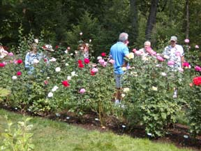
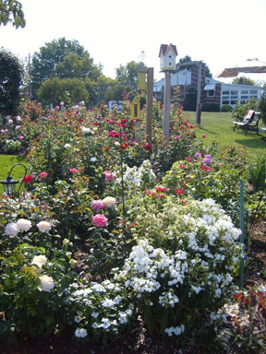
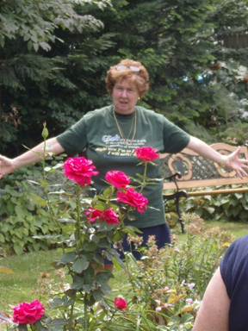
Left: Jim and Marva Spave’s garden
Above: Mike Wrightstone’s garden
Right: Judge Nancy says “Now to be a good spray, it HAS to be THIS wide!”

All garden tour photos by Bill Kozemchak

Report From the ARS National Convention
Bruce Monroe
Region 0 Director

The ARS National Convention was held in St. Louis on September 13-16. Over 300 ARS members registered for the convention. The convention hotel was in downtown St. Louis, only about two blocks from The Arch. We visited the top of The Arch and had a great view of the mountains of southern Illinois.
At the Board meeting on Friday, the Board voted to accept the bid of the York Area Rose Society to host the 2009 Mini National Convention. Congratulations to York, and we all look forward to another great Mini-Convention.
Jeffery Ware, the new Executive Director of the Society was introduced to the Board. He has extensive experience with non-profit organizations, particularly with fund raising. Although he has been on the job less than two months, he has already formulated a seven point plan he hopes will make an immediate difference in the ARS. Highlights of this plan include improving customer service and making sure the magazine is never late. He also plans to promote the Gardens of the American Rose Center and make them a destination for families visiting the region. His complete plan is available on the ARS website at:
http://www.ars.org/About_ARS/executive_director.html
The Board also completed work on the dues increase started at the previous meeting in St. Paul. The annual dues for a rose society were increased $10/year to $70/year, effective the first of the year. This increase is in line with the increases in individual membership dues approved in St. Paul. Life memberships and foreign membership dues were also increased. Finances have improved, partly because a number of members paid their dues in advance before the dues increase went into effect. Declining membership continues to be a problem despite the efforts of the Membership Committee.
In other news, the Judging Committee is considering a compete rewrite of the Judging Manual chapter on challenge classes and collections. And I was elected to a three year tem as a trustee of the Rose Research Trust Fund.
Bruce Monroe
.

BY-LAWS UPDATE NOTICE

This is to give notice that there will be a vote on changes to the Penn-Jersey District By-Laws at our Rose Get-a-Way weekend meeting. The meeting will be on February 15, 16 and 17, 2008 at the Eden Resort Inn in Lancaster, PA. Individual District ARS members will receive a ballot prior to the meeting. The ballot may be cast in person at the meeting or mailed to Gustave Banks 117 Farmdale Road Mt Holly, NJ 08060-3296. Mailed in ballots must be received by February 11, 2008
The ARS requested that the district review our by-laws. To this purpose District Director Elaine Adler appointed the following to a committee. Elaine Adler, Gus Banks – Chairman, Kevin Glaes, Marion Forstenhausler, and Georgianna Papale.
Our review found that our by-laws meet all of the ARS requirements. We did find a need to make a number of changes. The proposed changes are listed below. The complete current Penn-Jersey District By-Laws can be found on our web site.
The members of the District will have the opportunity to vote on the changes to the by-laws at our Rose Get-a-Way weekend meeting. Ballots will be mailed to all ARS members prior to the meeting. All members are encourged to attend the business meeting and vote.
When passed by the District, the changes must be submitted to the ARS Board of Directors for their review and approval.

Gus Banks
Chairman,
By-Laws Committee

PROPOSED BY-LAW CHANGES

Article III, Section 1 | change “prescribed” to “and/or assigned” | Covers ARS members transferring into the district
Article IV, Section 2 | delete “and three (3) persons representing the three (3) major geographical areas of the District. Elected and appointed officers may not also serve as geographical area representatives. The geographical area Board members shall, to the extent reasonably possible, represent the views and concerns of the local societies in their respective areas.” | Removes geographic representatives that are no longer required due to better communication methods and difficulty in filling positions.
Article IV, Section 3 | change “shall” to “may” | Changes mandatory requirement to optional.
Article IV, Section 3 | insert “email,” after “mail” | Updates communication methods.
Article V, Section 3 | delete entire section.  “The three (3) elected geographical area representatives shall include one (1) representative of each of the three (3) major geographical areas of the District as follows:  Western/Central PA Area (Harrisburg, Pittsburgh, and South Penn Area Societies)  Eastern/South Central PA Area (Del-Chester, Lehigh Valley, Philadelphia, Reading/Berks,  and York Societies)  New Jersey Area (Garden State, Jersey Shore, North Jersey, South Jersey, and West Jersey Societies)  Elected and appointed officers may NOT also serve as Geographical Area Representatives.”  Renumber following sections. | Removes geographic representatives that are no longer required due to better communication methods and difficulty in filling positions.
Article V, Section 4 D | delete entire section.  “The three (3) geographical area representatives shall be elected by members of the appropriate Societies in attendance at the District Meeting, from nominations made by (1) District Rose Societies, (2) individual District ARS members, and (3) self-nominations. Nominees must be ARS members. Terms of office for these positions shall be concurrent with that of the District Director.” | Removes geographic representatives that are no longer required due to better communication methods and difficulty in filling positions.
Article V, Section 5 | delete “or in any of the three (3) elected geographical area representative positions” | Removes geographic representatives that are no longer required due to better communication methods and difficulty in filling positions.
Article V, Section 7.A.7 | change “preparation of Budget to be presented” to “fiscal oversight of the District and reporting” | Aligns by-laws with current practices. District Director provides fiscal oversight.
Article V, Section 7.A.8 | add “Annually arrange for the preparation of a District Directory of District Officers, local Societies and their Officers, Newsletter Editor(s), Consulting Rosarians, Horticultural and Arrangements Judges, et al, which will be furnished to District Officers and to each local Society President.” | Aligns by-laws with current practices. District Director prepares the directory.
Article V, Section 7.D.3 | delete paragraph “Annually prepare District Directory of District Officers, local Societies and their Officers, Newsletter Editor(s), Consulting Rosarians, Horticultural and Arrangements Judges, et al, which will be furnished to District Officers and to each local Society President, and be offered for sale to members at a charge sufficient to cover production costs.”  Renumber following paragraphs. | Aligns by-laws with current practices. District Director prepares the directory.
Article V, Section 7.E.5 | delete paragraph “Prepare a recommended annual budget, in coordination with the District Director, for consideration by the Board of Directors and approval by the membership at the District meeting.” | Aligns by-laws with current practices. District Director provides fiscal oversight and direction.
Article V, Section 7.E.6 | change “at the end of the year,” to “at the end of the District’s year,” | Clarifies period.
Article V, Section 8.H | delete paragraph “Parliamentarian shall: 1. Serve in an advisory capacity to the District Directors at District and Board of Directors meetings.” | Removes Parliamentarian from list of appointed officers and aligns by-laws with current practices. District Director may appoint a parliamentarian if one is needed for a meeting.
Article V, Section 8.H | add paragraph “Chair, Membership shall: 1. Develop ARS members within the District.  2. Provide societies with names of new ARS members in their area.” | Adds Membership Chair to list of appointed officers and aligns by-laws with current practices.
Article VI, Section 1.A1 | change “and the (3) Geographical Area Representatives” to “and three appointed ARS members.” | Replaces geographic representatives with regular ARS members.
Article VI, Section 2.A | delete “annually” | Removes requirement for annual audit.
Article VII, Section 1. Sentence two | change “shall” to “may” | Removes mandatory language.
Article VII, Section 1.B | change “residing within the District” to “as defined in Article 3, Section 1. | Covers ARS members transferring into the district.
Article VII, Section 1.C | Add after Members “and to all District Rose Societies.” | Adds District Societies.
Article VIII, Section 1 | change “assess” to “assets” | Corrects spelling.
Article IX, Section 2. | change “eight (8)” to “five (5)” | Reduces number required for quorum.

Midge – The Battle Continues
I asked a number of rosarians around the District on their methods and success in trying to control midge. Here’s what I got back

Bill Kozemchak – Levittown, PA
I have not had much problem with midge. In the past I used liquid Diazinon in my spray. Then as midge became more of a problem in our area I also used granular Diazinon. This year I applied granular Diazinon from my stockpile and used The Bayer Complete Insect Killer for Soil and Turf concentrate in my spray mix.
The last time I went looking for the concentrate I couldn't find it, however the Ready to Spray hose end bottle is exactly the same percentage of ingredients as the concentrate and the same 32 oz. size. It contains 0.72% Imidacloprid (Merit Insecticide), 0.36% Beta-Cyfluthrin (Tempo Ultra Insecticide), and 98.92% other ingredients.
continued on next page
I use this as directed at 1/2 oz. per gallon of water. Used as a soil drench it is 3 oz. per gallon. I guess I will use it this way once I deplete my Diazinon supply.

Bill Sehl – Neptune NJ
This year I was fortunate not to have any infestations with midge to speak of. However the day after our rose show, I was out walking around my yard looking after things I hadn't been taken care of for that whole week before. I started to admire my lovely big green bush (41/2 feet tall by 4 feet wide) of Knock Out. Not a flower anywhere to be seen.
On closer inspection. about 1 inch of all the tips were burnt and crisp. I cut them all off and sprayed with Bayer Advanced Insect, Disease & Mite Control. ( the fine print on the inside label said it was good for rose midge). First time I have used it. That was a week ago. We will have to see which comes first, the bud and flowers or the first frost!

Fr. Gervase Degenhardt – Pittsburgh PA
This won't be helpful to you but I thought I'd relate it to you anyway. I have NO midge at all in my new garden. Where I now live, the only sunny space I have is by our parking garages with lots of cement and blacktop. I have 12 minis, 6 HTs, and 1 floribunda in pots. This is their first year and none have midge (yet, and I hope, never).

Ralph Stehle – Pittsburgh PA
I have not had a problem with midge for the past 8 years. I still have two bags of the forbidden granuals which I use every May. I also feel that Pro-Teck and Messenger help me there a lot. I use both products often.

Gus Banks – Mt. Holly NJ
No midge here in Mount Holly. I spray regularly (weekly) with Bayer's "Bayer Advanced Triple Action Insect Killer for Lawns and Gardens". At least up till when I thought I was sick.
I started spraying early (right after pruning) with a heavy spray that covered the soil too. Then followed with weekly spraying.

Glenn and Donna Smith – York Haven PA
Conditions: Southern exposure, very little wind, raised beds, favor overhead watering
We went a whole summer before we realized we had midge. It came in the previous Fall when one of the hurricanes came in right before the District Convention.
The whole next summer we had very little bloom. We started looking what the problem was and discovered we had midge.
We have woods surrounding our property, so our micro climate stays a bit protected more than other gardens. We only get winds when an east windstorm blows.
A few years ago, we still had midge very bad, Jr spread 3 or 4 very large bags of Diazinon throughout. It did the trick and got our Midge problem under control.
Now with Diazinon taken off the market, we have started using Bayer Complete Hose end sprayer, along with the Bayer granular. We start treating for midge mid-April (granular) and continue to alternate monthly. The reason we start a bit early, our garden is warmer and we do see damage this early.

Wayne Geltz – Lititz PA
Bayer's product, "Complete Insect Killer for Gardens", in the ready-to-use liquid sprayer seems to do the job. Since nearly all midge activity is nocturnal, I apply the chemical just before nightfall. I soak the soil in and around the rose beds in the evening just as you are losing daylight.
If the days are dry and the soil moisture is low I water the surface of the soil in the evening to activate the chemical. I like to maintain high soil moisture
for at least 6 days to eliminate the Midge. In my garden I apply a soil drench to the rose beds around the third week in April and the middle of July.

Nancy Redington – Chambersburg PA
No midge. Garden is new, airy, on a hill with not much shade, not much of any insecticide usage. Milky Spore inoculated soil last year. Roses spread out in several different areas with breaks in between.

Kevin Glaes – Reading PA
I had good success this spring with the Bayer Grub Control granules and spraying every two weeks with the Bayer Rose and Flower Insect Killer concentrate. Then I couldn’t find any more of the concentrate and didn’t spray in July through first part of August and they came back at what seemed to be twice the numbers. I purchased a 2oz bottle of Merit (Imidacloprid) powder from Rosemania and used this every week with moderate success. I decided to try the Bayer Complete Insect Killer for Soil and Turf and this has done the job for me.
continued on next page

The combination of Beta-Cyfluthrin and Imidacloprid in this product seems to do the trick. Imidacloprid alone did not work well.

Thanks to all who responded. The pattern for control looks like the combination of granules and spraying is necessary to keep these little hoodlums under control. I know I sometimes wish for Diazanon but then I remember that I have a well for both the house and garden and, no matter how deep the well, the organophosphates in Diazanon are so long-lived that they will make it down to the water table.

The first lesson is that newer, smaller gardens are less susceptible. Older, larger gardens are more susceptible and, once a population is established, they are hard to bring under control. Control used to start in mid-May for me, but that has been moved back to mid-April. Don’t know if that stems from warmer springs or the evolution of midge or a combination of both.
I know there is a lot of research going on and, hopefully, the chemical companies will bring out a product that is effective with out so much frequent spraying. And gets the blessing of the EPA.

Page on right taken from the American Rose Annual 1939 Copyright American Rose Society.

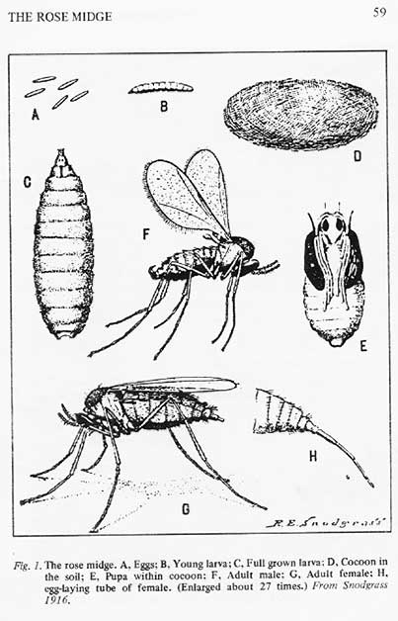

Consulting Rosarian School

The Pittsburgh Rose Society will host a Consulting Rosarian School on November 17, 2007 in Pittsburgh, PA. The school will start at 9 am and run until 5 pm, lunch will be included. There is a $10 fee to cover expenses. The CR class will be held in the Clubhouse at the rose garden in Renzie Park. Directions to the park can be found on the Pittsburgh Rose Society website: www.pghrosesociety.org.
The school will serve to requalify any current CRs. Any one interested in becoming a Consulting Rosarian must attend the school and complete the open book test. There is an additional ARS $10 fee for individuals taking the CR test. The school is open to anyone who wants to increase their rose growing knowledge. You do not have to be a CR or take the test to become one to attend.
To become an ARS Consulting Rosarian you must:
- Be an ARS member for three consecutive years.
- Be an active member of a local society.
- Must have grown various types of roses for five years and be knowledgeable in rose culture.
- Must provide three letters of recommendation from CRs.
- Must participate yearly in Roses in Review.
- Must exhibit a continuing willingness to share knowledge and an enthusiasm for the rose and the American Rose Society.
Anyone attending the school must have a copy of the CR Manual. Manuals will not be available for purchase at the school. They must be purchased directly from the ARS. Allow at least ten days for shipping when you order the manuals. Anyone interested in attending the school or becoming a Consulting Rosarian please contact Georgie Papale,412-563-6755, msgeorgi@ix.netcom.com to register for the school.

District Consulting Rosarians
The Rose Vine is received by many of our members who may not have contact with a local society. This list of Consulting Rosarian is published to give them access to CR help. To help you find a CR close to you the list is sorted by area code. If you note a needed correction please contact me about it.
Gus Banks
District Consulting Rosarian Chairman

Denyse Roy Oakland NJ 07436 201-396-9266
Rhea Felknor Emerson NJ 07630 201-599-9458
Harry J Tyson Philadelphia PA 19150 215-224-7865
Edwin MacFarland Glenside PA 19038 215-576-1436
Thomas R. Mayhew Langhorne PA 19053 215-757-8049
William J. Kozemchak Levittown PA 19057 215-945-8098
Bruce Monroe Wilmington DE 19810 302-478-5733
Dolores Howley Pittsburgh PA 15236 412-655-3299
Ralph G. Stehle Pittsburgh PA 15237 412-364-3227
Evelyn M Oberlander Allison Park PA 15101 412-486-0649
Richard H. Oberlander Allison Park PA 15101 412-486-0649
Ralph Costa Allison Park PA 15101 412-486-4730
Mary T. Dutkovic Millvale PA 15209 412-486-7502
Georgianna Papale Pittsburgh PA 15220 412-563-6755
Fr Gervase Degenhardt Pittsburgh PA 15201 412-682-6888
James E. Conklin Harrison City PA 15636 412-744-7163
Dorothy Zenkevich Pittsburgh PA 15236 412-881-6795
John A. Consigliero Pittsburgh PA 15220 412-922-4045
Cyndy Baines/Scalf Hainesport NJ 08036 609-261-0633
Gustave R. Banks Mt Holly NJ 08060 609-267-3809
Mark E. Huss Coatesville PA 19320 610-238-5212
Mrs Patricia Pitkin Mohrsville PA 19541 610-488-1817
Patricia Bilson Paoli PA 19301 610-644-1860
Elaine L. Adler West Chester PA 19382 610-692-5631
Joachim Makosch Kenhorst PA 19607 610-777-4121
Kevin F. Glaes Reading PA 19605 610-926-4428
Terri Johns Dover PA 17315 717-292-6247
June King Fayetteville PA 17222 717-352-7225
Patria Lawrence Chambersburg, PA 17201 717-264-5361
Mrs Nancy Justice Redington Chambersburg PA 17201 717-264-6488
Ms Joan L. Singer Chambersburg PA 17201 717-352-2212
Donna Smith York Haven PA 17370 717-938-9991
Glenn R. Smith, Jr York Haven PA 17370 717-938-9991
Wade D Smith York PA 17401 717-676-0188
Marva Ann Spare Harrisburg PA 17111 717-564-1741
Joseph R Winterhalter II Camp Hill PA 17011 717-612-1575
Michael Wrightstone Camp Hill PA 17011 717-774-7208
Judy Yingling York PA 17406 717-840-9596
Rev David A. Yingling York PA 17406 717-840-9596
Mrs. Lois J. Conklin Harrison City PA 15636 724-744-7163
Ms Diane Wilkerson Red Bank NJ 07701 732-219-0339
Nicholas LaRocca Lakewood NJ 08701 732-367-7169
Mrs Betty Jane Jolly Neptune NJ 07753 732-774-3127
Frank Benardella Englishtown NJ 07726 732-792-1120
William J. Sehl Neptune NJ 07753 732-922-2654
Mrs Susan K. Gebelein Blackwood NJ 08012 856-227-8578
Henry B. Weisl Moorestown NJ 08057 856-234-6583
Robert Schwarzkopf Mt Laurel NJ 08054 856-235-2014
Richard N. Nipe Cherry Hill NJ 08003 856-424-5550
continued on next page

CRs continued

Mrs Theodora Saidman Cherry Hill NJ 08003 856-429-1288
Mrs Cora Williams Cherry Hill NJ 08003 856-484-4425
Elaine Reinas Cherry Hill NJ 08002 856-486-1214
George Reinas Cherry Hill NJ 08002 856-486-1214
Sharon L Davis Pitman NJ 08071 856-589-1043
Mrs Marion Forstenhausler North Caldwell NJ 07006 973-226-7319

What Were They Thinking?
This article is, hopefully, the first in a series of articles on questions that arise about aspects of rose shows that may appear strange to beginners. These articles will attempt to address questions that seem to arise quite often. The answers to these questions are written by famed judges Zeek Zablonsky and Tweek Terwilinger.

Question:
Many times you walk up to an arrangement in a Rose Show and it has the big winning ribbon but the arrangement and the stuff with it seems to have nothing to do with the title of the class. There are other arrangements in the group that really “speak” to the title and they don’t do as well. What’s up with that?
Answer:
This question has been asked more than once. Indeed, I was once asked “Why have titles for the class at all, if no one bothers to ‘interpret’ the title?”
So we will start with the score card which is the basis for all of the awards given.
The most important part of the design is the Perfection of the Roses. Which is as it should be. 30 of the possible 100 total points may be given for the perfection of the blooms in the arrangement. If there is only one bloom, it may be worth up to 30 points and if there are, say - 5 blooms, each one would be worth up to 6 points to total 30 points. See how that works?
So, bad bloom form and condition of the blooms and other plant material can take you out of contention for an award right from the start. Again I say - this is how it should be. This is first and foremost a rose show, not a design show.
The next most important consideration is the Design itself. It merits a possible 30 points and those points are divided into Balance, Dominance, Contrast, Rhythm, Proportion and Scale.
Each of these principles merits a possible 6 points each. A problem in one principle could influence one of the other principles and add to the penalties.
For instance, a problem with Balance could affect Rhythm and maybe that Balance problem is seated in the fact that the proportion and scale is all off. Three principles are affected in this example.

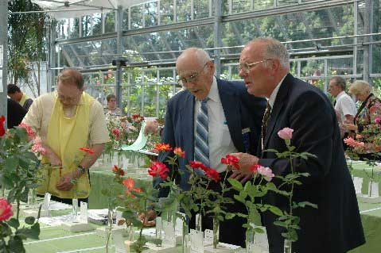
“Persimmon Pleasure? I dunno. Looks like a marigold to me!” Rocco Lapenta and Dick Nipe judging at the Jersey Shore Rose Show.
Next is Conformance. This is worth a possible 15 points. 5 points each for the proper naming of the roses, conformance to design type and other specifics required in the schedule such as size, backboards and bases, and use of certain materials.
The next area I want to explain is Distinction – this is worth 10 points. The Guidelines for Judging Rose Arrangements explains it this way – “A Uniqueness that sets the design apart. A superiority in every respect, which includes the technical execution and construction.”
So far I have talked about where 85 possible points of the arrangement come from in the judging. It is only now that I come to Creativity and Expressiveness worth a possible 15 points.
And each of those two components is worth a possible 7.5 points. You might think, “got ya there”!
Well, not really, A really great arrangement that fills all the other requirements can beat a poor arrangement that “interprets the theme better” any day of the week. It is because you would rarely lose all points for interpretation unless maybe you did a Yellow and Black arrangement for a class that was to be traditional entitled “Baby’s First Birthday”.
continued on next page

As you can see, there is more than just “interpretation” involved in awarding the first place ribbon in a class and, indeed, all the stars and glitter do not make a winning “Fourth of July” and could even be a distraction to the roses which should be featured.
The long and short of it is this: Interpretation is a very small part of the arrangement point scoring. To do well, concentrate on showing off your beautiful roses in a wonderful setting that hints at the class title and I guarantee you will see the blue ribbons follow.
Last but not least, there is usually the option of what is called a comment card, where the exhibitor could even explain away their choice of the Black and Orange birthday class. The child was born on Halloween!
Question:
I am new at shrubs and old garden roses. I have gotten most of my roses at the corner nursery. I understand pretty much what the a hybrid tea and floribunda should look like and the distinction between miniatures and minifloras sort of make sense. But what makes a shrub a shrub and not an OGR and how do you know if it is a modern shrub, old shrub and some of these other classifications. And what are the difference between the shrub, Victorian and Dowager classes?
Answer:
The ARS classification system we use to put roses into classes for shows can seem arcane. The first point to understand is that there are modern classes (floribunda, hybrid tea, etc.) and old garden rose classes (alba, damask, etc.) and one class for species. Lucky for us, there is a definite dividing line.
The modern classes (the modern era of rose breeding, if you will) started in 1867 with the introduction of the first hybrid tea “La France”. There is some debate that La France was the first but, for our discussion, the clear marking of a date is what is important. Any class (other that species) in existence prior to 1867 is an Old Garden Rose class. Thus, the damask, alba, gallica, etc., classes have at least one member rose that has been in commerce or described in literature prior to 1867.
All that is pretty straight forward, but here is the part that can make you a little cross-eyed. There are two ARS certificates awarded at shows for Old Garden Roses: Dowager Queen and Victorian. The Dowager certificate is awarded to a rose from an OGR class and the variety was introduced prior to 1867. The Victorian certificate is awarded to a rose from an OGR class and the variety was introduced in 1867 or later. The reason for this distinction is that the hybridizing of a certain class of roses, say hybrid perpetuals, did not stop abruptly in 1867, but continued on for some time.
The thinking behind granting two awards for OGRs is that the newer varieties (1867 and later) had better breeding, giving the blooms better color, substance, etc. and would therefore always win against the older (pre 1867) varieties. Whether this is true or not is not in the scope of this discussion.
Species may or may not fit into this system within a rose show. The ARS created the Genesis certificate to be awarded at shows that have a species class in the schedule. If there is no species class in the show, the rose competes in the Dowager or Victorian class based on it’s date of “discovery” or when it first appeared in literature.
Now to the shrubs. The 20th Century saw an explosion of complex breeding programs as hybrdizers sought to produce rose bushes that would have distinct places in the landscape. The bloom form and bush type did not lend themselves to be easily placed in one of the existing classes so the catch-all Shrub class was created.
It is very difficult to define what a Shrub rose should look like in bloom and bush form. As with the OGRs, the thinking was that the early types of shrub roses, Hybrid Kordesii, Hybrid Moyesii, Hybrid Musk, and Hybrid Rugosa, the four classifications that make up the “classic” shrubs, may not compete well with the more modern shrubs with their larger blooms and better color (I disagree as to whether the blooms are “better”) and so the Classic Shrub certificate was established. A rose show may have separate classes for classic and modern shrubs or not depending on the society and show committee. If there is no separate class for classic shrubs, then all shrubs are entered in the one shrub class at the show.
An understanding of all this is made easy for you if you consult the ARS Handbook For Selecting Roses. Pages 6 – 11 give a good explanation of the system outlined above. The date of introduction is listed for the more popular OGRs and the symbol ** is used to denote if a rose is eligible for Dowager Queen. And of course, when in doubt, always ask a fellow exhibitor. They are always more than willing to help.

The Rose Vine
Published by the
Penn-Jersey District
of the American
Rose Society
1408 Ponds Edge Rd.
West Chester, PA 19382

