The Rose Vine
July 2007
Volume 41, Issue 2
Penn-Jersey District of the American Rose Society;s quarterly newsletter

The Bug Days of Summer

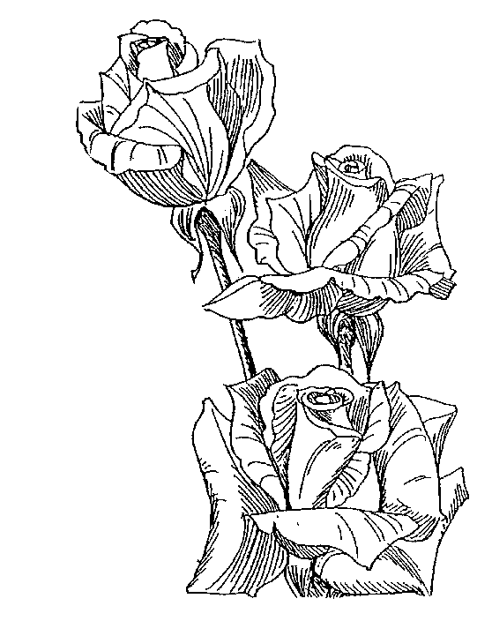
Rusty ‘83

Contents:
Director’s Message 2
A Diamond Celebration 3
Convention Registration 4
ARS Financial Report 5
Visit to Elizabeth Park 7
The Fragrance of Roses 8
Otherwise Normal People 10
Rose Show Results 11

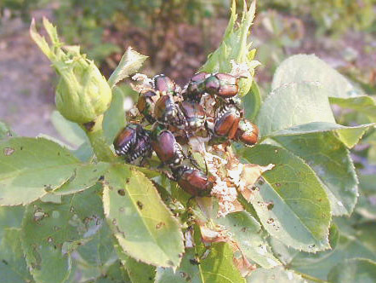

The beetles have met and voted: This year’s favorite rose for beetles (in my garden at least) is Frau Karl Druschki.
I really can’t complain too much about them though, I haven’t had too many on the roses this year. I hope you are not having much of a problem with the little &#$*##’s either.
This issue contains the results of the June shows and I have already marked the calendar with the “days till show” countdown for District. One “silly season” ends and another begins.
I was quite pleased to see quite a few new people exhibiting at our shows and, even better, they were doing well. We all know that we need as many new exhibitors as possible and I hope you took the time to welcome them and help them out.
I got a copy of Otherwise Normal People and read through it the first night. It is thoroughly enjoyable! What struck me was that here was a writer who (at least to my knowledge) had no real background with rose societies and rose shows, she got the point that it’s not the roses, it’s the people! Quotes of “the nicest people” and “fun to be with” and “good people to be around” are found throughout the book. I often think that even if the rose didn’t bring us together, I would still like to hang out with the people at the shows. I know that without the rose, I would probably never know most of you, but through the rose, I have met you and enjoy hanging out at the shows and conventions with you.
I look forward to Harrisburg and seeing all of you again. Did I mention free beer in the hospitality room? As Frank Benardella said to me one time, “the best part of the conventions is sitting around the hospitality room and talking. That’s the best part.” And so it is for me too.
One thing we should all try to do is get more of our newer members to the convention and make them feel welcome. If you see someone you don’t know, introduce yourself and see if they are enjoying themselves. I know we can seem like a closed group at first glance, so we must dispell that and try to be as inclusive as possible. Here’s to a sucessful District. See you there.

Kevin

From the District Director’s Desk

June, as always, was a busy month for rosarians in our area of the county. Many of us managed to participate in four or five rose shows as well as special awards dinners and picnics. I reached an all time personal high of six shows including the ARS National in St. Paul. Now I am paying for all that “fun” with the weediest garden in town. We’ve been lucky here, enough rain to keep extra watering to a minimum, but Canada Thistle and purslane grow even better than roses under these conditions, and they love the fertilizer! My rosarian tip of the month – get your mulch when you have time to put it in place. The piles next to my rose beds are a constant visual reminder of my poor timing.

As most of you know, the American Rose Society has been struggling with money and membership issues for several years. On the Agenda for consideration at the Board of Directors meeting in St. Paul at the end of June were recommendations from the Finance Committee for changes in the ARS magazine publication and in the membership dues structure. Acknowledging the importance of the decisions to be made, nearly all of the ARS Board members were present for this meeting which resulted in a vote to increase membership dues and approval of a change in the publishing schedule for the ARS Magazine. See the report elsewhere in this RoseVine prepared by Bruce Monroe, a member of Penn Jersey, and also the Region 0 Director.

The ARS is again in search of an Executive Director as the position has been vacant since the end of May. The Board authorized the Executive Committee to hire a particular candidate if that was its decision after an additional interview.

Other items of interest from the Convention – if you are ordering from the ARS using a credit card, order on line (cost to the ARS 2.5%) or better yet, pay by check. Orders phoned, faxed, or mailed to the ARS using a credit cost the ARS 4%. Some changes in the guidelines for judging Challenge Classes have been proposed. If you have thoughts on this subject, talk to Bruce Monroe who is a member of the committee studying this. The Board approved an electronic ballot option to be available in the next national election. More information on this will be in future ARS Magazines. Pre-publication orders for Modern Roses 12 are being accepted at a discount price. Check the ARS website for more information.

The Rose Show at St. Paul was small, in part due to weather conditions this Spring and in part due to the modest registration. Attendance at national conventions has been dropping for some years. Many believe this is due primarily to the increasing cost of transportation and hotels. Others feel it is mainly attributable to “too many conventions” – Spring and Fall National and All Miniature National. In any case, it has been a subject for informal and formal discussion. One proposal is to alternate a Spring and Fall Convention each year.

ARS President Steve Jones has asked all Districts whose By Laws were adopted more than ten years ago to conduct a review. I have asked Gus Banks to Chair a Committee to review the Penn Jersey By Laws which were last revised before 1997 and to report to the District Meeting in Harrisburg this September. Please forward any comments or suggestions to Gus.

If any of you have other items for the agenda at the District Meeting, let me know eadler@westtown.org or 610 692-5631.

The information and registration forms for our District Convention are included in this RoseVine. The Greater Harrisburg Rose Society has organized a wonderful event for us – hope to see you there!

ARS President Steve Jones just emailed the Board of Directors to inform us that the Search committee has chosen Jeffrey Ware as the new Executive Director of the ARS. Jeffrey has accepted the offer and will start officially next Monday, July 23.
Link to old annuals
Elaine

A Diamond Celebration

Ron Chronister

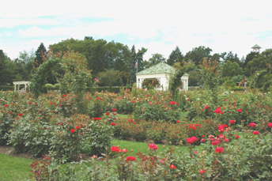
The Greater Harrisburg Rose Society is pleased to host the 2007 Penn-Jersey District Fall Convention and Rose Show. The Convention will be held at the Holiday Inn East on Lindle Road in Harrisburg. The Holiday Inn is just off Route 283 a few miles from the Harrisburg East exit of the Pennsylvania Turnpike.

For those of you who are not familiar with Central Pennsylvania, our area offers many attractions that you may want to visit during and after the Convention. Harrisburg, as Pennsylvania's capitol, boasts one of the most beautiful Capitol Buildings in the country. It is generally open on weekends and provides guided tours for those who plan in advance. In addition, the Whitaker Center in downtown Harrisburg has an excellent IMAX Theatre and other exhibits of interest. And, surprisingly, Harrisburg has a Civil War Museum which has a fairly nice display of historic items.

Nearby Hershey is home to Hershey Gardens, which has an extensive rose garden that should be displaying beautiful fall blooms in September. The rose garden is actually celebrating its 70th birthday this year. For those seeking thrills and excitement, Hersheypark offers a wide array of rides and entertainment. Lancaster County, home of the Amish, is a short drive to the East and Gettysburg is within an hour’s drive as well.

During the Convention there will be several educational and informational presentations that will hopefully enhance your gardening skills and expand your use for roses. Among the esteemed speakers for the Convention are Steve Jones, President of the ARS, Craig George, Director of the Hershey Gardens and David Clemens, hybridizer of several well-known mini-flora roses.

On Friday, September 7, there will be a Judging school for anyone interested in becoming a

Hershey Gardens photo byTom Mayhew

horticultural judge and for current judges who need to audit a school to maintain their credentials. In addition, on Friday afternoon there will also be a slightly irreverent seminar on artistic design of interest to arrangers.

On the afternoon of Saturday, September 8, there will be three seminars. The first is an informative presentation on rose rosette disease by Jim Reddington. Following this presentation David Clemens who will talk about hybridizing roses and the “search for Secretariat”. (Many of you may know that David Clemens has given several of his superb mini-floras names of famous horses.) The culmination of the afternoon sessions will be a discussion about Portland and Hybrid Perpetuals by Steve Jones.

As the title of this article denotes, the theme for the District Convention and Rose Show is Diamond Jubilee in celebration of our society’s 60th anniversary. We hope that you will plan to attend the Convention. There are always beautiful roses on display at a Penn-Jersey District Rose Show and I am sure that the show this year will offer each of us an opportunity to enjoy roses at their finest.

Additional information can be found at:
www.GHRS.Info

THE GREATER HARRISBURG ROSE SOCIETY
HOSTS
THE PENN-JERSEY FALL DISTRICT CONVENTION AND ROSE SHOW
September 6-9, 2007

Name: _____________________________________________
Spouse or Life Partner: _____________________________________________
Address: _____________________________________________
_____________________________________________
(City) (State) (Zip Code)
Telephone ______________________ E-mail_______________________

Do you plan to exhibit? Horticulture Yes____ No____
Artistic Design Yes____ No____

Do you plan to attend the Judging School? Yes____ No____
If a horticultural judge candidate, $10 $_______

Registration - Mandatory Individual $30 $_______
(Before August 24) Spouse/Life Partner $10 $_______

Late Registration – Mandatory Individual $35 $_______
(After August 24) Spouse/Life Partner $15 $_______

No.
Friday Night Awards Dinner _____ Roast Turkey ($32 ea.) $_______
_____ Grilled Salmon ($34 ea.) $_______
No.
Saturday Night Dinner _____ Stuffed Chicken Breast ($33 ea.) $_______
_____ Roast Sirloin ($35 ea.) $_______

Total Amount Enclosed $_______

Make Checks payable to Greater Harrisburg Rose Society
Send Registration & Check to: Judy Carey, 1507 Carlisle Road, Camp Hill, PA (17036)

Hotel Registration

Reserve your hotel room directly with The Harrisburg East Holiday Inn, 4751 Lindle Road, Harrisburg, PA, (17111). Telephone (717) 939-7841

Reserve your room by August 16, 2007. Room rate $95 (Single or double)
For special rate mention the Greater Harrisburg Rose Society
Please indicate nights you plan to stay at hotel: Thurs.___; Fri.____; Sat.____; Sun.____

Report From the Spring American Rose Society Board Meeting
Bruce Monroe
Region 0 Director

The ARS Board met in St. Paul on Friday, June 29, with almost all of the 30 directors in attendance. Prior to the Board meeting the Executive Committee (President, President-Elect, two directors elected by the Board, and the treasurer) authorized the staff to borrow $40,000, increasing Notes Payable to about $130,000, so that current bills could be paid.
The Finance Committee presented the following analysis of ARS operations to the Board. The analysis is based of past financial results, current financial results (2007 through April with a projection for the rest of the year), and projected financial results for future years, assuming no changes were made in the dues structure and that expenses continued to increase as they had in the past.
Year Net Loss
2005 (66,397)
2006 (45,580)
2007 (69,785)
2008 (75,924)
2009 (162,908)
2010 (208,254)
Cash flow (as opposed to net income) was positive in 2005 and 2006 only because of borrowings, an increase in accounts payable, timber sales of about $60,000 in 2006, and a one time contribution of $100,000. These items had been excluded from the analysis.
The Finance Committee then presented a financial analysis of a number of possible changes, including dues increases ranging from $5/yr to $15/yr, continuing to publish 11 issues of the ARS magazine and an annual per year, and changing the ARS magazine to either 5 issues and an annual per year or to 6 issues per year with no annual. The bimonthly magazine was projected to have 80 pages plus a four page cover, as opposed to the current monthly magazine which has 40 pages and a four page cover. Publishing and mailing bimonthly instead of monthly resulted an estimated saving of $52,000 a year in printing and mailing costs. The projected cost savings were obtained from a discussion with the printer. The analysis also took into account such factors as decreasing membership, increasing postal rates and printing costs, and potential loss of advertising revenue because of fewer issues (however, only two advertisers advertise in every issue).
Based on this analysis, the Committee recommended a $12/yr dues increase and going to 6 issues of the magazine per year, with no Annual. The Board then recessed for lunch and had an opportunity to digest the recommendations over lunch.
Following lunch, the Board voted nearly unanimously to raise dues $12/yr. Originally the increase was to be effective July 1, but this was later changed to August 1 due to unforeseen difficulties in implementing the July 1 date. The complete new schedule is:
New Dues Schedule – effective August 1, 2007
Category | 1-year | 2-year | 3-year | Life
Individual | $49 | $95 | $140 | $1,000
Joint | 62 | 117 | 170 | 2,000
Senior (65+) | 46 | 89 | 132 | 500
Senior Joint | 59 | 114 | 169 | 1,000
Canadian | 54 | 102 | 151 | 1,325
Canadian Joint | 67 | 124 | 181 | 2,650
USA/Can. Youth | 10 | 20 | 30 | $1000
Foreign | 59 | 112 | 166 | 1,340
Corporate | 250 | 500 | 750 | N/A

Currently, there are changes to Associate (amount added to an Individual membership to make a Joint Membership), Corporate, Life, and Youth membership dues. However, the Board will most likely consider if any changes should be made to these categories, especially to life memberships, at the fall meeting in St. Louis.
With respect to publications, there was considerable sentiment on the Board to retain the Annual. The Board voted, again nearly unanimously, to amend the recommendation from 6 issues with no annual to 5 issues and an annual. For the rest of 2007, there will be a July issue of the magazine, a combined August/September issue, a combined October/November issue, and an Annual.
I regret that the Board had to take these actions. But based on the continued deteriorating financial condition of the Society, the increasing debt and increasing accounts payable, and the fact that this problem had not been addressed for far too long, the members of the Board felt that we had no choice to take this drastic action now. The ARS had not increased dues for 6 years, despite the fact that cost of living has increased 16% and postage had increased 21% in that period. The dues increase six years ago was the only increase in the last fifteen years, so our dues schedule had not kept up with increasing expenses.
Although these changes are projected to put the ARS on a stable financial position with respect to ongoing operations for the current year and for next year, the $130,000 debt remains. Some, as yet unspecified, fund raising activity will take place to pay it off. In addition, the projection is that the cash flow will likely become negative again in 2009 so periodic, small increases dues may be necessary to keep up with increasing costs.
I want to emphasize that the poor financial position of the Society has not been caused by the American Rose Center, the Garden of the American Rose Society located near Shreveport. The Center is supported by the income from an approximately $5 million endowment fund, whose proceeds are restricted to support of the Gardens. However, the Society benefits because it has rent free use of the buildings on the grounds and also retains all gate admissions and receipts from special events, such as "Christmas in Roseland," a holiday lighting display.
As you may know, the Executive Director of the Society has resigned and there is a search for a new Executive Director. The Search Committee recommended a candidate to the Executive Committee, but the Executive Committee had not interviewed the candidate and was not ready to make a recommendation to the Board. It is possible the position may have been filled by the time you receive this.
In other matters, internet voting will most likely be an option for the next ARS election. This could result in a considerable saving in the cost of elections. Corporations have been carrying out stockholder voting by this method for several years, so the techniques, as well as the techniques for detecting fraud, have been well worked out.
Modern Roses 12 will be out soon. Order your copy now.
Because of the early season and the late spring date, the rose show was small. There were only 9 blue ribbon hybrid tea and grandiflora blooms. There were no entries in the Nickelson Bowl, and few entries in the other large rose challenge classes. Results are on the ARS website.
The ARS Judging Committee has begun a rewrite of the section on Challenge Classes. I have been assigned the job of preparing the initial draft. Comments and suggestions are welcome.
Bruce Monroe
.

Roses In Review
Diane Wilkerson – Penn-Jersey Roses In Review Coordinator
It’s time for Roses in Review. The list of cultivars for 2007 appeared in the June ARS Magazine, but you can get a copy from RIR Coordinator Diane Wilkerson, email hiptownrose2@aol.com or 732-219-0339. Even better, go on line and report http://www.stsrv.com/rir/rirsplsh.htm!

Jersey Shore Rose Society visits Elizabeth Park
Story and Photos by Bill Kozemchak

On Sunday June 24th the Jersey Shore Rose Society took a bus trip to Elizabeth Park in West Hartford, Connecticut. According to the ARS garden guide it is the oldest public rose garden in the US, opening in 1904. It also lists the garden with 15,000 roses and 800 varieties. The trip cost only $10 for anyone who was interested, a real bargain considering the price of gas. Everyone met at the Monmouth mall at 8:30 am and the bus departed for a 3 ¼ hour ride to the garden, definitely the way to travel. Garden photos and rose stories were exchanged on the ride up. There was also plenty of time for rose questions between some of the newer members and the captive veteran rose growers.

Frank Benardella let me preview his copy of Otherwise Normal People Inside the Thorny World of Competitive Rose Gardening, a new book about rose growers and the crazy things they do. The author Aurelia C. Scott is from our good friend Clarence Rhodes’ hometown of Portland, Maine. As he was the “inspiration” for the book, chapter one is dedicated to him. Our other good friend, John Mattia from Connecticut appears in chapter two. Frank told me he is in the chapter on sex (rose breeding).

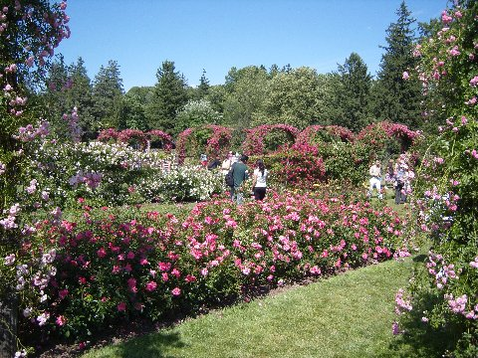

Many other nationally known characters (rosarians) are included throughout the book. Rose history is interspersed in stories about the rosarians, making it a very easy read. You will not get bored with long passages just on the history of the rose. I found this a very interesting way to educate and entertain the reader at same time.

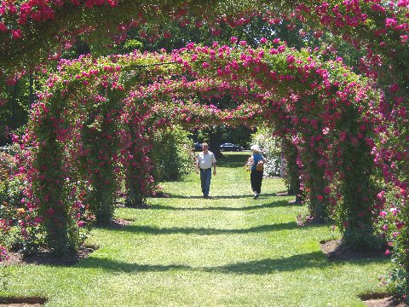

We arrived at Elizabeth Park around noon and headed for the rose garden. The Connecticut Rose Society was also holding their annual rose show that day, but judging was still taking place. We had heard the climbers were in full bloom, but some of the other roses were a bit past their prime. Walking up to the garden we were struck by a wall of color. It was magnificent! The garden is set up with a very large central gazebo with five spokes of arches branching out in different directions. Large ramblers in full bloom covered these arches which were around probably 12 feet high and 18 feet wide. Some of
the spokes had arches of all one color, others had arches alternating between dark pink, light pink and white. The varieties were Excelsa, Dorothy Perkins, and White Dorothy Perkins. Walls of roses in full bloom surrounded the garden and divided the areas between the arch spokes into smaller “rooms”. Although some of the smaller beds may have been a little past, there was still plenty of color in the garden, and some of the beds were in full bloom. I don’t think we could have caught the garden at a better time. Plenty of us had our cameras going non-stop for a while. My guess is some of these photos will turn up in both the Penn-Jersey and ARS photo contest.

(continued on next page)
Elizabeth Park continued from previous page
Tom Mayhew also came, so some may be in the winners’ category. Clarences’ home society, The Maine Rose Society, also came down on a bus that day to visit the garden and show.

The rose show opened around 1:00, so that was our next stop. It was held in the Pond House Café at the Park. Outside the entrance, Clarence had a couple of his potted roses on display. They were beautiful, of course, and hopefully no one wheeled them away. Although most gardens in the area were early, and the show a little smaller than normal, the quality was excellent. They had the same kind of spring we did. There were very high quality entries around the room, and some gorgeous ones on the head table. I found a few roses that I wasn’t familiar with and added them to my wish list. We had time to visit with some old friends who either judged or exhibited in the show, and then headed back to the garden to explore a little more.
The bus left Elizabeth Park at 4:00 and we were back in New Jersey by around 7:15. It was a great trip with perfect weather and good friends. I would like to thank Bill Sehl one more time for arranging one of the best trips I have been on.

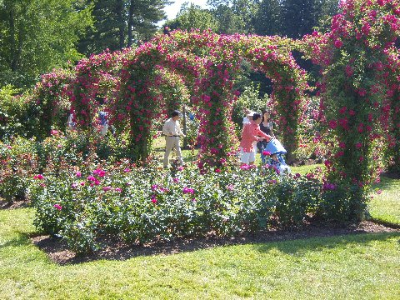

The Fragrance of Roses
by Ralph Stehle

Reprinted from the newsletter of the Pittsburgh Rose Society

(At Ralph Stehle’s instigation I checked issues of all the years that I have been editor of this NEWSLETTER and found that only once did I touch on the topic of fragrance, but it is too lengthy to introduce it into this issue, so here is a shorter treatment. The more lengthy treatment will come later. This treatment rests upon Macaboy’s The Ultimate Rose Book. Ed)
The fragrance of the rose has always been one of the main qualities that has drawn us to the flower. The Persian poet Ha’afiz speaks of his being “lured into the garden by the scent of roses” where he found comfort from the fever of unrequited love; and the Greeks believed that Eros carelessly spilt some of the nectar of the gods on a rose. The flower has retained its sweet perfume ever since.
If he did, he must have been careless with several vintages, for the rose offers not just one perfume but many. Think of the pure soft sweetness of the Damasks and the Centifolias; of the warmer fragrance of the Teas, which does vaguely resemble that of a fresh packet of China tea; of the sharper, more piercing scents of such modern garden roses as ‘Fragrant Cloud’ or ‘Double Delight’. Then there is the intense musk-like fragrance of some of the Ramblers, such as Rosa filipes, R. moschata and R. multiflora. Their scent is exhaled, not by the petals as occurs in other roses, but by the stamens. A note of musk can be detected in the scent of many of their descendants, such as the Hybrid Musk Roses and the cluster-flowered roses like ‘Elizabeth of Glamis’. The scents of roses are as varied as their colors. It is a shame we cannot photograph them!
Unfortunately, there are too many roses Eros seems to have missed, and “They do not smell like they used to!” is one of the commonest remarks when the subject is roses. Even allowing for the elusiveness of scent, which varies with the weather, the time of day, the age of the flower and the sensitivity of one’s nose (smoking notoriously blunts the sense of smell), this does seem to be true. There are relatively few modern garden roses that can give the rich fragrance that is the birthright of the old French roses.
After denying the obvious for many years, hybridists are now actively seeking to improve things, but they are not finding the process easy at all.
For one thing, fragrance appears to be what students of genetics call a “recessive character,” which makes it difficult for a hybridist to plan for. Crossing two fragrant parents is as likely as not to result in a brood of scentless seedlings, and a rose which is itself scentless may yet be able to give the gift to it children and grandchildren. “Charlotte Armstrong,” parent of “Sutter’s Gold,” “Tiffany” and “Mojave,” and the grandmother to “Chrysler Imperial,” “Mister Lincoln,” and “Double Delight” is one such, and “Dr. A. J. Verhage” another. The family trees of fragrant large-flowered roses will often show the names of the same few roses some examples are “Ophelia,” “Crimson Glory,” “Signora,” and, further back, “Lady Mary Fitzwilliam”. Indeed, it was the belief of Wilhelm Kordes that “Lady Mary” was the most potent of all donors of perfume that led to the revival of the almost-extinct old variety.
The business is complicated by the fact that breeders are usually looking for other things as well as perfume. For a new rose to be successful it must score highly for shape, color, vigor, disease resistance and what have you, and not all these desirable characteristics appear to be compatible with rich fragrance. The priceless gift of repeat flowering, for instance, comes from the China rose, which is only mildly fragrant at its best, and many of its early crosses with the old European roses were scarcely fragrant. “Where has the perfume gone?” is a question that has been asked for a while! Tough, long-lasting petals seem less able to release their scent than those more delicate, which is why the cast-iron varieties you find in the florist’s tend to give only vague smell that all growing plants have. The search for new colors has not helped any either. Some think it fortunate that the “Persian Yellow” proved unable to transmit its heavy odor along with it golden color, but, as a rule, there has to be a suffusion of red on the petals of a yellow rose if there is to be scent as well. (“Sutter’s Gold” is an example, “Friesia” is an exception.) The earlier orange-red varieties tended to scentlessness, but there are fragrant ones coming forward – “Dolly Parton” and the duller-toned “Fragrant Cloud” are as strong and sweet as any of the dark reds and rich pinks with which fragrance is traditionally associated.
The best spur towards the restoration of fragrance is for the rose-buying public to insist on it. The hybridists are working on the problem, but when a scentless rose can sell as well as one with fragrance, the temptation to put it on the market will still be there. If only they would resist it!

Insectarian of the Year
PETI (People for the Ethical Treatment of Insects) has announced it’s prestigious Insectarian of the Year award. The citation reads, in part: “It was a mild morning in May and the rose garden had just been sprayed. Donna Smith was walking through the garden and spotted a praying mantis that had gotten doused. Reacting quickly, she plucked the mantis from the bush and ran to the outside tap where she proceeded to wash the mantis off. Spending some time with the mantis, Donna felt that she was going to be OK. At last report, the mantis was still residing in the garden and doing well.”

ARS Annuals On Line
Google has digitized some of the early American Rose Society Annuals and placed them on the web. Years 1916 to 1932 are available. The page is located at: http://books.google.com/books?id=nxACAAAAYAAJ&printsec=frontcover&dq=editions:03P-Lp9_XPIQKRQi0-a9nS
Otherwise Normal People
Inside the Thorny World of Competitive Rose Gardening
by Aurelia C. Scott
Algonquin Books Of Chapel Hill 235 pages $22.95 - $15.61 plus $3.99 shipping at Amazon.com

I knew when I started this book that I wouldn’t be able to discern what was “otherwise” in “otherwise normal people.” You mean having a passion for roses, spending countless hours in the rose garden, getting up at 2 am to haul roses to some mall on the other side of the state, spending several hours on one rose trying to get a petal to move 1/100 of a millimeter to the left, sitting outside the judging area for several hours trying to remember if you removed a cotton ball from your best rose isn’t considered normal? I thought that the book might focus on those bits and miss the larger picture. But the book doesn’t and it is a great tribute to rose people and what makes them tick. And the key here is people. It is a book about people who happen to have a passion for roses.
Aurelia Scott has a great gift for capturing people in words. I enjoyed reading about people I know written by someone I don’t know. Does the author see the same traits in a person that I do? Does the author convey the essence of that person as I see it? The answer is a hearty Yes! She conveys their passion for roses well and is able to get into the deeper reasons for this passion. And, again, most often the deepest reason is people. I would fill up this entire newsletter with quotes from people she interviewed who said things like “Rose people are just…the kindest, most generous, most interesting people” (June Benardella) and “…there aren’t any better people in the world” (John Mattia).
Ms. Scott ably interweaves paragraphs of conversations with rose history and lore. They are not given separate chapters but are commingled so that you are constantly moving among roses and people with no barriers between the two. So, then, these rose nuts are inseparable from there roses? I think you know the answer to that!
The book concentrates on perhaps a dozen people with a timeline that leads to the ARS National Show in California. But the book does not give us just a dozen people.
Many more have one or two quotes that she uses to get her point across effectively. While she makes a few minor (very minor) mistakes as to ribbons and classification of OGRs, these are trivial and should be passed over without thought. The book is not meant to be a strict explanation of the ARS Guidelines, but the people and their roses.
Beneficiaries of the Governor’s new early release program? Some of the characters in the book. The “brain trust” of secondary products checking out their latest prototype for a siphonex-type nozzle! From left: John Mattia, Clarence Rhodes, Frank Benardella. Photo by Tom Mayhew
I am surprised at the nuances that she picked up and emphasizes. The unwritten rule that, if asked by a fellow competitor about what he/she should do to groom a rose, you give an honest answer, is explained well in the book. She also distinguishes well between the “hybrid tea people” and the “OGR people”. One groups says “Look at that center!” The other group says “Smell this!” You figure out which is which.
One person in the book I don’t know but now definitely want to meet is Jeff Stage. He sounds like a lot of fun and his quotes are great. The funniest scene in the book is when he and his wife put a bunch of crystal trophies (not the Waterford!) that he no longer wants out at the end of the driveway for anyone to take. Sitting on his porch, he hollers at a pair of ladies walking along on the sidewalk across the street “You guys want some crystal?” To which they reply “Sorry, sir, we don’t do drugs!”

Get the book and enjoy the people! You will read about some people you know, some you don’t. If you don’t know anyone in the book, you need to come to our convention so you can spend a weekend with thses people.

Kevin

Local Rose Show Results June 2007

West Jersey Rose Society June 2
Queen Veteran's Honor Ken Borrmann
King Dublin Ken Borrmann
Princess Signature Ken Borrmann
Prince Jema Ken Borrmann
Duchess Elizabeth Taylor Tom Mayhew
Mini Queen Kristin Frank Benardella
Mini King Sorop Internat Frank Benardella
Mini Princess Ruby Frank Benardella
MiniFlora Queen Tiffany Lynn Frank Benardella
MiniFlora King Foolish Pleasure Tom Mayhew
MiniFlora Princess Conundrum Glenn & Donna Smith

Philadelphia Rose Society June 3
Queen Cajun Moon Ken Borrmann
King Affirm Ken Borrmann
Princess Signature Ken Borrmann
Prince Mavrik Wayne & Deb Geltz
Duchess Gemini Ken Borrmann
Mini Queen Fairhope Andrew Hearne
Mini King Sorop Internat Wayne & Deb Geltz
Mini Princess Memphis Queen Pat Bilson
Mini Prince Baby Boomer Wayne & Deb Geltz
Mini Duchess Hilde Bill & Kathy Kozemchak
MiniFlora Queen Dr. John Dickman Bill & Kathy Kozemchak
MiniFlora King Tiffany Lynn Pat Bilson
MiniFlora Princess Conundrum Ken Borrmann

Del Chester Rose Society June 9
Queen Let Freedom Ring Ken Borrmann
King Gemin Wayne & Deb Geltz
Princess Cajun Moon Ken Borrmann
4th HT Moonstone Ken Borrmann
5th HT Dublin Ken Borrmann
Mini Queen Sorop Internat Andrew Hearne
Mini King Minnie Pearl Bruce Monroe
Mini Princess X Rated Bruce Monroe
4th Best Mini Irresistible Bill & Kathy Kozemchak
5th Best Mini Sam Trivit Joachim Makosch
MiniFlora Queen Liberty Bell Pat Bilson
MiniFlora King Dr. John Dickman – Andrew Hearne
MiniFlora Princess Conundrum – Ken Borrmann

Garden State Rose Society June 9
Queen Moonstone Mike Mitchell
King Marilyn Monroe Frank Benardella
Mini Queen Irresistible Patricia Patterson
Mini King Kristin Frank Benardella
MiniFlora Queen Solar Flair Frank Benardella
MiniFlora King Conundrum Rocco LaPenta
Mini Flora Princess Leading Lady Frank Benardella

South Penn Area Rose Society June9 & 10
Queen Gemini Dale & Elaine Martin
King Dublin Cleone & Howard Hawkesworth
Princess Gold Medal Cleone & Howard Hawkesworth
Prince Red Lion Dale & Elaine Martin
Mini Queen Dr. John Dickman Pat & Don Lawrence
Mini King Fairhope Kim & John Spittler
Mini Princerss Surfside Pat & Don Lawrence
Mini Prince Miss Flippins Dale & Elaine Martin

Reading Rose Society June 10
Queen Let Freedom Ring Ken Borrmann
King Cajun Moon Ken Borrmann
Princess Dublin Ken Borrmann
Mini Queen Autumn Splendor Glenn and Donna Smith
Mini King Breath of Spring Curtis Aumiller
Mini Princess Child’s Play Curtis Aumiller

Pittsburgh Rose Society June 16
Queen Moonstone Dick & Evelyn Oberlander
King Uncle Joe Larry Grundler
Princess Dublin Dick & Evelyn Oberlander
Prince Crystalline Dick & Evelyn Oberlander
Mini Queen Hilde John Consigliero
Mini King Glowing Amber Dolores Howley
Mini Princess Soroptimist International Georgie Papale
Mini Prince Pierrine Dorothy Zenkevich

York Rose Society June 16
Queen Moonstone Glenn & Donna Smith
King Tineke Don & Laura Wade
Princess Folklore Don & Laura Wade
MiniFlora Queen Solar Flair David & Judy Yingling
MiniFlora King Luscious Lucy Don & Laura Wade
MiniFlora Princess Memphis King Glenn & Donna Smith
Mini Queen Sandy Lundberg Don & Laura Wade
Mini King FairHope David & Judy Yingling
Mini Princess Little Flame Joe Makosch

The Rose Vine
Published by the
Penn-Jersey Distirct
of the American
Rose Society
1408 Ponds Edge Rd.
West Chester, PA 19382

