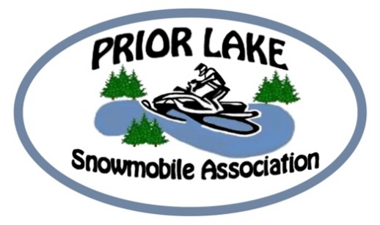

50th Anniversary

Meet a Member:
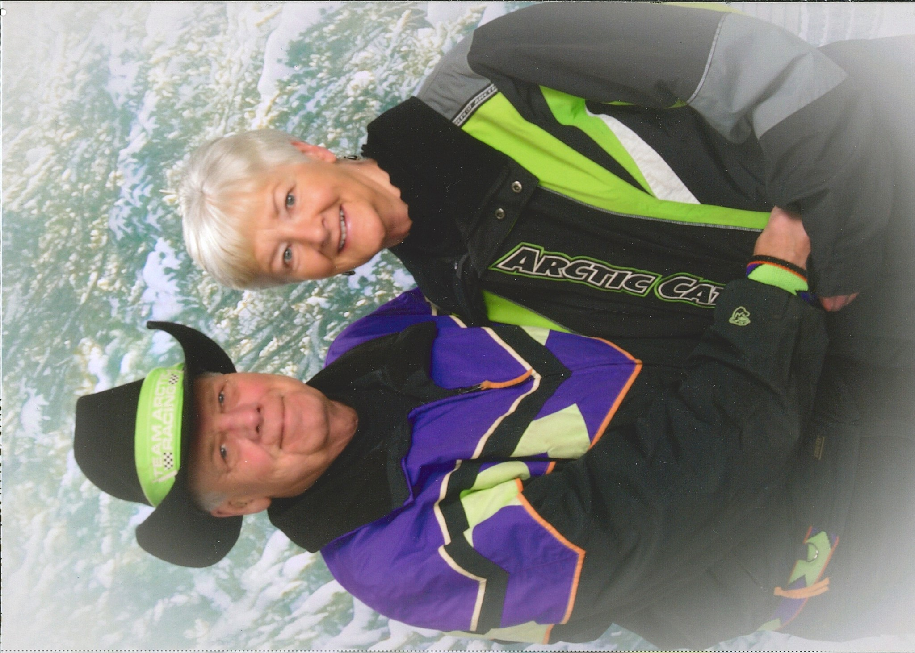
Richard “Jake” and Annette Jacobson.
A wonderful couple that starting riding in 1969 and always faithful to the Arctic Cat family. His father sold Arctic Cat for a number of years but Jake figures he has owned 22 different sleds in the 49 years of snowmobiling. Over those years he did find his favorite sled, a 700 mountain Cat, also known as a Wildcat. He, however freely admitted that with an Arctic Cat Snowmobile that you NEVER have a least favorite.
Many people have found the places they love to ride, Jake and Annette are no different. His favorite place was Dubois Wyoming, however Wind River Range, Douglas and Bayfield County in Wisconsin are also on his list of top places to ride as well as the Black Hills of South Dakota.
Jake and Annette joined PLSA in 1978. His neighbor was a member and asked him to join. Just to throw in more information he stated his neighbor sold and rode Arctic Cats as well. Yes Jake you love your Arctic Cat brand.
Favorite memories of the club. I have known Jake and Annette for 20 years and with the exception of 2020, they loved coming to the Christmas parties, attending club trips and just enjoying the company of other members.

What’s coming up for Club activities!
November 10th is our next meeting and our membership drive. Come to the meeting and invite your neighbors or friends that own snowmobiles. We will provide a short orientation of who the PLSA is and what we do. Then meet the other members and find out how to become involved with the club and keep snowmobiling going in our county. Appetizers will be served and items from the past 50 years will be on hand to look at. Prior Lake VFW Basement 7:00 p.m
Christmas Celebration
Our Christmas Party is back. Mark it on your calendars for Saturday December 4th in the basement of the Prior Lake VFW. This year it will be chicken, ribs, potatoes, corn and a dessert. Cost is $10/person and club will pick up the extra cost and tip.
Gift exchange: Always a lot of fun. If you wish to participate, bring a gift for a guy, gal or either. Gift should be around $20. The fun starts after dinner and here is how it works. Those that bring a gift will be given a ticket. When your number is drawn you go to the table and grab one of the gifts and open it up in front of the group, but if others have opened gifts up prior to you, you can steal their gift and then that person needs to go back and select a new gift. A gift can only be stolen two times and then it is done and can no longer be taken. When all gifts are selected from the table the game is done. Lots of fun and a great tradition!

Club Trips
Looking at a number of trips this year! The first one is at Virginia MN. Accommodations are at the Pine Inn for January 13th through the 16th. Cancellation is 48 hours prior to arrival. Do not wait as the rooms will go fast. 866-263-0535. This is one of the most popular rides and the trails are always great. Never been on a club ride or group ride? This is one not to miss and veteran members will help guide you along the way.
We are also looking for a Wisconsin ride and perhaps a Grand Rapids ride however details are still coming.
Trails
December 1st is the official opening of the snowmobile trails and the trails need some volunteers to put in the signs. If you are interested in helping, email priorlakesnow@gmail.com and someone will get back to you with trail boss information and when trails in certain areas will be put in. Also watch our Facebook page or our webpage www.priorlakesnow.com for updates.

See you on November 10th Prior Lake VFW 7:00 p.m.

