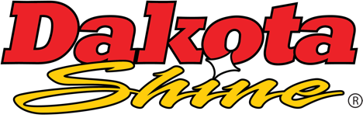  Part #31101  REFERENCE GUIDE  V2.43 |  | 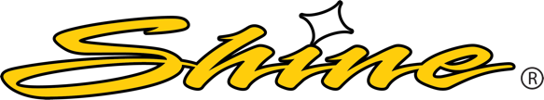  IT TODAY,  PUT IT TO WORK TOMORROW!
SMALL INDUSTRIAL  KIT (w/ hardener)  CONTENTS  (1) 1 Gallon Dakota Prep  (1) 1 Gallon Dakota Shine  (1) 8 fl oz Catalyst Hardener  (4) Disposable Measuring Cups  (1) Stir Stick  (6) Scrub Pads (heavy duty)  EQUIPMENT NEEDED  - Paint Gun  - 1.4mm Tip  - Conventional, Gravity Feed recommended  - Regulator  - Set to ~60 psi  - Water/Oil Trap  - Air Hose  - Solvent (for cleanup)  - OEM Exact Match Paint  - Optional Paint Touch-Up  - Respirator & Gloves (recommended)  - Clean Towel  - Rags  - Wash Bucket  - Water Hose  - Pressure Washer  NEED ACCESS TO  - Wash Bay  - Water Hose  - Pressure Washer  - Air Compressor  - Well-ventilated area for application, if available
  STEP 1 | CLEAN & DEGREASE
  STEP 2 | DAKOTA PREP | Similar to the process of wet sanding by hand to lift and break up oxidation
  Mix ~ 8oz Dakota Prep with ~ 1gal water and soak the scrub pads in the bucket
  Scrub the oxidized surface with a wet, saturated pad and Dakota Prep from the bucket, avoid excessive pressure, rinse often (similar to wet sanding by hand)
  Focus on areas with greatest eye appeal, including wheels, hoods, panels
  Keep pad wet and rinse in the bucket of Dakota Prep often to avoid scratching
  If Dakota Prep dries on the surface, repeat this step on that area
  Rinse the entire unit with fresh water and allow to dry completely
  STEP 3 | DAKOTA SHINE | Fix Faded Paint
  If necessary, areas of missing paint can be touched up at this point – Use only OEM Exact Match Paint and feather out the coverage (optional)
  Prepare equipment as directed ← then add the equivalent of 2oz Catalyst Hardener to 1qt Dakota Shine and mix before transferring to paint gun cup
  Apply one thin layer of Dakota Shine using an even spray pattern – Split tracks on every pass and keep the paint gun perpendicular to the surface
  MORE IS NOT BETTER – focus on thin, light and uniform passes
  Do not coat the surface as you would with paint
  Use cardboard or mask to prevent unwanted overspray
  Overspray on glass can be cleaned with solvent – avoid spraying plexiglass
  Results should be seen almost immediately
  There is about a 20-minute window to correct any mistakes once started
  If a spot was missed, feather out any overlap in one thin, light uniform pass
  Beyond 20-minutes, spot fixes will not blend
  Once finished, let unit sit for as long as possible, keep away from rain and dust
  Drying and recommended exposure times listed below
  STEP 4 | CLEANUP
  Add 1 - 2oz of Solvent to the spray gun cup and swirl
  While still connected to air, trigger the gun in a safe direction to clear tip
  Any overspray on glass can be wiped with Solvent and a Rag
We suggest allowing a minimum of  - 1 to 4 hours until the surface is dry (avoid dust)  - 2 hours before exposure to harsh outside elements  - 12 hours before exposure to a work environment  - 1 week before exposure to aggressive cleaning  - 4+ weeks before reapplying Dakota Shine |  | 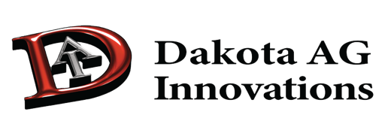  For more in depth instructions and additional tips, scan below    Support@DakotaShine.com  www.DakotaShine.com  Help Line: 888-996-7801

