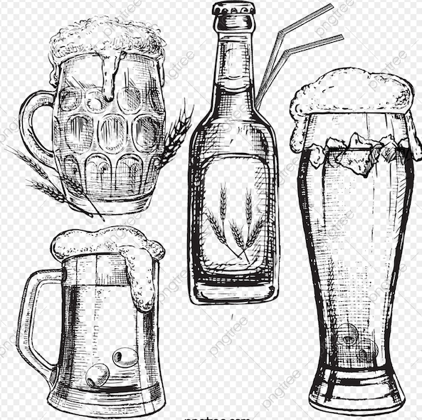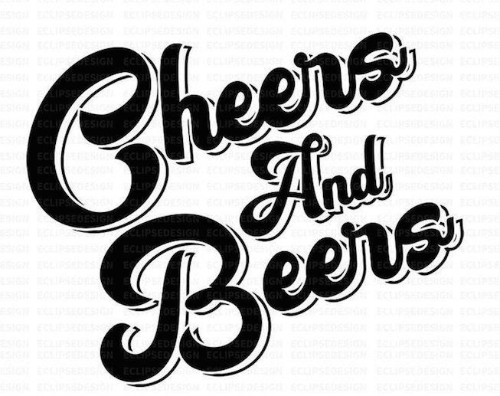

* Budweiser
* Miller Light
* Blue Moon
* Bud Light

**Draft: (10oz, 16oz, 22oz)**

* Bells 2 Hearted
* Sam Adams (Seasonal)

**Wine:**

* Franzia (Merlot, Chardonnay, White Zin)
* Woodbridge (PinoGrigio)

**Cans:**

* Bud Light
* Budweiser
* All Day IPA

**Seltzers:**

* Truly (Strawberry Lemonade)
* White Claw (Raspberry, Lime, Mango, Black Cherry, Grapefruit)

**24oz Cans:**

* Coors Light
* Bud Light

**Non-Alcoholic:**

* O’Doul’s
* Heineken 0.0
* Labatt Blue

**Ciders:**

* Angry Orchard
* Redd’s Apple Ale
* Blue Moon
* Strohs
* Bells (Seasonal)
* Mikes Hard Lemonade (Cranberry Lemonade, Lemonade, Black Cherry Lemonade
* Smirnoff Ice Triple Black
* Modelo
* Leinenkugals Berry Weiss
* Heineken
* Heineken Light
* Two Hearted
* Dark Horse
* Fat Tire
* Rolling Rock
* Sam Adams (Boston Lager)
* Molson
* Guinness
* Coors Light
* PBR
* Labatt
* Labatt Light
* Corona
* Corona Light
* Busch Light

**Bottles:**

* Miller Light
* Bud Light
* Budweiser
* Bud Light Lime
* Michelob Ultra
* Michelob Light
* Michelob Amberbock

**Whitmore Lanes & Lounge**