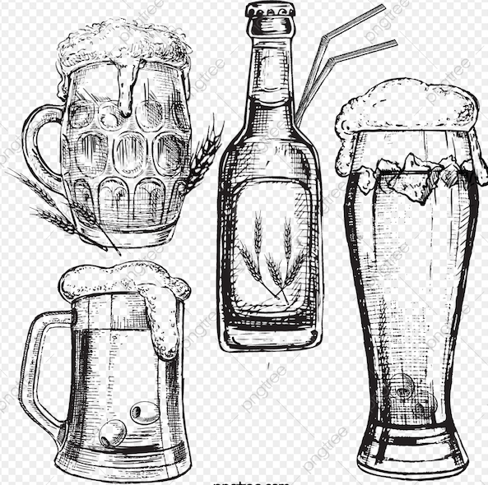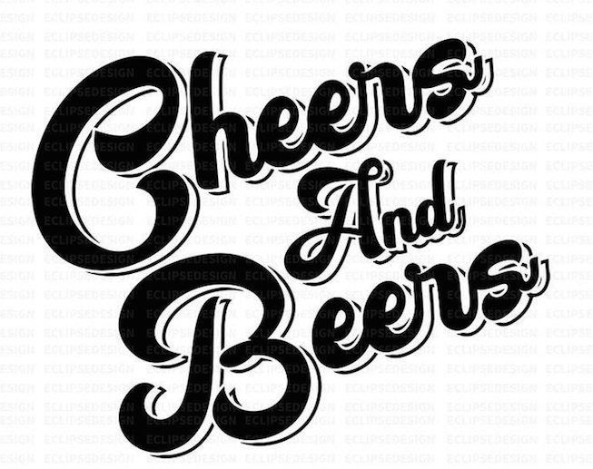

**Seltzers:**

* Truly (Strawberry Lemonade)
* White Claw (Raspberry, Lime, Mango, Black Cherry, Grapefruit)
* Truly Vodka (Cherry & Lime, Blackberry & Lemon, Peach & Tangerine, Pineapple & Cranberry)
* NUTRL (Raspberry, Pineapple, Mango, Watermelon)

**Draft: (10oz, 16oz, 22oz)**

* Bells 2 Hearted
* Sam Adams (Seasonal)
* Blue Moon
* Bud Light
* Labatt
* Miller Lite

**Wine:**

* Merlot
* Chardonnay
* White Zin
* Pino Grigio

**Cans:**

* Bud Light
* Budweiser
* All Day IPA
* Crooked Tree Raspberry Ale
* Crooked Tree IPA

**Ciders:**

* Angry Orchard
* Redd’s Apple Ale
* Triple Jam

**24oz Cans:**

* Coors Light
* Bud Light

**Non-Alcoholic:**

* O’Doul’s
* Heineken 0.0
* Labatt Blue
* Two Hearted
* Dark Horse
* Fat Tire
* Rolling Rock
* Sam Adams (Boston Lager)
* Molson
* Guinness
* Coors Light
* PBR
* Labatt
* Labatt Light
* Corona
* Corona Light
* Corona Premier
* Blue Moon
* Strohs
* Bells (Seasonal)
* Mikes Hard Lemonade
* Busch Light

**Bottles:**

* Miller Light
* Miller High Life
* Bud Light
* Budweiser
* Michelob Ultra
* Michelob Amberbock
* Modelo
* Leinenkugals Berry Weiss
* Heineken
* Heineken Light

**Whitmore Lanes & Lounge**