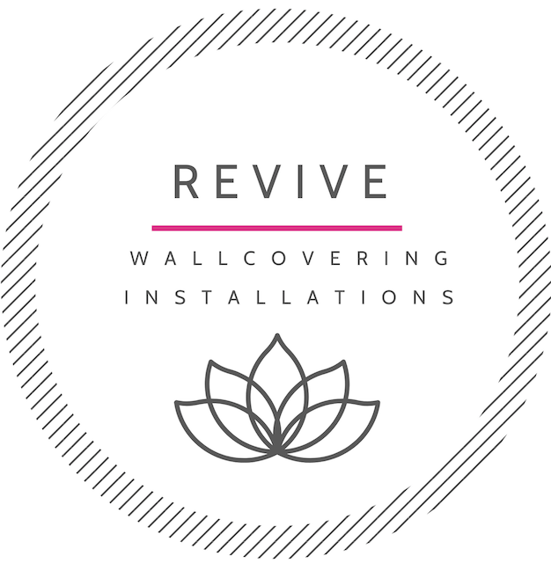

Thank you for your wallcovering installation inquiry!  I look forward to providing a complimentary quote to you for the installation of your wallcoverings!

Below you will find my client information form for you to complete.  Please fill this out with as much detail as possible and attach photos of your walls/spaces.

**I do require this form to be fully completed to provide you with your quote.**

When you receive your quote it will include an accurate estimated amount of wallcovering that will be needed to be ordered.  If by chance you have purchased your wallcovering already, please provide the amount of wallcoverings you’ve purchased, I will confirm you have the correct amount.  If you haven’t purchased just yet, no worries you will soon know how much is required!

I look forward to hearing back from you and providing a quote!

Kindly,

Diana

To see REVIVE!s portfolio of installations please click this link: https://www.picuki.com/profile/revive_wallcovering_vancouver

Follow @Revive_Wallcovering_Vancouver to see our latest installations

***COVID-19: Due to the recent COVID-19 outbreak, I take this very seriously and have put into place additional safety measures to ensure my safety along with my clients safety. I am personally being extremely cautious following the social distancing and self isolation practices, I am committed to limiting my exposure as much as I can. I personally sanitize my equipment including sanitizing the drop cloths I use prior to starting each new project. I simply ask that there will be no other contractors on-site while I am working on this project & I will have the room to myself as I am working. It is a risk to still be doing business at this time but I feel if these practices are followed and respected on both-ends I can continue to work safely. I appreciate your co-operation!***

Revive Wallcovering Installation ~ Client Information Form

**\* Name**:

**\* Contact phone number**:

**\* Address:**

**\* Approx.** when are you looking to have this project completed by:

**Exact** Length & Width of **each wall receiving the wallcovering** (measured in inches) Please specify if there is a windows/doors etc. and include a photo of the molding around the doors and windows if applicable**.**

**Room 1: Type Of Room:**

* **Wall #1**:     " H  x     “ W

* **Wall #2**:     “ H  x     “ W

* **Wall #3**:     " H  x     “ W

* **Wall #4**:     “ H  x     “ W

**\*Wallpaper Specs Selected For This Room/Wall:** If you've purchased the wallcovering please provide the amount of Wallcoverings purchased:

**\* Photos of each wall space:** (Attach photos of wall space to be covered via email or text please) -

**Room 2: Type Of Room:**

* **Wall #1**:     " H  x     “ W

* **Wall #2**:     “ H  x     “ W

* **Wall #3**:     " H  x     “ W

* **Wall #4**:     “ H  x     “ W

**\*Wallpaper Specs Selected For This Room/Wall:** If you've purchased the wallcovering please provide the amount of Wallcoverings purchased:

* **Photos of each wall space:** (Attach photos of wall space to be covered via email or text please) -

**Room 3: Type Of Room:**

* **Wall #1**:     " H  x     “ W

* **Wall #2**:     “ H  x     “ W

* **Wall #3**:     " H  x     “ W

* **Wall #4**:     “ H  x     “ W

**\*Wallpaper Specs Selected For This Room/Wall:** If you've purchased the wallcovering please provide the amount of Wallcoverings purchased:

**\* Photos of each wall space:** (Attach photos of wall space to be covered via email or text please)