* 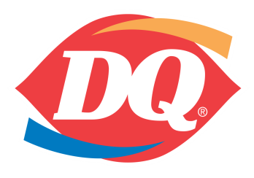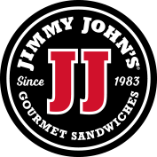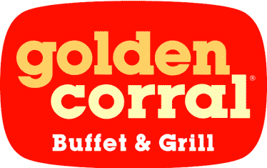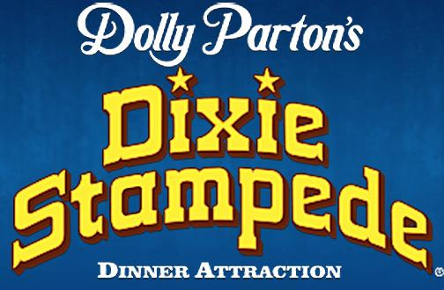

***Meals, Lodging and Fun***

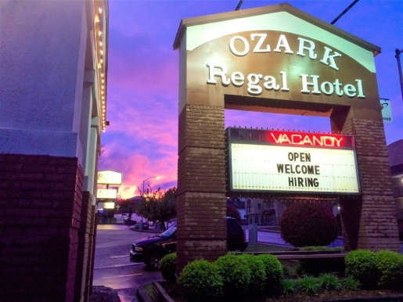Imi

* Go to www.lickingcamps.com to register on line. There will be no paper registration available.
* Select your options. It is simple and fast.
* You will receive a confirmation e-mail.

**Choose One or All Three**

**1. 6 Meals:** **$62** 2 Hot Hotel Breakfasts, Dixie Stampede, Golden Corral Adult Buffet, Dairy Queen, Jimmy Johns-All Include a Drink

**The meal option includes the Dixie Stampede Dinner and Show (an $86 value)**

**2. Dixie Stampede Dinner and Show** **Only:** **$39 (a $50 value!!)**

**3. Motel Rates (per night):**

* **Best Western West Pointe $79**
* **Barrington Hotel $75**
* **Quality Inn $65**
* **Branson Ozark Regal $55**
* **Windmill Inn $45**

***2018 Branson***