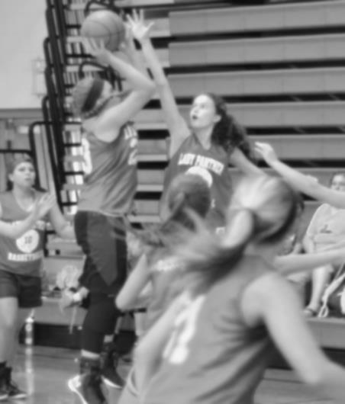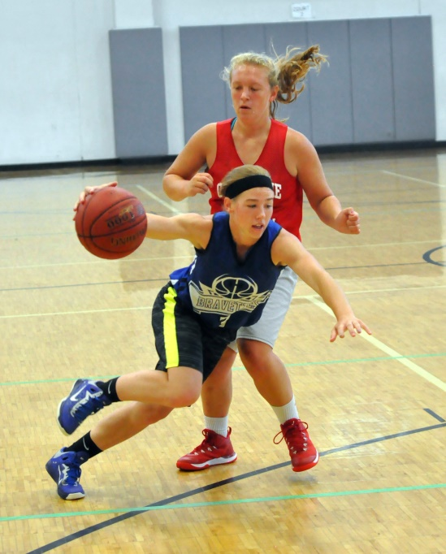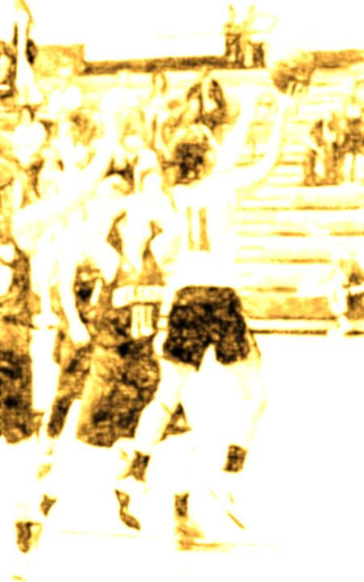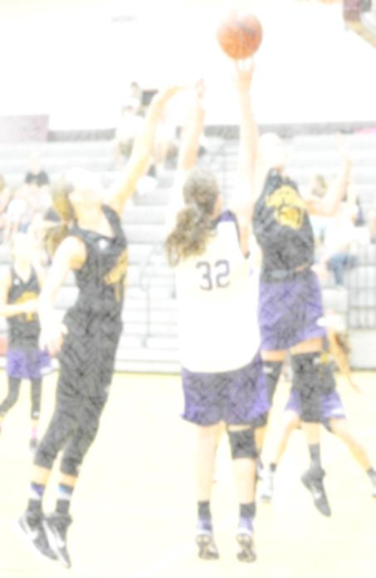

2017 State Champions

**Mercer, MO**

**Incarnate Word Academy, MO**

**Mercer, MO**

**Oran, MO**

**Adrian, MO**

**Strafford, MO**

**St. Pius**

**Incarnate Word Academy, MO**

**Dale, OK**

**Pella, IA**

**Iowa City, IA**

**Mendon-Unity, IL**

**Hardin-Calhoun, IL**

**Camp Point Central, IL**

**Edwardsville, IL**

**STATE FINAL FOUR**

**PAST STATE CHAMPS**

**2015 State Champions**

**Incarnate Word, MO**

**Park Hills Central, MO**

**Sequoya, OK**

**2016 State Champions**

**Hardin-Calhoun, IL**

**Mound City, MO**

**Strafford, MO**

**2013 State Champions**

**Crane, MO**

**Incarnate Word Ac., MO**

**St. Charles Lutheran, MO**

**Walnut Grove, MO**

**2014 State Champions**

**Crane, MO**

**El Dorado Springs, MO**

**Incarnate Word, MO**

www.lickingcamps.com

**2012 State Champions**

**Eminence, MO**

**Republic, MO**

**Harrisburg, MO**

**Mount Vernon, MO**

**Missouri –** District Champs

Scott County Central

Delta

Mercer

Puxico

Oran

Neelyville

Gainesville

Adrian

New Haven

Saxony Lutheran

Central Park Hills

Boonville

Cardinal Ritter

Southern Boone County

Licking

Strafford

**Illinois -** Sectional Champs

Mendon Unity

Camp Point Central

Edwardsville

Hardin

Breese Mater Dei

Civic Memorial

**Arkansas –** State Qualifiers

Marmaduke

Quitman

Valley View

**Kansas -** State Qualifier

Pittsburg-St. Mary’s-Coglan

**Iowa –** State Qualifiers

Iowa City

Pella

**Oklahoma –** Area Qualifiers

Coyle

Davenport

Elk City

Heavener

Kiefer

Sequoyah

**Sectional/District/Regional Champs/State Qualifiers**

The Road To State Passes Through Licking Summer Camps

2017 HONOR ROLL