Licking Summer Camp
Est. 1993
Volleyball Quincy, IL
June 14-15, 2018

Bracket Results
Hannibal over Payson-Seymour , IL 25-14, 25-16
Macomb, IL JV over Payson, IL JV 25-11, 25-10
M S&T All Camp Team
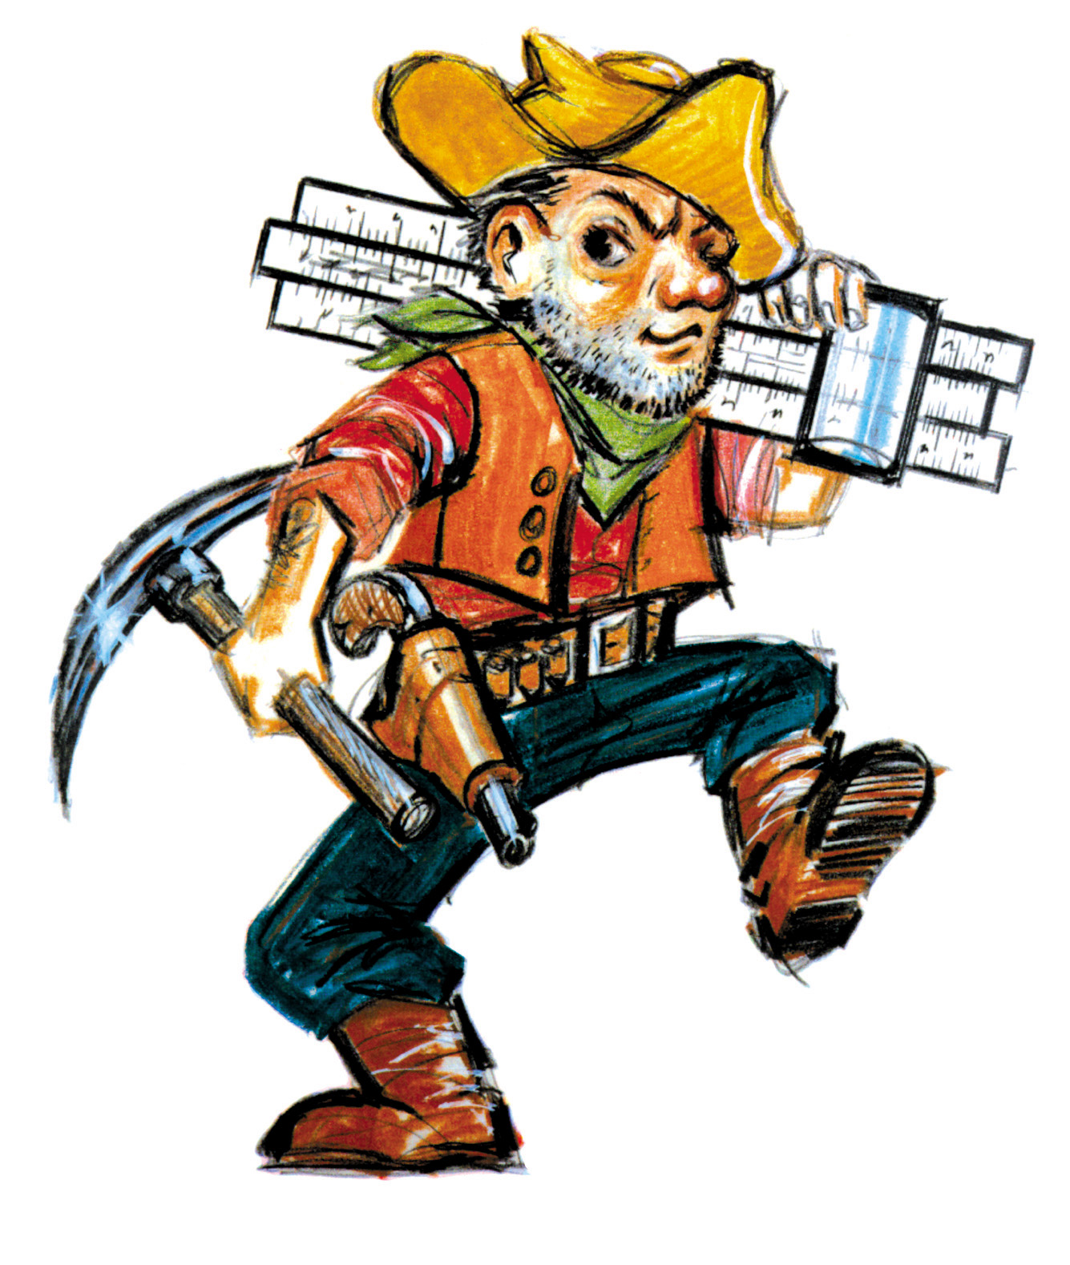

Haley Ballinger (MVP) Hannibal Sr.
Cassie Eidson Payson-Seymour, IL Sr.
Eylse Johnson Kirksville Sr.
Kaylee Falconer Hannibal Jr.
Riley Epperson Payson-Seymour, IL Sr.
JoJo Nichting Kirksville Sr.
Mackenzie Klingele Quincy, IL Sr.
Taylor Keck Quincy Notre Dame, IL Jr.
Paige Knuffman Liberty Jr.
Maggie Vallillo Macomb Jr.
Eanna DeGuzman Quincy, IL Sr.
Lily Buchannan Macomb, IL Soph.
Sydney Hummert Quincy Notre Dame, IL Jr.

