Licking Summer Camp
Est. 1993

Girls Basketball Rolla MO
June 14-16, 2018
M S&T All Camp Team
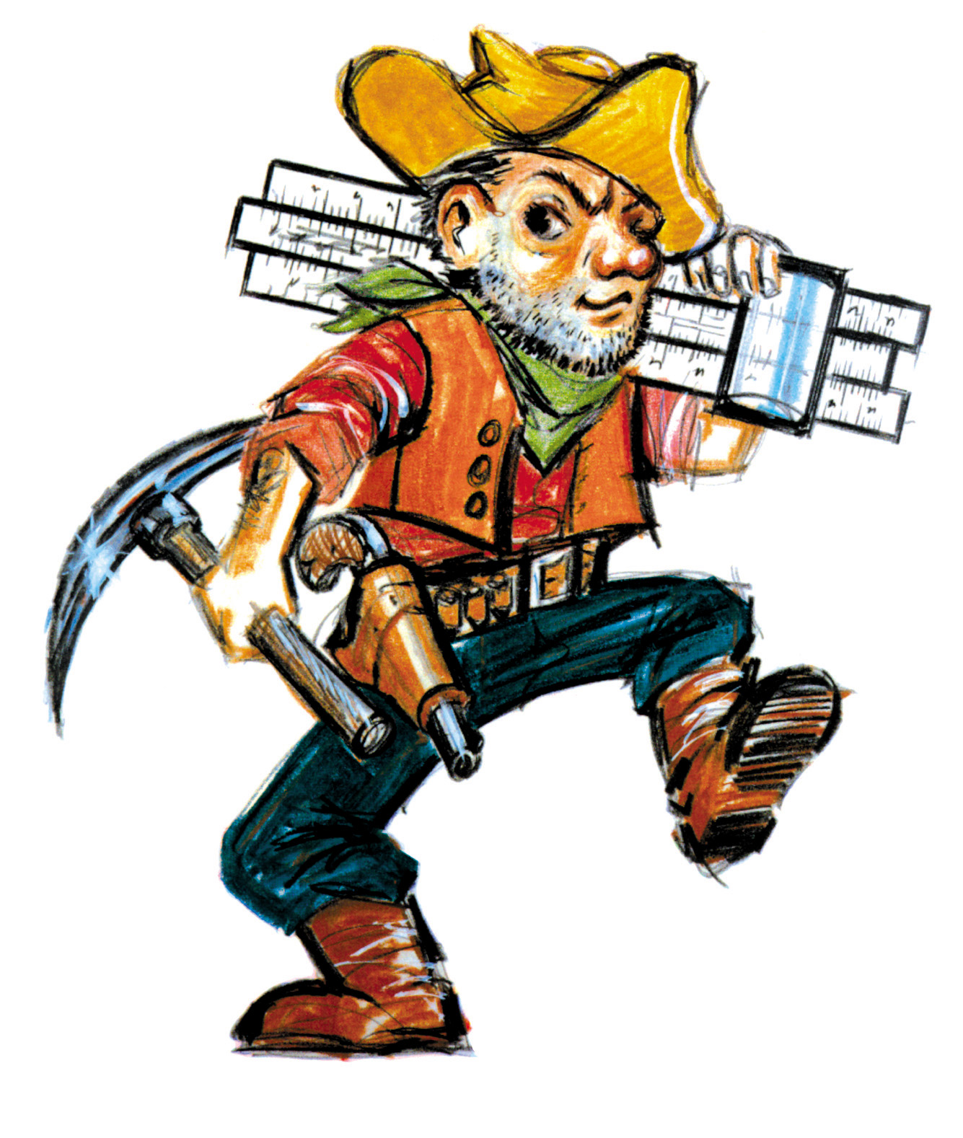

Bracket Results
Fair Grove 50 Moline, IL 38
St. James 51 Wentzville Holt 34
Brownstown-St. Elmo, IL 55 Fayette Academy, TN 37
Wellington-Napoleon 41 Battiest, OK 40
Moline JV 59 Rock Bridge JV
St. James JH 55 John Burroughs JH 39

Bailey Wells (Co-MVP) St James Soph
Alana Findley (Co-MVP) Fair Grove Sr
Jamie Hopkins Orchard Farm Sr
Ashlyn Wightman Gibault, IL Jr
Madi Peden Paxton, IL Sr
Jaliyah Green Wentzville Soph
Harley Maxwell Fair Grove Sr
Emily Hunt Fayette Academy Sr
Faith Bland Metro Jr
Amoni White Jennings Sr
Alyssa Hardaway Battiest, OK Sr
Claire Wilhour BSE, IL Jr
Sybell Howison Maynard, AR Sr
Breanna Diestelkamp Owensville Sr
Kenlee Nuss Forsyth Jr
Carleigh Jenkins Wellington Sr
Cristan Velsquez Sarcoxie Jr
Colby Crabtree Lexington Sr
Karley Henry Seymour Soph
Nancy Fritzscne Greenville, IL Sr
Riley Lock Sullivan Jr
Mikaela Donnely St James Jr

