**Licking Summer Camp**

*Est. 1993*

*Girls Basketball Branson, MO*

*June 20-22, 2018*

***Bracket Results***

Muldrow, OK 50 Praque, OK 45

Park Hills Central 56 Waukomis, OK 36

Thayer 52 Salisbury 20

Blue Eye 32 Poteau, OK 28

Davenport, OK 52 Leeton 25

Brashear 43 Balco, OK 42

Licking JV 44 Muldrow, OK JV 41

Monroe City JV 36 Pickneyville, IL JV 32

Green CountyTech, AR Fr 54 Crane JH 30

M S&T All Camp Team

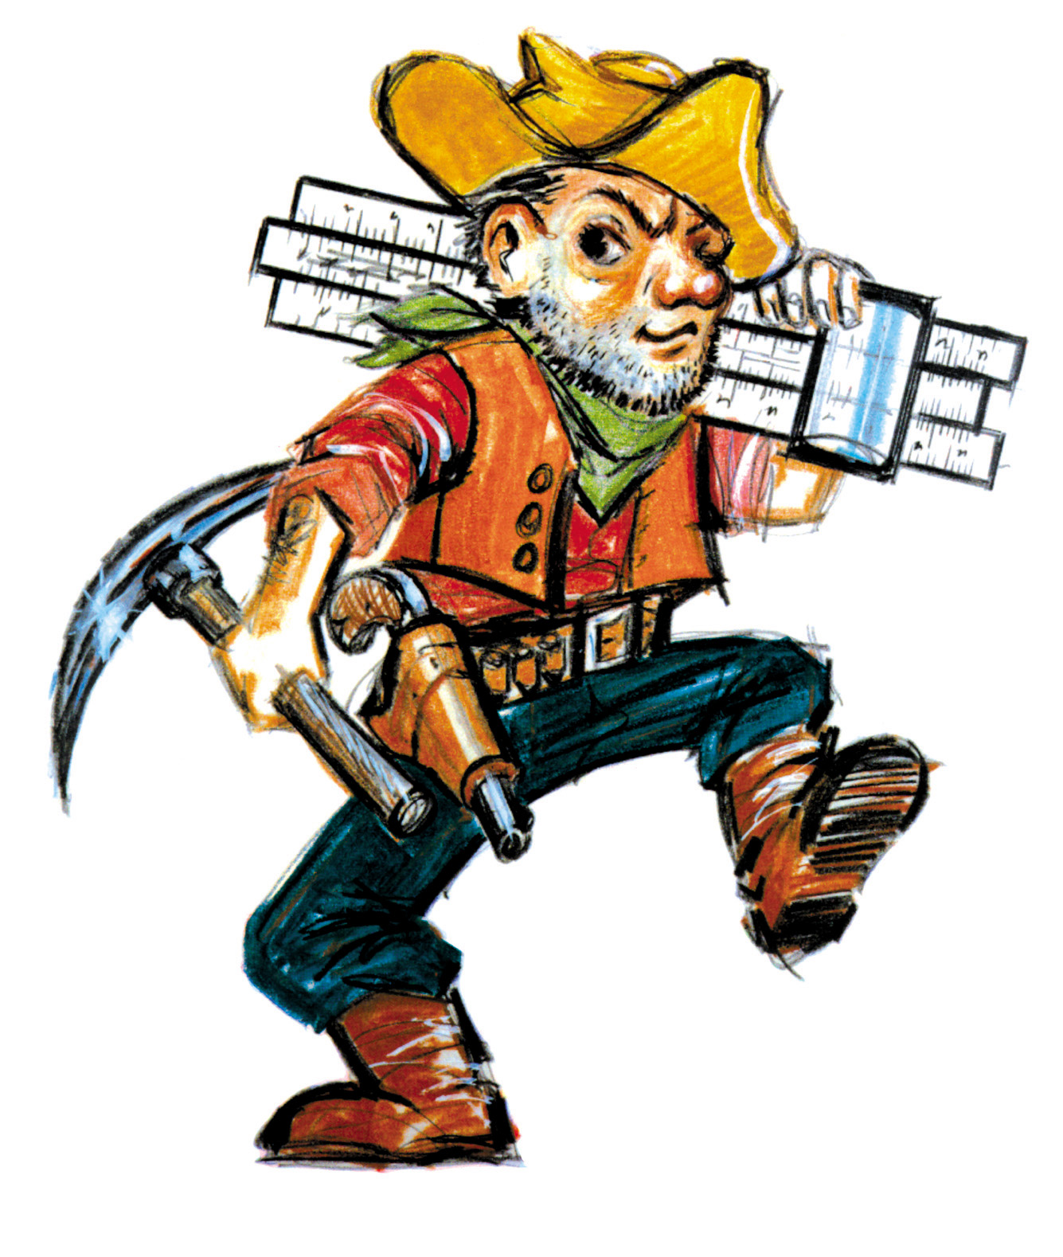

Hannah Boyett (MVP) Muldrow, OK Sr

Julie Stone (Co-MVP) Thayer Sr.

Sophia Horton (Co-MVP) Park Hills Central Sr

Sarah Hale Hillcrest Sr

Kohnnar Patton Blue Eye Jr

Allison Stiers Hermann Sr

Lexi Wood Poteau, OK Jr

Kelsie Orr Alton Sr

Cathy Farmer St Mary’s- Colgan, KS Sr

Taylor Arnold Blue Eye Sr

Karlee Holland Licking Jr

Taylor Cardwell Balko, AR Soph

Chantae Embry Prague, OK Soph

Taite Stites Sallisaw, OK Jr

Jaden Stell Houston Soph

Miranda Givens Broken Arrow, OK Sr

Jaden Summers Monroe City Sr

Faith Sullivan Naylor Jr

Bailey Rissmiller Blair Oaks Soph

Cassie Carlo Gainesville Sr

Taylor Cordwell Balko, OK Soph

Blake Scholl Jamestown Sr

Ashley Myers Commerce, OK Soph

Kendrick Bailey Hollister Soph

Maddie Harelson Davenport, OK Sr