Licking Summer Camp
Est. 1993
Boys Basketball Mexico, Mo
June 28-29, 2018
Bracket Results
Linwood, KS 53, Spokane 29
Southern Boone JV 41 Mexico JV 39

M S&T All Camp Team
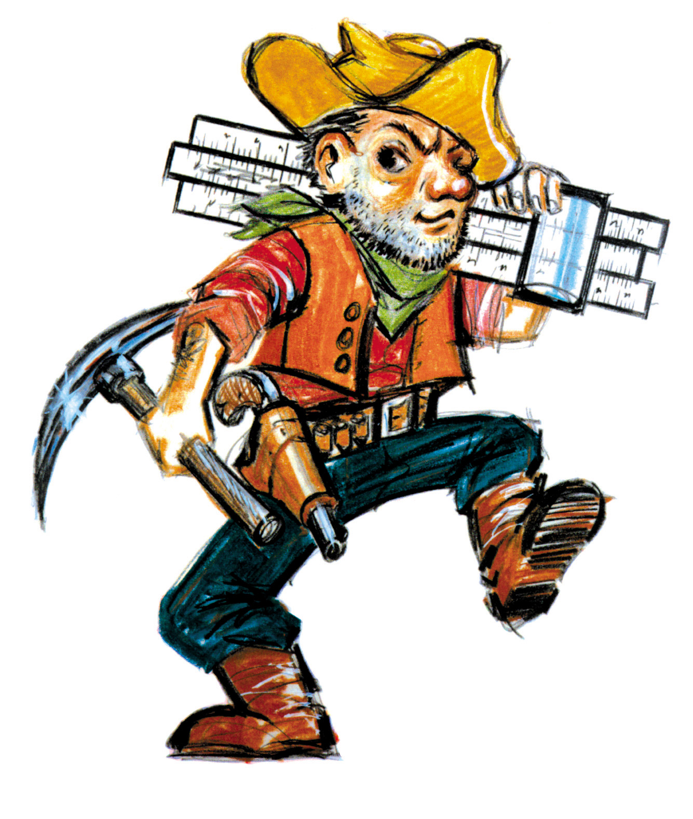

Jacob Coleman (MVP) Linwood, KS Sr
Jackson Bray Spokane Soph
Isaiah Reams Mexico Fr
Nolan Ford Linwood, KS Sr
Garret Housman Brashear Soph
Dawson Wright North Callaway Sr

