**Licking Summer Camp**

*Est. 1993*

*Girls Basketball Mexico, Mo*

*June 28-29, 2018*

***Bracket Results***

***Southern Boone 51, Centralia 49***

***Fatima JV 45, Monroe City JV 37***

***Montgomery Co JH 48, Southern Boone JH 22***

M S&T All Camp Team

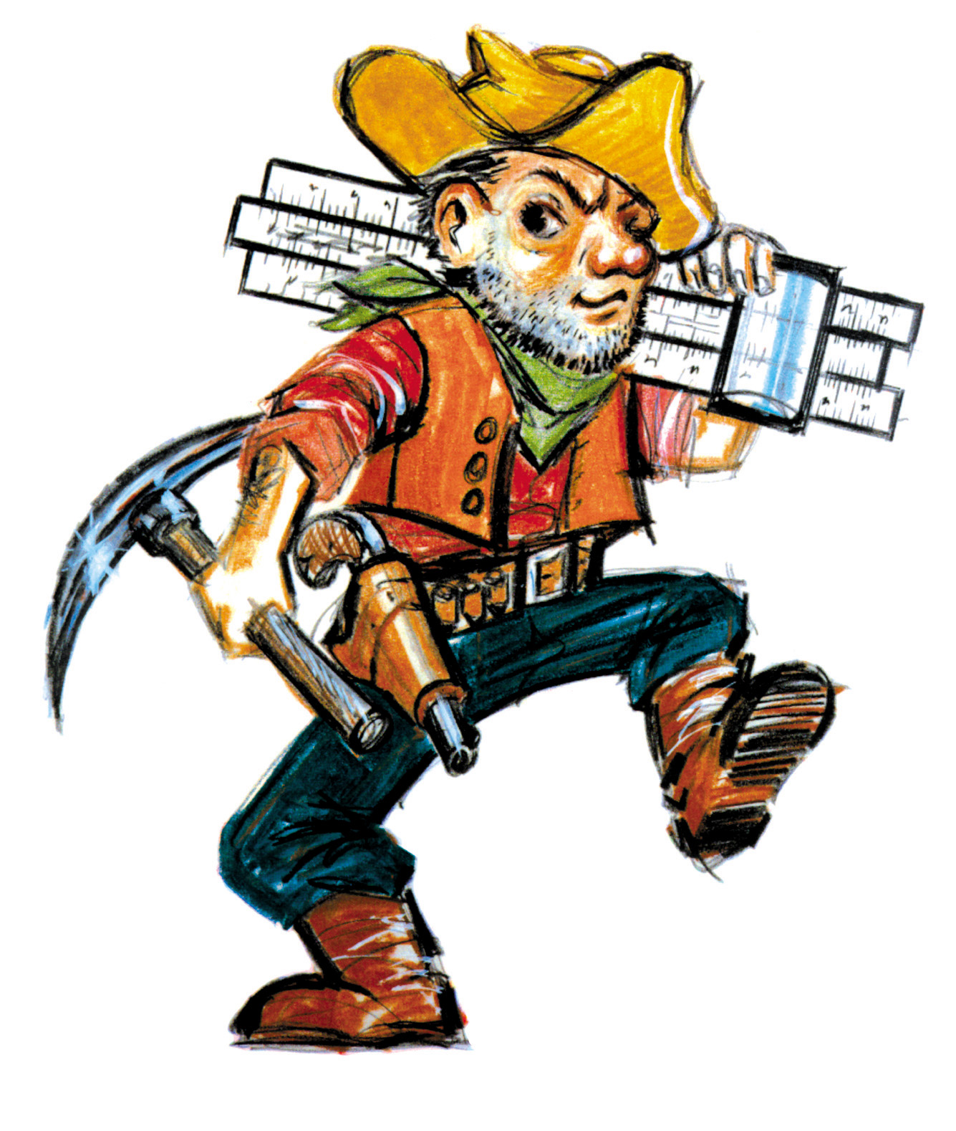

Jersee Wren (MVP) Southern Boone County Soph

Carter Simkims Centralia Sr

Logan Blevins Mexico Jr

Daelyn Schmauch North Callaway Jr

Elizabeth Willouer Columbia Home School Sr