**Licking Summer Camp**

*Est. 1993*

***Basketball Rolla, Mo***

***July 12-14, 2018***

***Bracket Results***

***St. James 49 Rolla 29***

***Liberty, IL 38 Green Forest, AR 35***

***St. Louis Notre Dame 48 Newburg 42***

***Festus 52 Villa Duchesne 29***

***St. James JV 39 St. Louis Notre Dame JV 30***

***St. James JH 52 Newburg JH 23***

M S&T All Camp Team

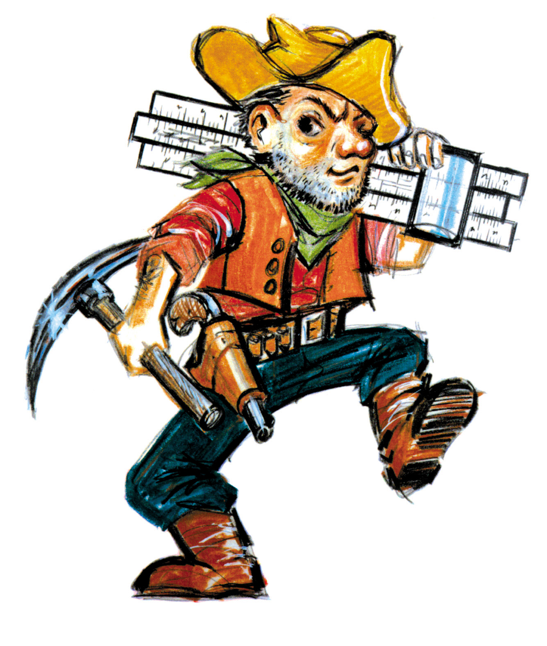

Savonna Ricetti (Co-MVP) St. James Sr.

Ashley Farrar (Co-MVP) Green Forest, AR Sr

Kassidy Heying Marshall Sr

Molly Effer Ursuline Sr

Jerzi Johnson United, IL Jr

Ashley Rinehart St. James Sr.

Brooke Meylor Harrisburg, IL Sr

Bailey Brookshire Newburg Fr

Jordyn Steffen Vienna Sr

Landrey Sweeney Jay, OK Jr

Carrie Hoffa Versailles Sr

Maddie Youngblood Green Forest, AR Soph

Ellie Rogers Rolla Jr

Jaden Schuette Liberty, IL Soph

McKenzie Northup Keokuk, IA Sr

Robin Kirk Lincoln, AR Jr

Marissa Miller ROWA, IL Sr

Hanna Nissen Camanche, IA Sr

Jamari Whitaker Arkadelphia, AR Sr

Jenna Oetting Festus Sr

Raylea Potter Nashville, AR Sr