Coaches’ Testimonials
- Season is off to a great start; 4-0 and ranked #8 in Class 2-A. Your camp got us off to a great start and we learned a lot about our team while having a great time!” John Adams, Okoboji, IA
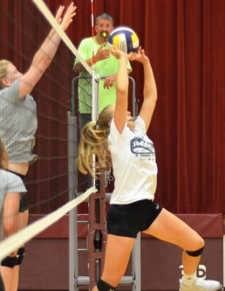
- “Just wanted to let you know that my team finished 18-0 in conference. We finally did it. 3A North Conference Champs in Valley Springs, Arkansas. We have come a long way since the first year that we attended your camp in Branson. I just want to say thank you for hosting such a great camp. My players and I look forward to it every summer. Christie Popejoy, Valley Springs, AR
- “Thanks again for another great experience.” Jason Peters, Heston, KS
- “As always, our schedule gave us very competitive matchups.” Andy Hampton, Wellington-Napolian
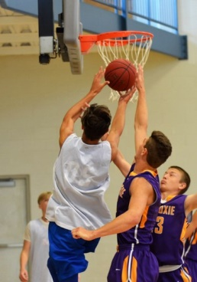
- “Very well organized camp. You guys always cater to our every need.” Joyce Williams, Northeast, Clarksville, TN
- “Excellent! I love the ‘everybody knows my name’ of this camp.” Marlene Talbert, Kirksville
- “I always appreciate how I am greeted by your staff and how we always feel so welcome.” Elise Asher, St. Elmo-Brownstown, IL
- “Your camp has become an important tradition for us and how we prepare for the season.” Ron Underwood, Mid Buchanan
- “Very well run, that is why we come back year after year.” Stephanie Curbow, Ash Grove
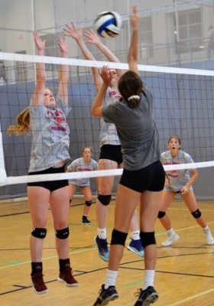
- “We love playing teams we never get to see.” Curt Riley, Tolton Catholic
- “Great Communication. Your response to our pre camp e-mails was great.”Rachel Stagg, Lathrop
- “As a first time attendee, everything was so easy to follow.” Shana Engel, Kirksville
- “This is a very smooth run camp.” Lisa Stiefel, Keota, OK
- “Thank you for all the time and effort you put into this camp.” Deanna Rohling, Neodesha, KS
- “One of the most organized camps we have been to.” Shelly Stone, Limestone, IL
- “Great camp. We felt very welcome.”Lee Coakley, Triad, IL
- “Thank you for scheduling our varsity and JV teams together. It was a big help.” Stuart Creamer, Danville, AR
- “As always, everything was great. We will always be back.” Kayla Schultz, Centralia
- “We are treated like family and that is why we keep making the long trip to come.” Liz Chermack, Enid, OK
- “We appreciate the positive attitudes of the staff.” Craig Cummins, Jonesboro, AR
