2019 Boys Basketball Coaches Packet

Dear Coach:

Enclosed you will find pertinent information about our camps. Please take the time to look over all of the enclosures, including rules modifications.

Jim Pritchett has put together the schedule for this camp. If you have questions or concerns, please direct them to Sam. His phone number is 573-578-7050 or e-mail: jim@lickingcamps.com

Because we are playing at multiple sites, and with so many teams, you will be given a copy of the Tournament bracket when you check in on the first day. If we see that we have not bracketed accurately, we will make changes on the first day and notify you before you leave that evening. Otherwise, the bracket you receive on the first day will be the one we follow for the tournament. IF there are changes we will contact the teams involved. Past experience has shown us that this is the best way. If you have two teams entered, we will try to keep you together as much as possible, but there may be times that your teams play at different sites.

We suggest, if you bring multiple teams, that you bring coaches for each team. It is possible that your teams could be playing at the same time and possibly in different gyms. This is especially true during the tournaments on the last day of camp. We try to avoid this as much as possible, but sometimes we can’t.
It is very important that we begin games on time. Teams that do not arrive on time will throw the entire schedule off.

Please arrive at least one-half hour before your first scheduled game. All teams will check-in at the location noted on the check in schedule. We have scheduled you to check in at a time that is convenient to you. If you desire to check in at a time prior to your scheduled time, feel free to do so. Please refer to the check in schedule.

We have spent a great deal of time in compiling a schedule that hopefully is as convenient to you as possible. With everyone’s cooperation in getting to your games on time, everything should go smoothly. Again, it is important that you give yourself ample time to travel from your home to your first game site and arrive at least 30 minutes prior to your first game.
We look forward to a good camp that will be enjoyable for all, and that will also challenge your players to improve.

Sincerely, Camp Staff
Please Bring your Own Warm-Up Balls for Camp!

Licking Summer Camp

dave@lickingcamps.com www.lickingcamps.com

LICKING SUMMER CAMP
BASKETBALL RULES MODIFICATIONS

1. All games must start on time.

2. Games will be played in two 15 minute halves with a running clock. The clock will stop in the last minute of each half.

3. All fouls in the act of shooting will result in one point and the ball being awarded to the offended team. All non-shooting fouls, under five fouls in a half, will result in the ball being awarded to the offended team. On the fifth team foul of the half, (with the exception player control fouls) and on each subsequent foul, a point and the ball will be awarded to the offended team. A player control foul will result in the ball being awarded to the offended team.

4. A player who is fouled in the act of shooting, and the shot is successful, will be awarded three points and possession of the ball will be given to the other team. A player who is fouled in the act of shooting a 3 point shot and the shot is successful, will be awarded four points and possession of the ball will be given to the other team.

5. In the last minute of each half, regulation rules will apply, and free throws will be shot.

6. If a team is down by 15 or more points in the last minute of the game, the mercy rule will apply and the clock will run without stopping. Exception: The one and one rule will go into effect on five fouls.

7. Overtime will be decided by the first team to score two points.

8. Individual fouls will not be kept.

9. A technical foul will result in two points and the ball awarded to the other team. (I instruct our officials that I do not want technical fouls called. Summer time should be a time of learning for everyone. I expect the adults to act like adults and if a player is having a problem with behavior, I expect the coach, not the officials, to correct it.

10. Three 30-second time outs per team per game.

11. Half time will be two minutes.

12. Time between games will consist of five minutes.

13. All other National Federation Rules will apply.

14. Note: These rules are designed to keep the games moving, but also to discourage excessive fouling by the awarding of points.

Delay Game Tactics

We have had several coaches question us regarding teams running offensive delay games for extended periods of play. In the past, we have always asked coaches through a “gentleman’s agreement” to refrain from employing a delay game or stalling strategies, except in the last minute of each half, when regular rules apply.

Our rules have evolved over the years, driven mainly by coach’s suggestions. No one wants to shoot free throws with a running clock in a summer camp game. On the other hand, most summer camps are way too rough. Our rule of points being awarded due to fouls has helped keep play at our camp games over the years relatively clean. If you foul under our rules, you will be punished.

However, since we do not shoot free throws, we have created a situation where a team with the lead that wants to hold the ball the entire second half has a very unfair advantage. There are limited strategic opportunities for a team that is behind to employ an effective strategy. Most importantly, stalling tactics - with no free throws being shot -deprives both teams of the primary goal of our camp, team improvement.

We are obviously not in a position where we can facilitate or employee a shot clock. Neither do we want to create subjective rules and place our officials in a tough spot by allowing the ball to be taken away from a team that is, in the opinion of the official, intentionally stalling. This could become quite judgmental. We would rather place our faith in the professionalism of our coaches and ask that delay games or stalling tactics not be employed until the last minute of each half, when the clock will stop and free throws will be shot.

Feel free to discuss this situation with us. If you have comments or further insight into this issue, we would be glad to hear from you. Our goal, as always, is to create an environment where your team can be challenged and improve.

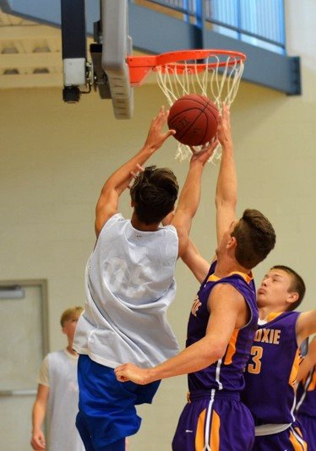
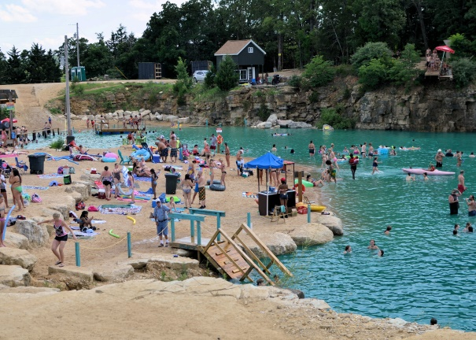
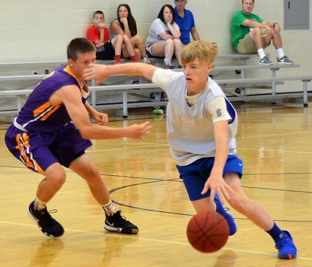
2019 Team Camp Gym Addresses
For Directional Use for GPS or Map Quest
Rolla:
MS&T 705 West 10th St. Rolla, MO
Rolla High School 900 Bulldog Run, Rolla, MO
Rolla Middle School 1111 Soest Rd, Rolla, MO
Rolla Junior High 1360 Soest Rd, Rolla, MO
Mark Twain Elementary 681 Salem Ave, Rolla, MO
Rolla Centre E 14th St & Holloway St, Rolla, MO
St. James High School 101 E Scioto St, St James, MO
St. James Middle School 1 Tiger Dr, St James, MO
St. James Elementary 314 S Jefferson St, St James, MO
St. James Rec Center 1204 Nelson-Hart Drive St. James, MO
Newburg High School 701 Wolfpride Dr, Newburg, MO
Immanuel Lutheran 807 W 11th St, Rolla, MO
Splash Zone E 14th St & Holloway St, Rolla, MO

Arnold:
Fox High School 751 Jeffco Blvd. Arnold, MO
Fox Middle School 743 Jeffco Blvd. Arnold, MO
Arnold Rec Center 1695 Missouri State Road Arnold, MO
First Baptist Church 2012 Missouri State Road Arnold, MO
Seckman High School 2800 Seckman Road Imperial, MO
Seckman Middle School 2840 Seckman Road Imperial, MO
Antonio Middle School 6798 St. Luke’s Church Road Barnhart, MO.

Joplin
Leggett & Platt Athletic Center: 3950 East Newman Road, Joplin, Missouri
Webb City High School: 621 N Madison St, Webb City, MO

Farmington:
Farmington High School One Black Knight Dr. Farmington, MO
Farmington Middle School 506 South Fleming Street Farmington, MO
Park Hills Central HS 116 Rebel Drive Park Hills, MO
Park Hills Middle School 8th and Columbia Park Hills, MO
Park Hills Central Elem. 900 St. Francis Ave Park Hills, MO
Mineral Area CC 5270 Flat Rive Road Park Hills, MO

Branson:
Rex Plex 1500 Branson Hills Parkway, Branson, MO
Sports Club 414 Buchanan Road, Branson, MO
Crawford Gym 1192 Bird Rd., Branson, MO
Branson First Baptist Church 400 South Sunshine, Branson, MO
Branson High School 935 Buchanan Rd Branson, MO
Branson Junior High 263 Buccaneer Dr. Branson, MO
Branson Intermediate 766 Buchanan Road Branson, MO
Branson East Elem. 308 Cedar Ridge Drive Branson, MO
Branson Primary 402 Cedar Ridge Drive Branson, MO
Hollister High School 2112 State Highway BB Hollister, MO
Spokane High School 1123 Spokane Rd. Spokane, MO

Quincy, IL
Quincy Senior High 3322 Maine Street, Quincy, IL
Quincy Junior High 100 South 14th Street, Quincy, IL
Baldwin Intermediate School 3000 Maine Street, Quincy, IL

Lake of the Ozarks (Camdenton)
Oak Ridge Elementary 526 Dare Blvd, Camdenton, MO
Hawthorn Elementary between the middle school and Oak Ridge
Camdenton Middle School 88 Laker Drive, Camdenton, MO
Camdenton High School 662 Laker Pride, Camdenton, MO

Lake of the Ozarks (Eldon)
Eldon High School Gym 201 West 2nd Street, Eldon, MO
Eldon Middle School 400 N Grand Ave, Eldon, MO
Eldon Upper Elementary 409 E 15th St, Eldon, MO
Eugene HS/Elem 14803 MO-17, Eugene, MO
Versailles HS 207 Westview Drive, Versailles, MO
Versailles MS 913 W Newton St, Versailles, MO

Mexico
High School 639 N Wade, Mexico, MO
Middle School 1200 W Boulevard, Mexico, MO
Hawthorne Elementary 1250 W Curtis, Mexico, MO
Mexico YMCA 1127 Adams Street, Mexico, MO

Perfect Team Bonding Experience:
A Team Float Trip
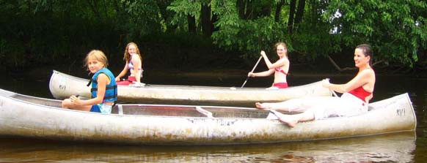

There are many canoe outfitters in the Rolla area. Most do a great job, however; several of our teams have had less than satisfactory experiences with floating in recent summers. To guarantee your satisfaction, we can now make the arrangements for you with outfitters we have screened for quality and dependability. We can secure for you a special low rate (lowest in the area) and can make arrangements for a team meal at the completion of your float. We can even secure for you a special motel rate if you are to stay over an extra day. The float we recommend will take 4-6 hours and will be on a “less populated” and “slower” part of the river, thus safer and more relaxing. This would be a perfect way to “kick off” your camp experience by coming in early and floating on Thursday; or staying over Saturday evening and concluding camp with a Sunday morning float.

636-232-4688
• Adventure Outdoors
• Rates: $15 per person
• Canoe or Raft
• Float 4 to 6 hours
• Located 15 minutes from Rolla
• Catered BBQ meal available
• Paddles and life jackets included

The above Canoe rate is the lowest on the river from a reputable outfitter. The above rate for a
Raft is a great price. The lowest rate on the river for a raft is $20 per person, with the average at $25 per person.

Call today for details!

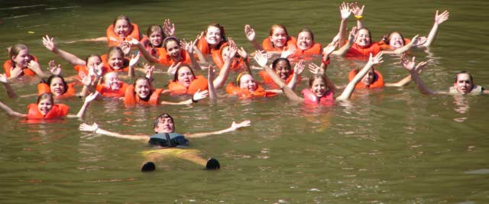

LICKING SUMMER CAMP FLOAT TRIP
SPECIAL

Reservation Information

School Name ________________________________

Coaches Name ______________________Coaches Cell # _____________

Coaches Home Address _____________

Coaches Home Phone _________________ Coaches Email: _____________

Date of Float _ Time of Start __ Length of Float (4 or 6 hrs)

Number of People who will canoe:

Number of People who will raft:

Would you like to have a meal catered at the completion of your float? Yes/No
(If you answer yes, we will contact you with details)

• For simplicity’s sake, and to avoid confusion, please allow Licking Summer Camps to make all your floating arrangements. That is the only way to guarantee the special camp rate.

• Adventure Outdoors (formerly Fagans) will handle all float trips this summer.

• Adventure Outdoors is the nearest outfitter to Rolla and is located on Highway 8, between St. James and Steelville.

• The rate will be $15.00 per person, rafting or canoeing (two people to a canoe, 3 people to a raft). You will not find a better rate from a reputable outfitter in the area.

• The float will be on the Upper Meramec River, departing from Scott’s Ford.

• In case of last minute changes, Adventure Outdoors can be contacted at 1-800-324-2674.

• Adventure Oudoors website address: www.adventureoutdoorsfloating.com.

e-mail this form to: dave@lickingcamps.com
upon receipt of this form we will e-mail you back a confirmation letter
Licking Summer Camp
COACHES SURVEY

1.What aspect of our camps benefited your team the most:

2. What suggestions would you make for improving future Shootouts:

3. Comments on the Camp Organization:

4. How were you treated by members of the community? We would be interested in both positive and negative experiences. Names of individuals or businesses that were helpful or not helpful would also be appreciated.

5. How were you treated by Camp Staff? Were you satisfied with the efforts of the officials? Once again, names or descriptions of individuals who were helpful or not helpful would be appreciated.

6. Other comments or suggestions:

Coaches Name ______________________________ School _____________________________________

Sport You Attended: (circle one) Volleyball or Basketball
Turn in at the end of Camp
Please Turn this form into the Gym Supervisor at the site where you play your Tournament.

All Camp Team Nomination Form:

Please Turn this form into the Gym Supervisor at the site where you play your tournament.

ALL CAMP TEAM
After you play your last game, before leaving camp, be sure to give your nominations for our all camp team to
the person in charge of supervision at that gym where you play your tournament. A Nomination Form is enclosed in this packet.
The Purpose of the All-Camp Team is to get recognition for deserving players. We will send the names of players who are chosen to all college women’s programs in the states of Missouri, Kansas, Arkansas, Illinois, Iowa and Oklahoma. We will include, with the players name and year in school; the coach’s name and school address. Players named to past teams have received a lot of mail from colleges. We will also post the names of players selected on the MoSports message board immediately after camp is concluded.
You will be able to see the complete list, of all the players selected from each camp, posted on our website.
Each coach will nominate one of their own players. This the fairest way to do it, since in a camp this big you will
not be able to see all of the other teams play. We will also get input from gym supervisors and officials in making the selections.
Under normal circumstances, the team who wins the upper division championship will have two players selected to the team, with the Most Valuable Player selection coming from this team. All other teams will usually have a maximum of one selection. We will try to get as many players as possible named to the team. We will limit the team to 20 players so obviously every team will not have a player selected.
We want the all-camp team to be a positive attribute for our camp

(Please Print)

Date of Camp attended _____________________

Players Name ____________________________________________________

School __________________________________________________________

Player’s Height _____________ Player’s Position ________________ Player’s Grade (fall 19) _________

Coach’s Name _____________________________________________ Coach’s Phone (optional) ___________

IF, for some reason, you forget to nominate a player please contact us ASAP to get your player nominated.

THANK YOU

dave almany 636-232-4688 www.lickingcamps.com dave@lickingcamps.com

CAMP POLICES
With the incredible increase in liability insurance rates in the wake of the 9/11 attacks, we began several years ago to charge an admission fee of $4 per spectator to attend our camps. We felt this was a more fair way to generate the revenue for increased insurance premiums, as opposed to raising our entry fee rates. With the help of our many corporate sponsors, we have been able to hold our entry fees at the same level for the past six years. We feel that we offer by far the most for the athlete’s dollar, of any camp around. The Admission fee will be good for all gym at all locations for the whole day. Thank you for your cooperation.

MOTEL/DORM SUPERVISION
We have had a great reception from the motels in the area we hold camps. They have appreciated the vast amount of business that the out of town participants and spectators in our program generate. We feel that the local motels have also been very hospitable to our visitors. We want to keep this good relationship and ask that you continue to monitor your athletes as to being respectful to the motel properties and the rights of other guests. If you should have a problem with a local motel, please notify our camp staff and allow for us to try and rectify your concern to your satisfaction.

COACHES TO DO LIST
1. Arrive at least 30 minutes before your first game on THE FIRST DAY OF CAMP.
2. Turn in your contribution for the coach’s book when you check into camp.
3. Receive an updated schedule before you play your first game.
4. Receive a Tournament Bracket when you check in on the first day.
5. Ask for help or assistance or help anytime you need it.
6. Fill out your nomination form for the all-camp team before you leave camp.
7. Bring your own warm-up balls.
8. Have Fun!
CHECK IN PROCEDURE
Please arrive at least 30 minute before your first game.. At this time you can pay your camp balance and receive your t-shirts and your coach’s gifts. You can also turn in your contribution to our coach’s notebook.
Please refer to the enclosed check-in list. The First day schedule included in your packet is tentative. There could be changes. Check the Web Site on a regular basis for updates. Be sure to pick up a revised schedule when you arrive on Friday.

MULTIPLE TEAM POLICY
Schools that bring more than one team to camp can use their players on either or both teams, according to that coach’s discretion. The philosophy of our camps is that competition is more important than winning. Teams are here to improve their skills for the upcoming season and we leave it to the total discretion of the individual coach as to how he or she employs their personnel.

LAST DAYS FORMAT
After all teams have played their last scheduled game, we will begin a single elimination tournament around noon on the last day of camp. The first round game of the tournament is included with the amount of games we guarantee. ALL teams in camp are scheduled to play in tournaments that should be at or very close to their expected level of play.

Please note that tournament brackets will have already been made and will be given to you on the first day of camp. We went to this format several years ago to eliminate confusion on the schedule. Poor communication with only one team can cause major difficulties. We learned the hard way that setting the bracket before play is the best way to go. If we have not bracketed accurately to assure good competition, then we still reserve the right to change the bracket after we see teams play. If any changes need to be made, you will be informed.

PROCEDURE FOR BUILDING THE CAMP SCHEDULE
Creating a schedule with a camp this large is a very big endeavor to undertake. When putting the schedule together, we take into account the following factors:

- The distance that teams have to travel to arrive at the camp site. Teams traveling the farthest will play the latest in the afternoon. We also try to let teams play games on their way to the check in site. An example would be: Teams coming in from the St. Louis area may stop to play in St. James before they check in.

2. Play teams of comparative strengths. It is very important that teams are challenged by teams similar in abilities. This is a very important factor to assure you of having a good and productive camp.

3. Keep schools that bring two or more teams to camp at the same site. We try to keep these teams together as much as possible.

4. Allow teams to play schools from different areas that you will not normally see during the regular season. Sometimes this doesn’t always work because some of the above priorities take precedent, but we try to have you play teams from different areas and states.

5. Teams that play late on the first night may not play the first games the next day. Once again this does not always work out because of the other above factors, but we do try.

6. Teams that are commuting do not have long breaks. These teams do not have hotels to pass the time, so we try to keep their schedules as compact as possible. The bigger the camp, the more gyms we will use, and the “domino effect” really takes hold. Add to this the complication of a team “bailing out” on us at the last minute, and we hope you get the idea of what a major headache the scheduling can become. Your patience and understanding is appreciated.

OUR GOAL
Our goal is for you to walk out of the gym on the last day of camp saying that our camp is not only the most economical that you have ever attended, but also the very best. If you have a problem, please allow us to try to fix it to your satisfaction. We want you to be treated well and to feel like your selection of our camp is appreciated. If you are not shown courtesy and appreciation by any of our camp workers, supervisors, or referees; we want to know about it. I also want to know if employees of motels, restaurants, or anyone else in the community; does not make you feel welcome. We want you to enjoy your experience in our community and we will do whatever it takes to make that a reality.

Badger Brand Shorts Sale

REGULAR PRICE $25 TO $30

GUARNTEED 100% SATISFACTION!
THE SHORT THAT HAS MADE US FAMOUS!

WE HAVE SOLD TENS OF THOUSANDS
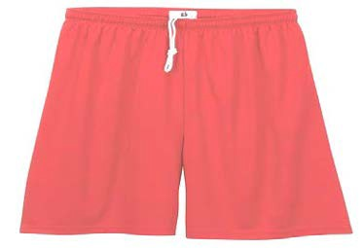

ON SALE AT THE REGISTRATION SITE
$15 A PAIR OR 2 FOR $26

WE ALSO HAVE SALE ITEMS and T-SHRITS

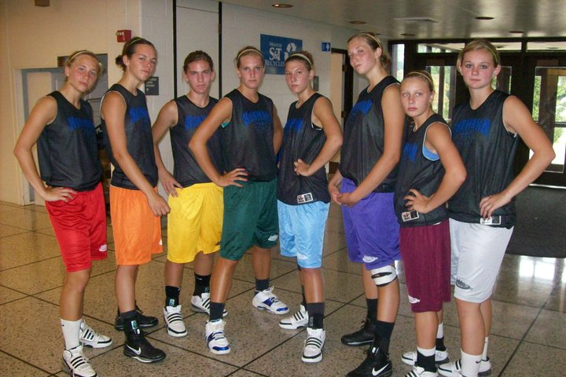
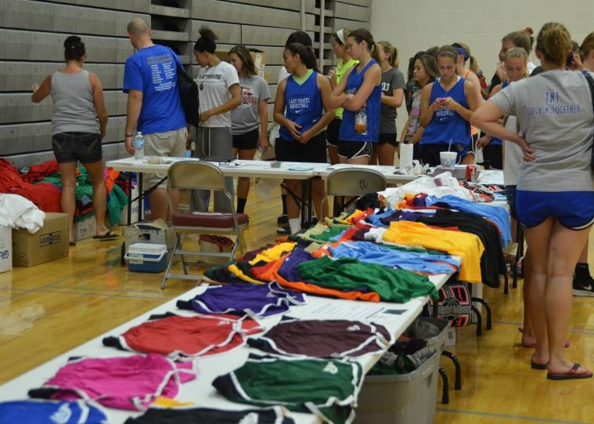

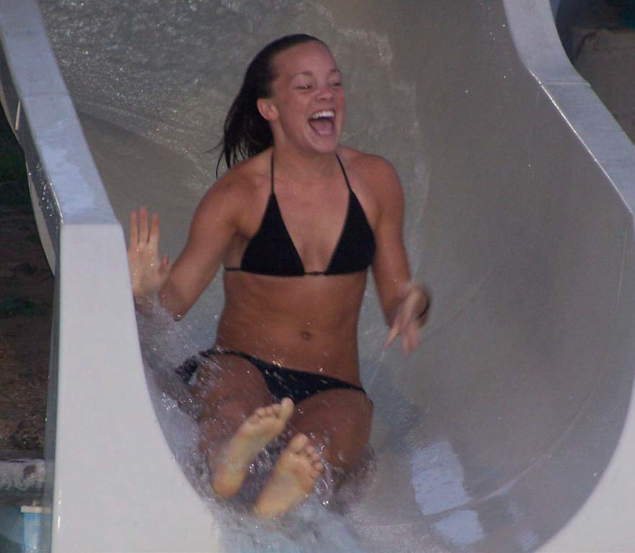
FIRST NITE AT SPLASH ZONE

ROLLA CAMPS ONLY

!!FREE!! Everyone in your traveling Party is Welcome

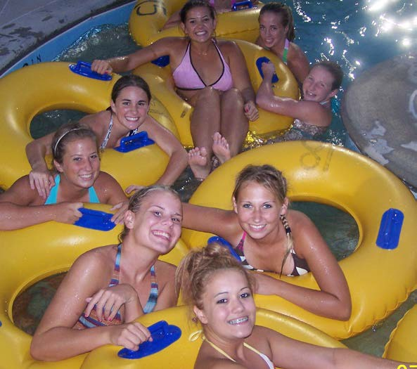
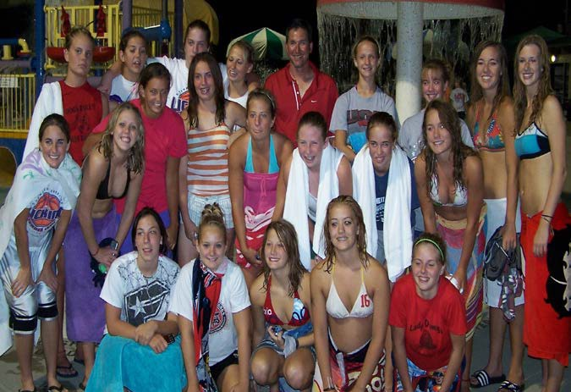

!!FREE!!

FIRST NITE
ROLLA CAMPS ONLY
7 PM TO 9 PM
SPLASH ZONE WATER PARK
LOCATED BEHIND THE ROLLA CENTRE

