2019 ROLLA INCLUSIVE PROGRAM OPTIONS

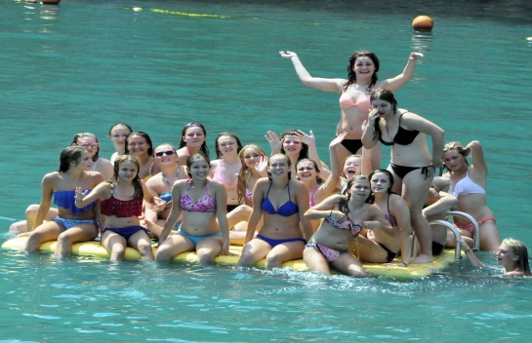
Lodging, Meals and Fun all for One Low Price
CHOOSE FROM ONE OF TWO HOUSING/MEAL OPTIONS
Option 1: MS&T University Housing: $55 for 2 day camps, $99 for 3 day camps.
Stay in University Housing and enjoy the below food & fun!
OR

Option 2: Super 8 Housing Options: $65 for 2 day camps, $114 for 3 day camps
Stay at the Super 8 and enjoy the below food & fun!
- Dorm/Motel room-1 night w/2 day camp, 2 nights w/3 day camp
- Extra Night Dorm/Motel prices below-breakfast included
- Five Meals for two day camps,
- Seven Meals for three day camps
- Professional souvenir Picture Packet (3 day camps for teams who stay in MS&T Residential housing)
- Free entry to Splash Zone
- Free entry to Fugitive Beach. (3 day camps only) (Includes life jacket)
- Slice of Pie Ice Cream Social (New)

INCLUDED IS A FREE LIFE JACKET FOR FUGITIVE BEACH
With MS&T housing option, for every 10 players coupons bought - the coach is free!

Meals Provided
Missouri Hick BBQ
Sirloin Stockade
Jimmy John’s
Dairy Queen*
Papa John’s*
(*three day camps only)
AND an all you can eat hot breakfast each morning in the Residential Life Cafeteria or the Super 8 Lobby.

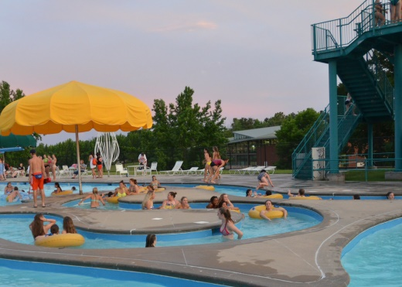
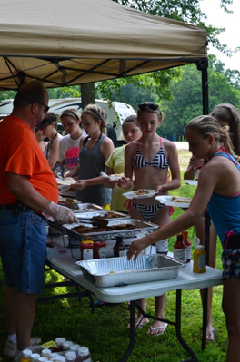

Missouri Hicks BBQ
Splash Zone Water Park

ALA CARTE RATE

- Extra Night Motel: $72 per room per night (up to four in a room)
Fugitive Beach
Breakfast included.
Extra Night Dorm: $20 per night per person Breakfast Included
- Extra Five meal voucher -three day camps - includes admission
Contact:
Dave Almany
636-232-4688
dave@lickingcamps.com
to Fugitive Beach- $44 ($62.67 menu price).
- Extra Three meal voucher- two day camps - $28 ($34.67 menu price).
- Extra Fugitive Beach Admission/Missouri Hick BBQ Coupons: $17.
Register for Camp and Rolla Inclusive Program at: www.lickingcamps.com

