* 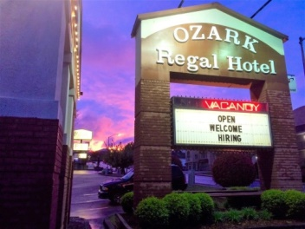

***2019 Branson Inclusive Options***

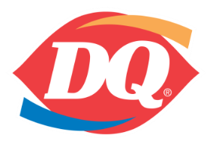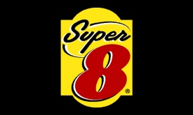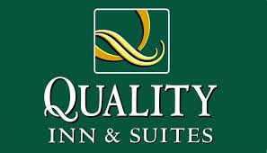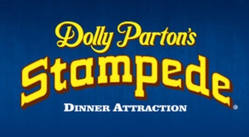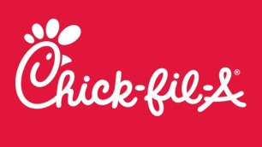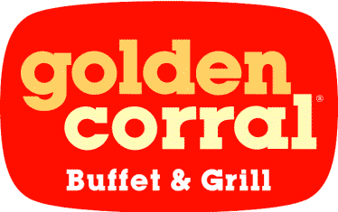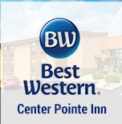

**MOTEL ADDRESSES**

Barrington: 263 Shepard of the Hills Expy

Days Inn and Suites 3010 Green Mountain Dr

Center Point Best Western: 3215 W 76 Country Blv.

Quality Inn: 2834 W 76 Country Blvd

Super 8: 2490 Green Mountain Dr

* Go to www.lickingcamps.com to register on line
* Select your options. It is simple and fast.
* You will receive a confirmation e-mail.

**Choose One or Two From the Following Options:**

**1. 4 Meals:** **$62** Dolly Parton Stampede, Golden Corral Adult Buffet, Dairy Queen, Chick-fil-A All meals Include Drinks

**The meal option includes the Stampede Dinner and Show (an $86 value)**

**2. Dolly Parton Stampede Dinner and Show** **Only:** **$39 (a $50 value!!)**

**3. Motel Rates Up to 4 in a room/per night and includes breakfast**

* **Best Western Centre Point Hotel $79**
* **Barrington Hotel $75**
* **Quality Inn $65**
* **Days Inn and Suites (formerly the Regal) $65**
* **Super 8 $65**