Licking Summer Camp
Est. 1993
Basketball Rolla, MO
May 31-June 1, 2019
Bracket Results
Civic Memorial, IL 37 Rolla 30
Civic Memorial, IL JV 44 Rolla JV 39

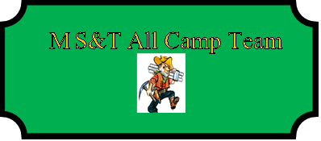

Anna Hall (MVP) Civic Memorial, IL SR
Kourtlamd Tyus Civic Memorial, IL SR
Page Ames St. Paul SR
Rebecca Janke Rolla SR
Madison Webb Ft. McGivney, IL SR

