Licking Summer Camp
Est. 1993
Boys Basketball Branson MO
June 5-7, 2019

Bracket Results
Forsyth 67 Muldrow, OK 61
Muldrow, OK JV Forsyth JV 42

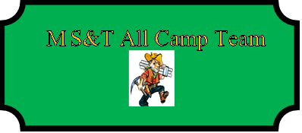

Joe Deroo (MVP) Forsyth SR
Collie Robertson Bismarck, AR SR
Trevor Turner Forsyth SR
Drew Clay Alton SR
Zane Gale Spokane SR
Parker York Bragg, OK SR
Colton McMullin Fountain Lake, AR SR
Conner Wright Muldrow, OK SOPH

