Licking Summer Camp
Est. 1993
Boys Basketball Rolla MO
June 6-7, 2019
Bracket Results
St. James 63 Lesterville 50
Salem JV 61 St. James JV 44

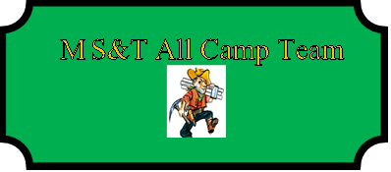

Mason Parker (MVP) St. James SR
Cason Gray Owensville SR
Cody Hendrix Camdenton JR
Brandon Myers Lesterville SR
Carter Chilton Salem SR
Bryce Long Camp Point, IL SR

