Licking Summer Camp
Est. 1993
Boys Basketball Rolla MO
June 6-7, 2019

Bracket Results
St. James 44 Sullivan 36
Cabool 59 Haileyville, AR 31
St. James 9 52 Mendon Unity JV, IL 37
St. James JH 44 Licking 7 38

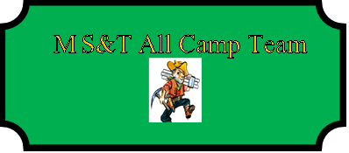

Hannah Marcee (MVP) St. James JR
Kami Conry Mendon-Unity, IL JR
Maddy Woolf Salem SR
Maddy Jones Maynard, AR SOPH
Mallory Shetley Sullivan SR
Riley Whitener St. James JR
Brooke Sinclair Dixon JR

