*Girl’s Basketball Rolla, MO*

*June 13-15, 2019*

***Bracket Results***

***Lutheran St. Charles 42 Macon 36***

***St. James 49 Ellington 46***

***Southern Boone County JV 42 Fayette, TN Academy JV 35***

***John Burroughs JH 59, St. Lames JH 47***

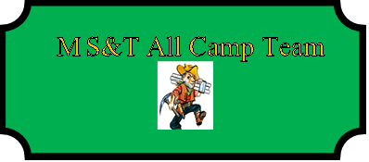

Jada Lindesmith (MVP) Lutheran St. Charles SR

Hannah Marcee St. James JR

Jaliyah Green Holt JR

Brooklyn Luna Fair Grove JR

Emily Ederer Doniphan SR

Tatum Hatridge Salem JR

Kaitlyn Eubanks Fayette Academy, TN SOPH

Aaliyah Scott Jennings SR

Claire Wilhour BSE, IL SR

Kaylee King Ellington FR

Allison Bullock St. James SOPH

Tyler Conkright Ellington SOPH

Claire Affolter Newburg SR

Alexus Miller Macon SOPH

Ayden Shannon Wellington-Napoleon SOPH

Bree Shannon Wellington-Napoleon SOPH